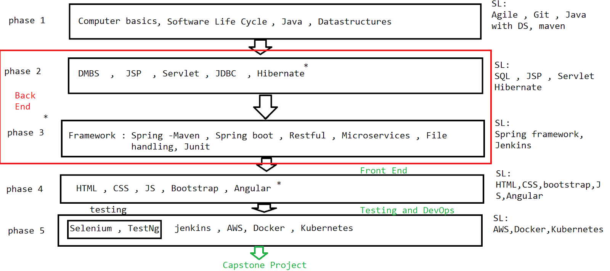

Each phase - phase end project - 100%

Attendance -100 %

Self-learning - 100%===================>phase end certificate

=> Mphasis-based assessments - 70 %

**Computer Fundamentals**

1. Computer basics
2. Operating system
3. Hardware
4. Software
5. Network
6. Network security
7. Computer Security

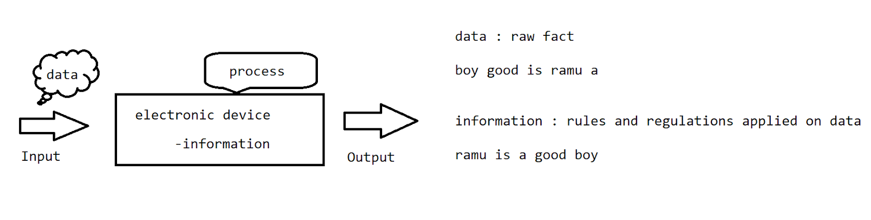

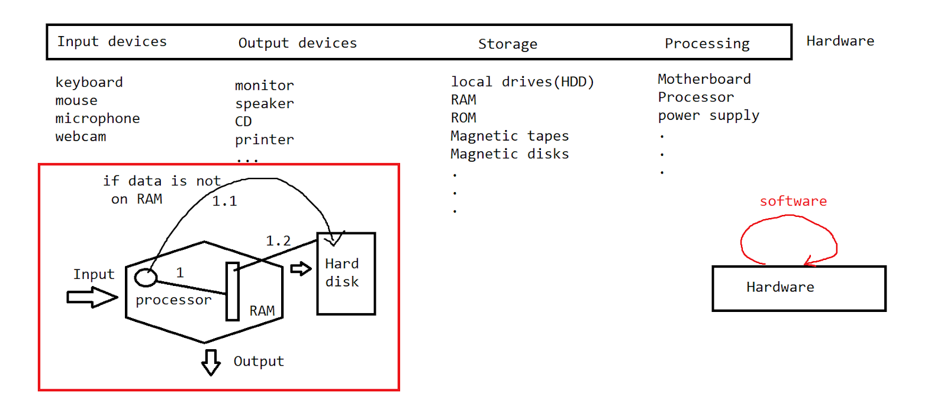

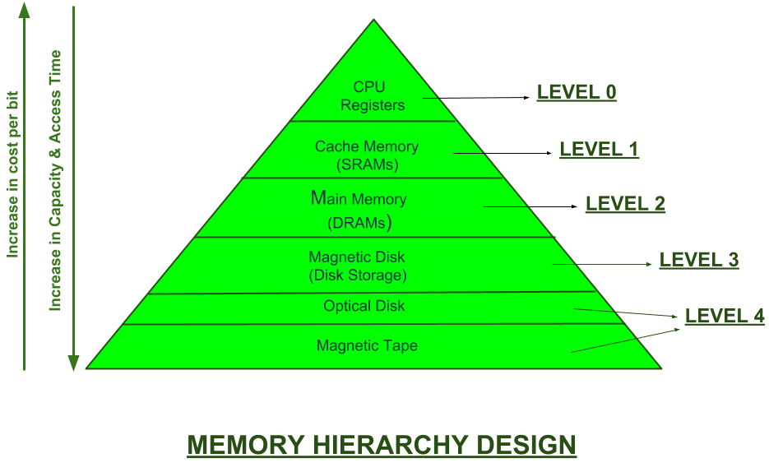

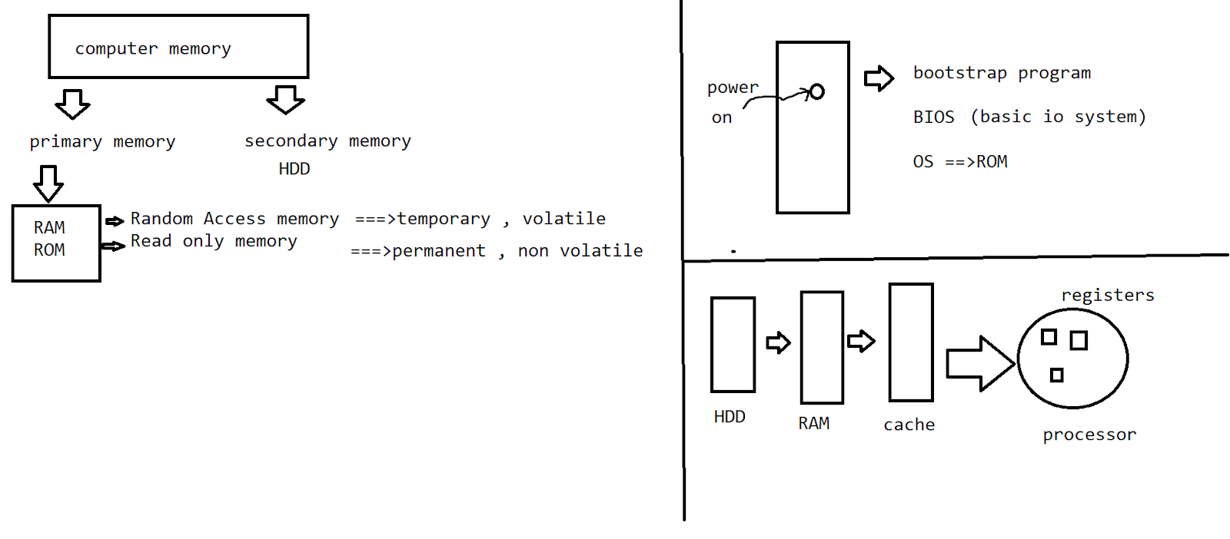

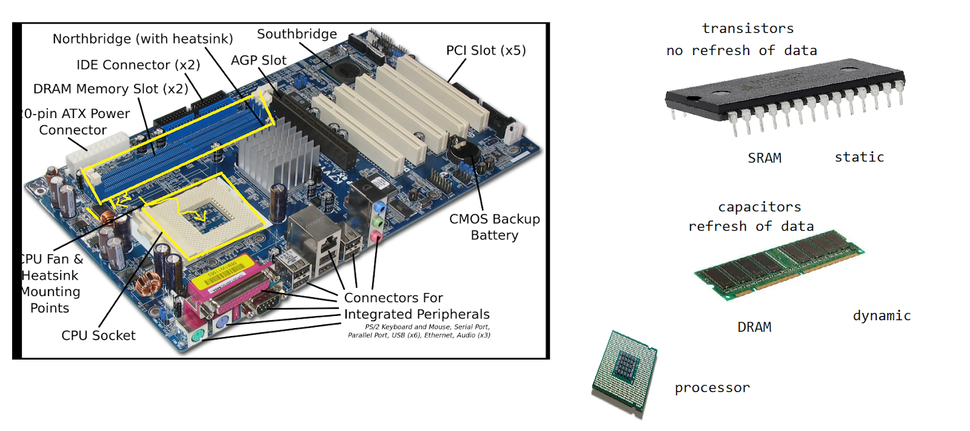

**Operating system**

It is a set of programs (software) that acts as an interface between the user and the computer hardware.

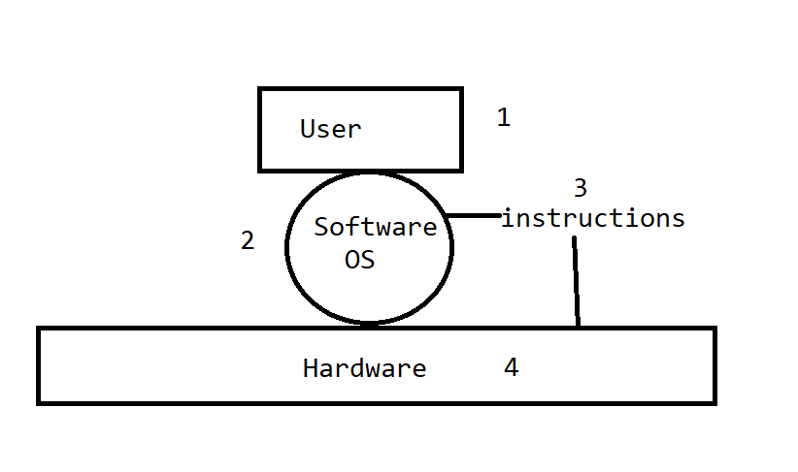

>OS jobs

1. Memory management
2. Process management
3. Device management
4. Error detection
5. Security
6. Job Accounting
7. Control over the system performance

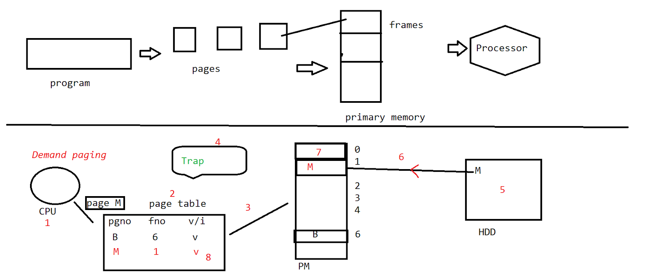

**Networking**

Group of devices connected with each other via a medium

Transmission medium - cables, wires …   [wired / wireless]

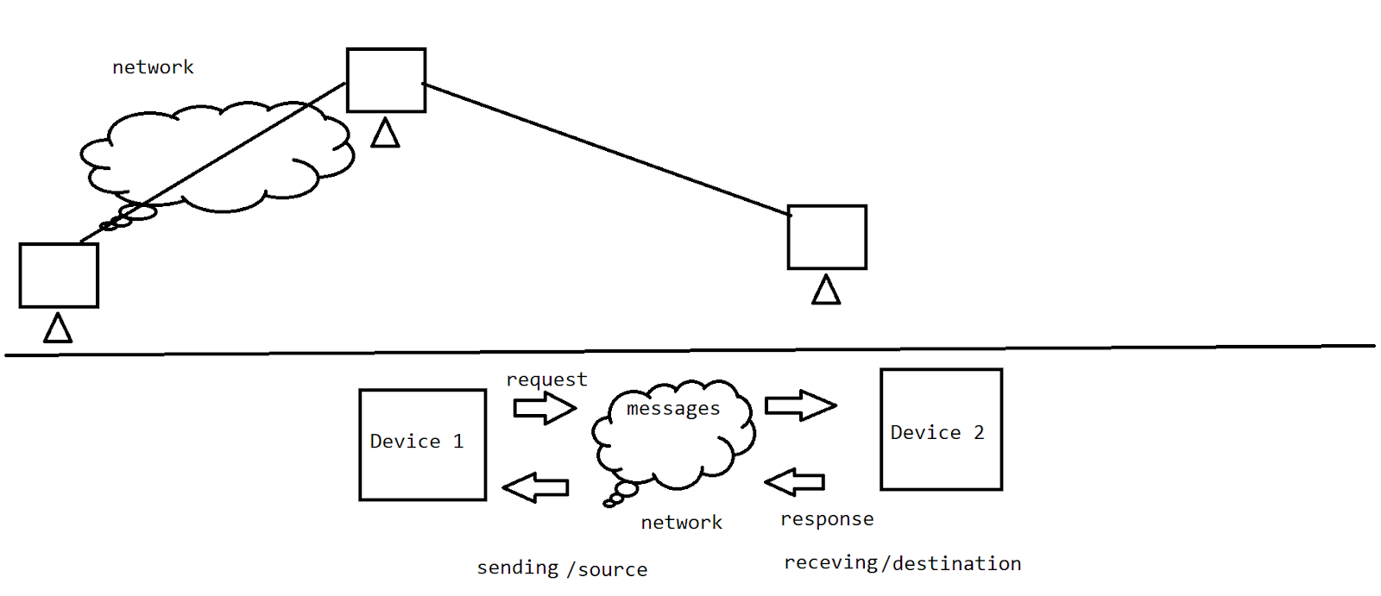

-communication bw sender and receiver

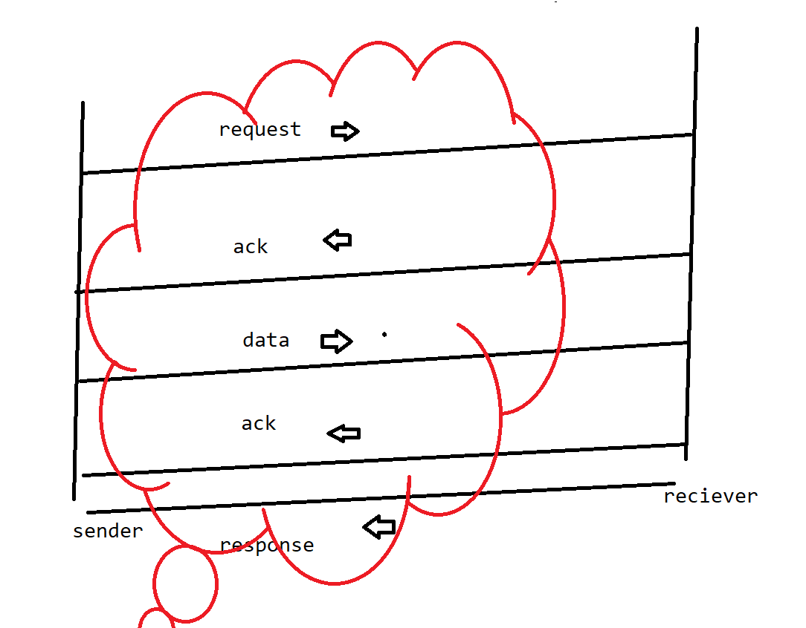

HTTP: hypertext transfer protocol

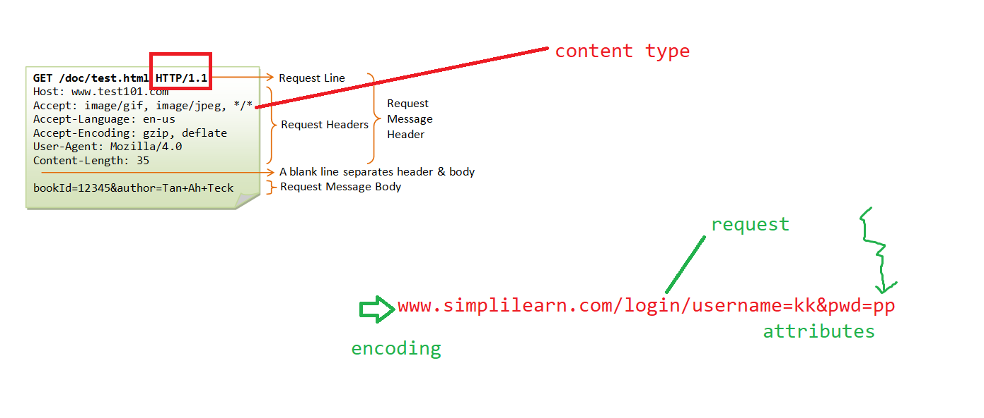

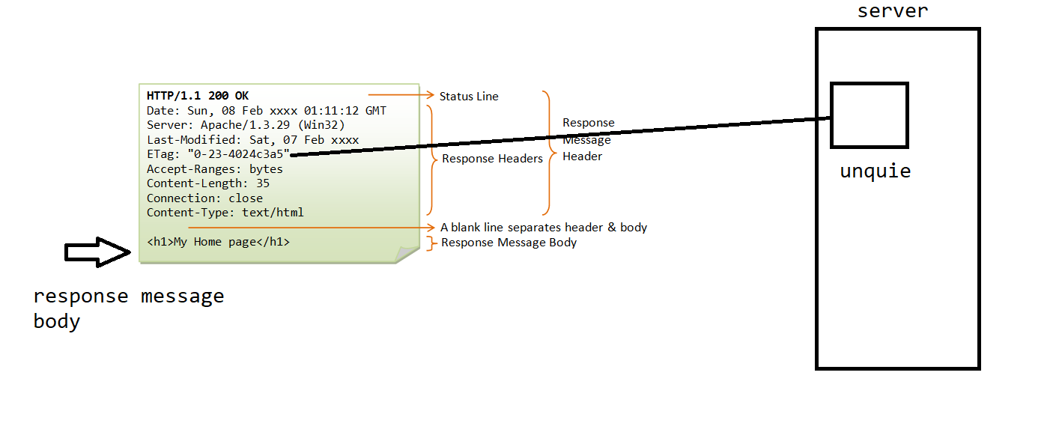

OSI Layer :

Open system interconnection

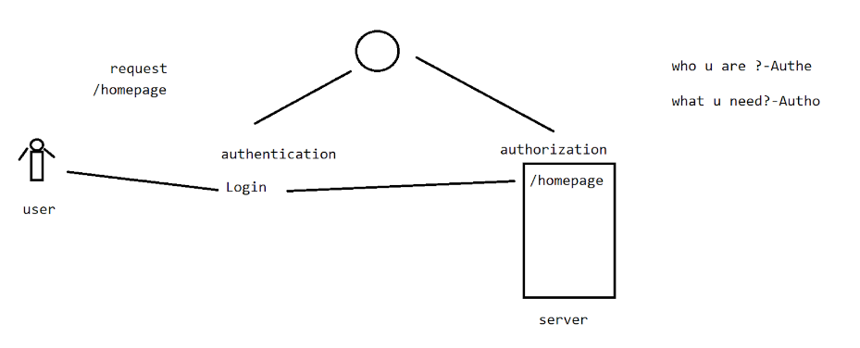

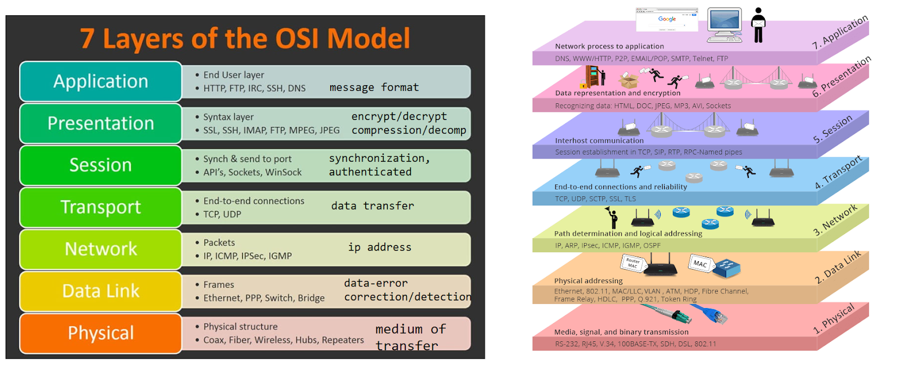

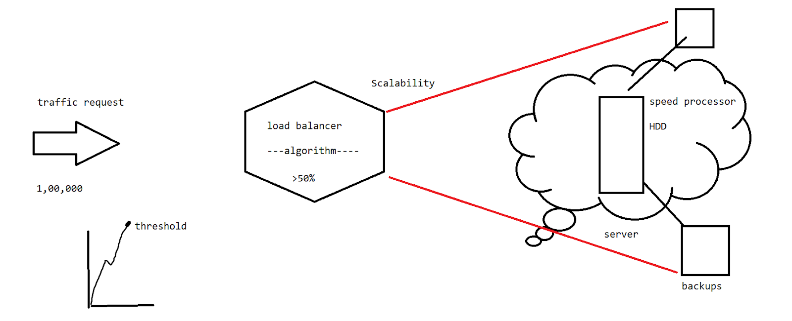

* When there is heavy traffic of requests, then the load balancer is going to show the way toward scalability.-scale up / scale down

Network Topology :

Network medium :

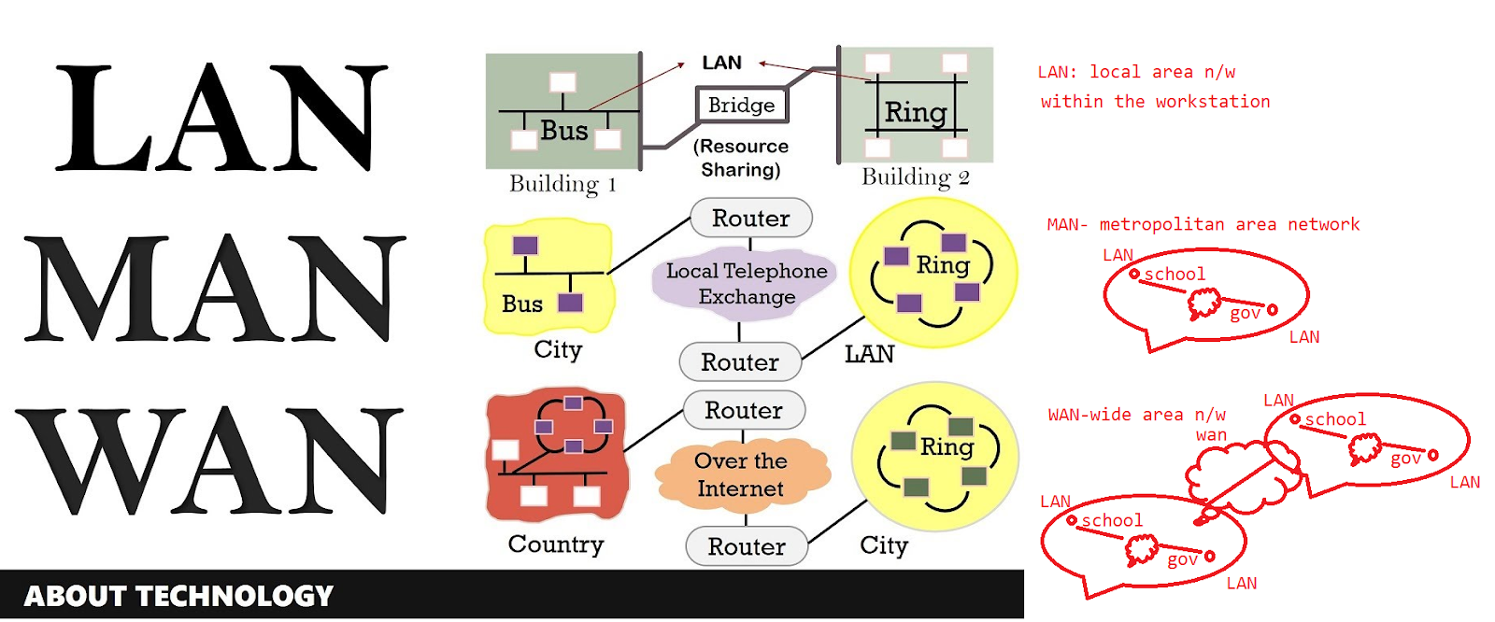

Topology is the structure that is used for connecting the systems.

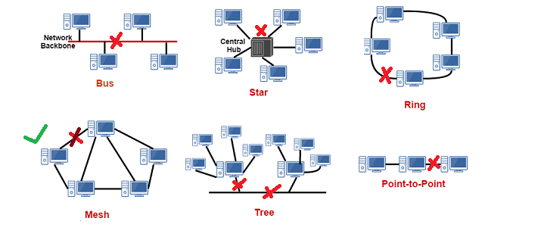

The mesh topology is the most reliable one for transmitting the data.[it has an alternate channel for communication if there is some failure].

2/5/2023

Self-learning -

|  |
| --- |
| Agile Scrum Foundation - E-Learning (4 hours) |

3/5/2023

>Transmission modes

On a network, it confirms the direction of the transmission of the message

1. simplex

2. half duplex

3. Full duplex

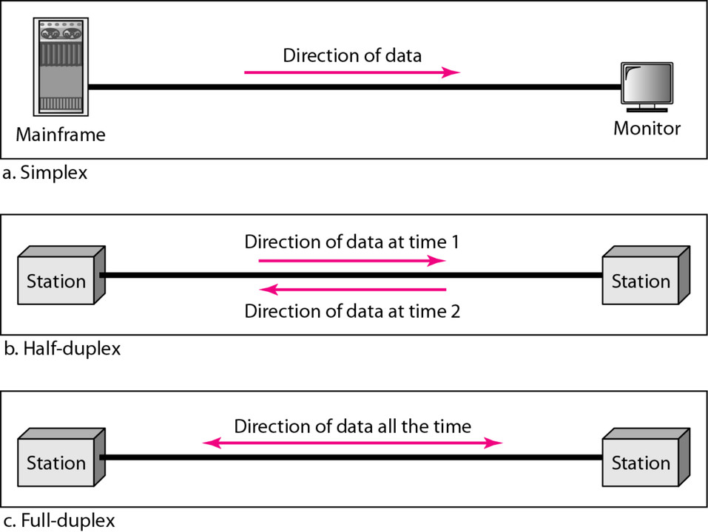

Simplex - unidirectional

Half duplex - can have multiple msgs from source to destination and from destination to source at only once.

Full duplex- bidirectional communication on the channel

>Internet

Global medium to interchange the information

1. It uses the standard IP(Internet protocol)--address suite to link to several devices
2. It is an international network of networks
3. They are connected via optical cables, wireless, electronic nw technologies.
4. It consists of business, public, education and govt nw.
5. HTTP is the standard protocol used for sending/receiving the information .
6. Extensive range of resources.

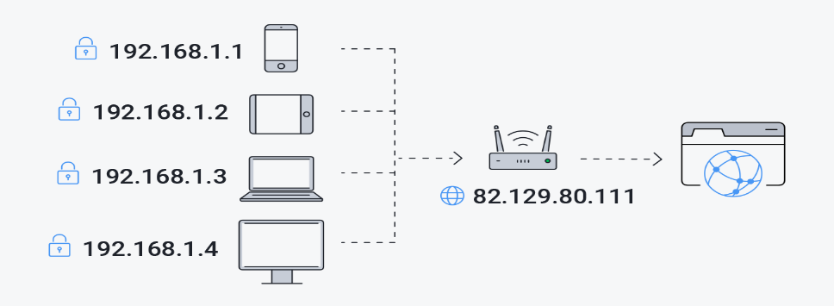

>Intranet

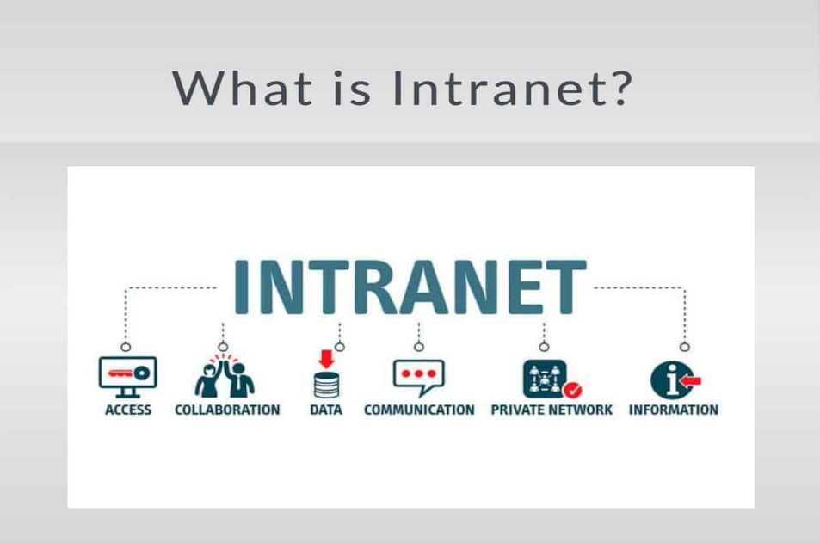

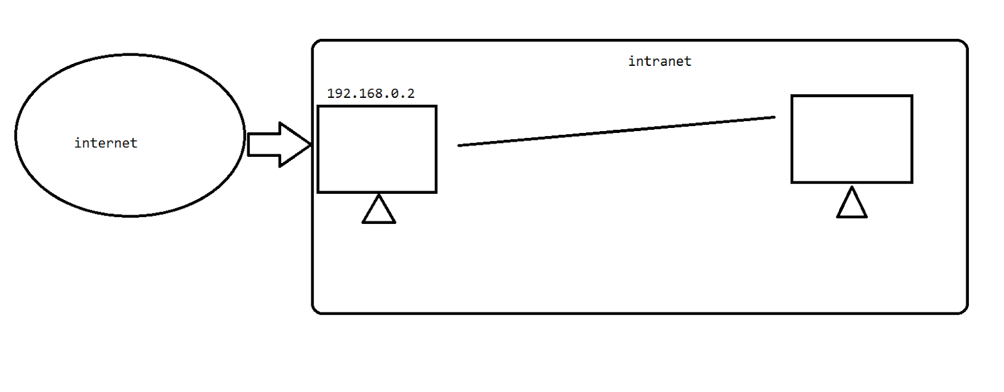

It is a private network with restrictions kept on accessibility.

Extranet :

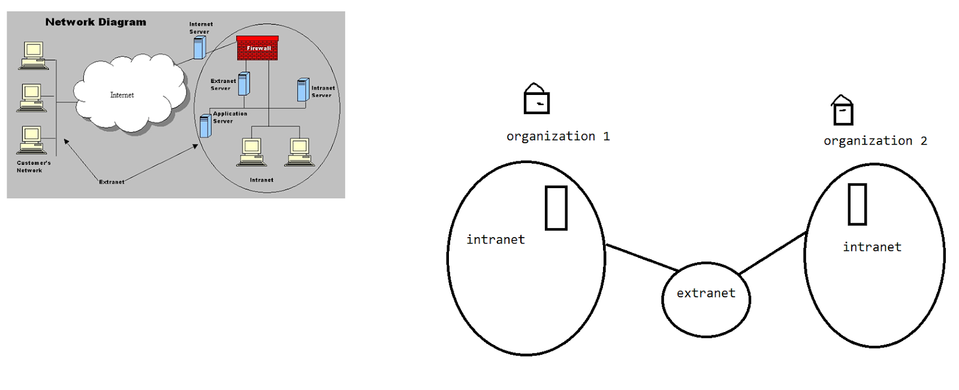

Computer Security :

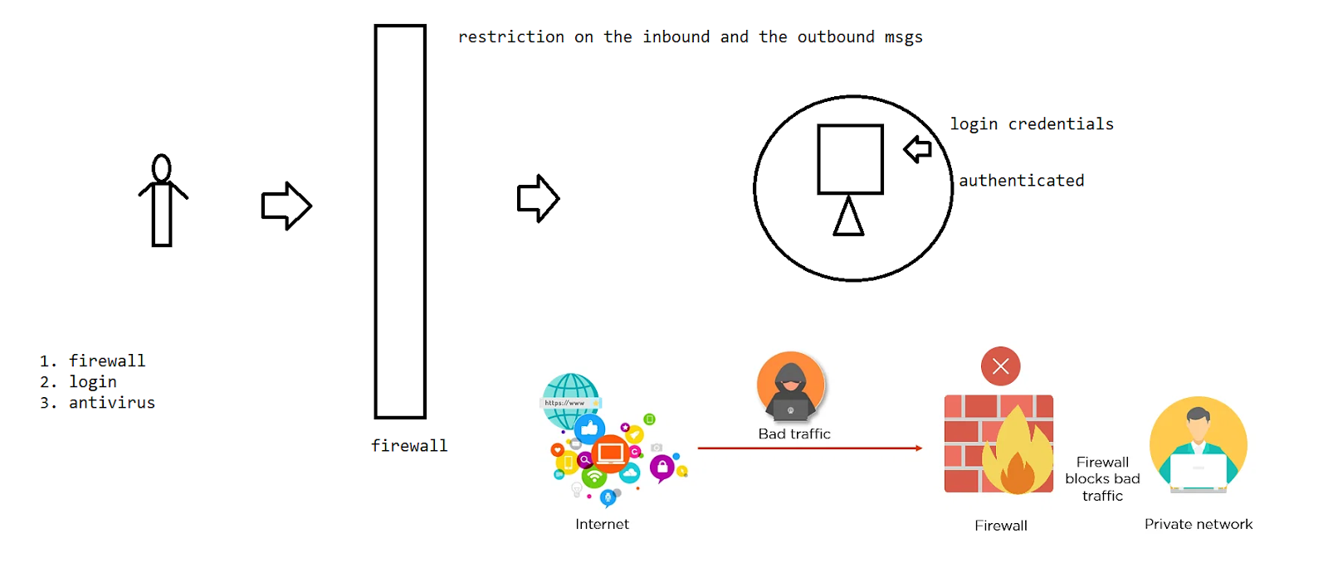

CIA traid

C- confidentiality       I-Integrity       A- availability

C- prevent unauthorized disclosure of sensitive information.

I- prevent unauthorized modification of system and information.

A- prevent disruption of service and productivity

These are the fundamental security principles upon which information security is processed.

C- ensuring that the info is inaccessible to unauthorized ppl , commonly we enforce via encryption,ID and password

I- safeguarding the system and the inform from being modified by the unauthorized ppl, there by we need to ensure the protected data is accurate and trustworthy.

A-ensuring that the authorized ppl have access to the info when needed, this keeps them the current updates .

-backup/scaleup

Network security :

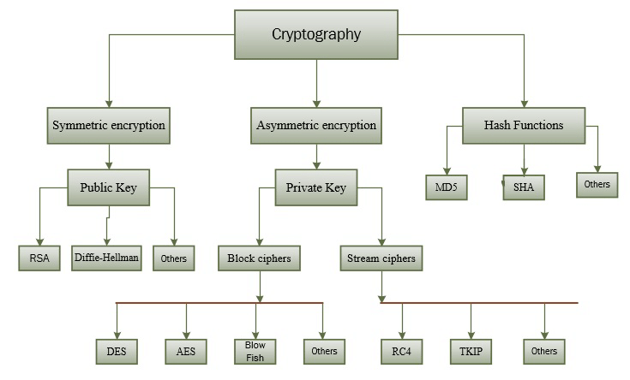

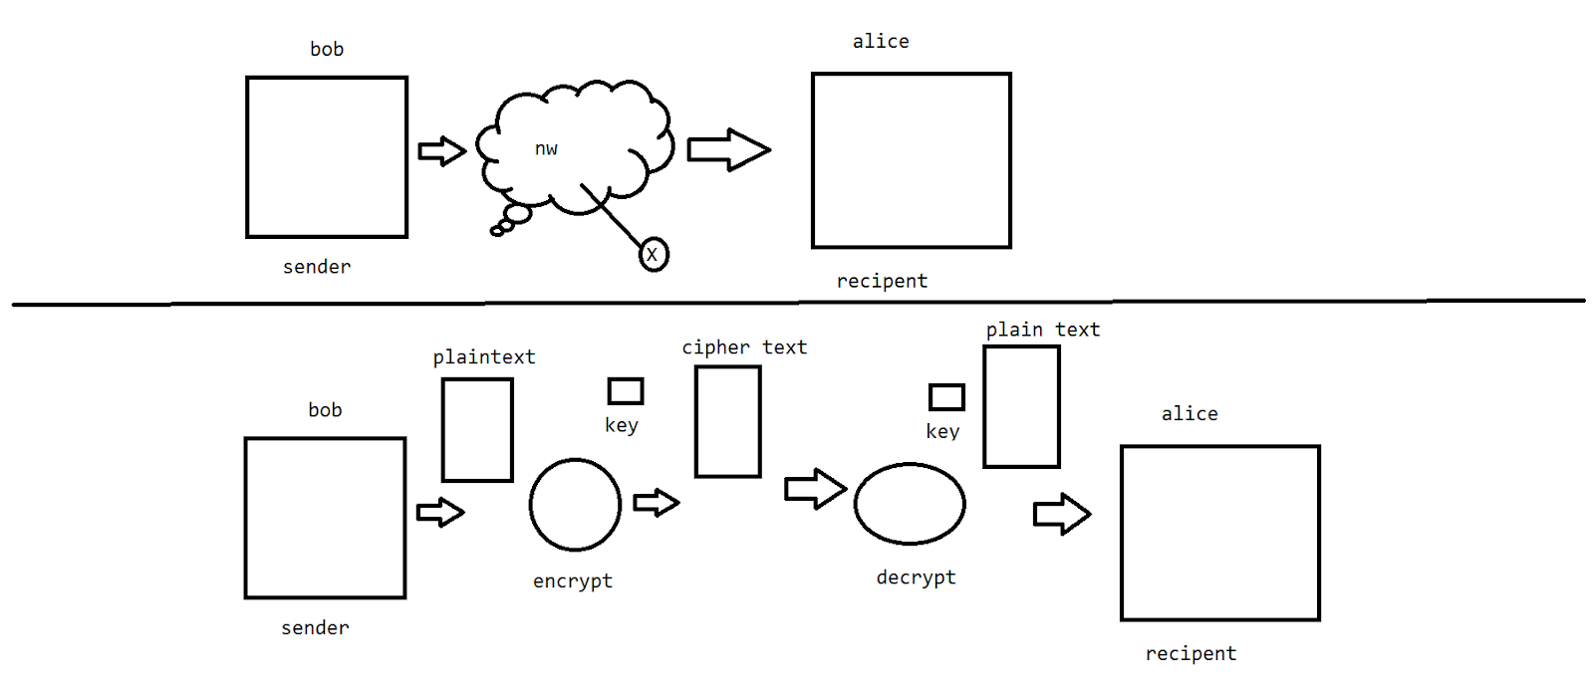

**Life Cycle of Project**

Project: Collaborative action performed by a group of people to complete a task

Product: This is the end item that we get after completion of the project

>Every project needs a life cycle in order to complete the project and deliver the product.

>Water fall model

>Agile model

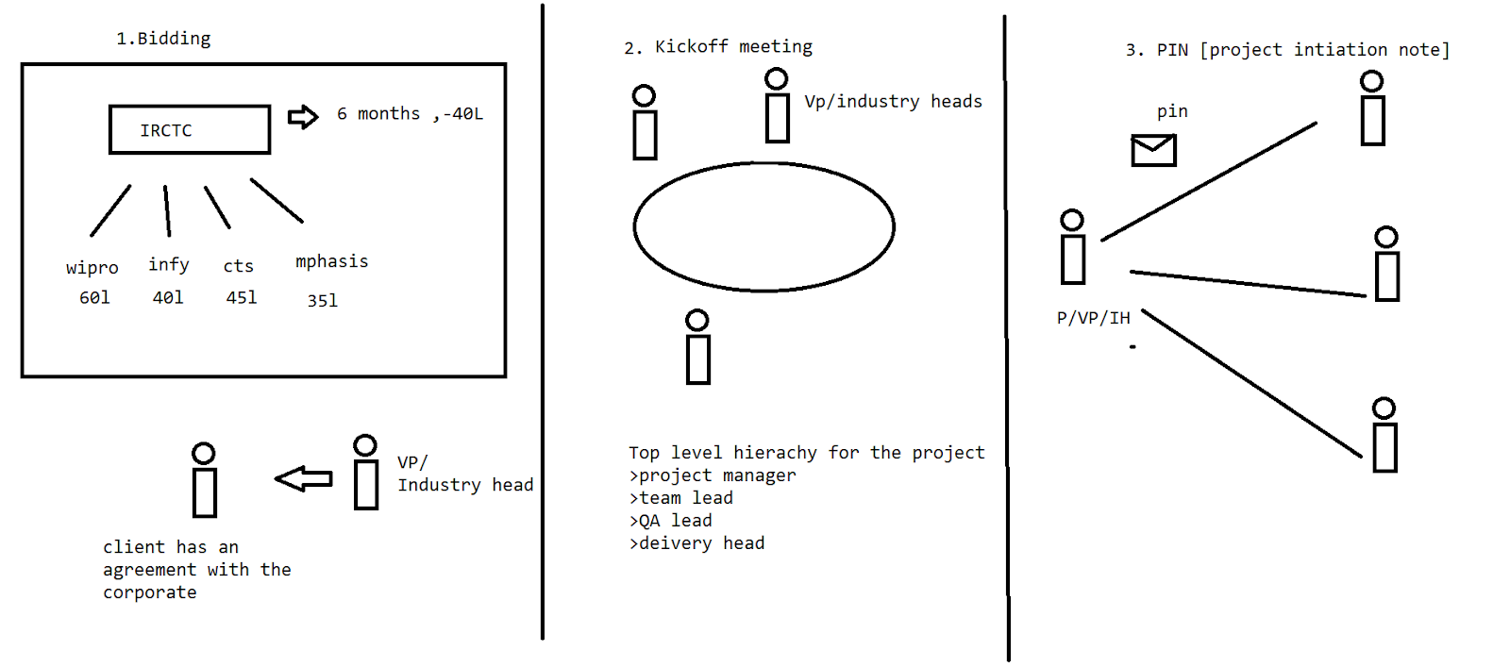

Software Development Life Cycle (SDLC)

Traditional model - Waterfall.

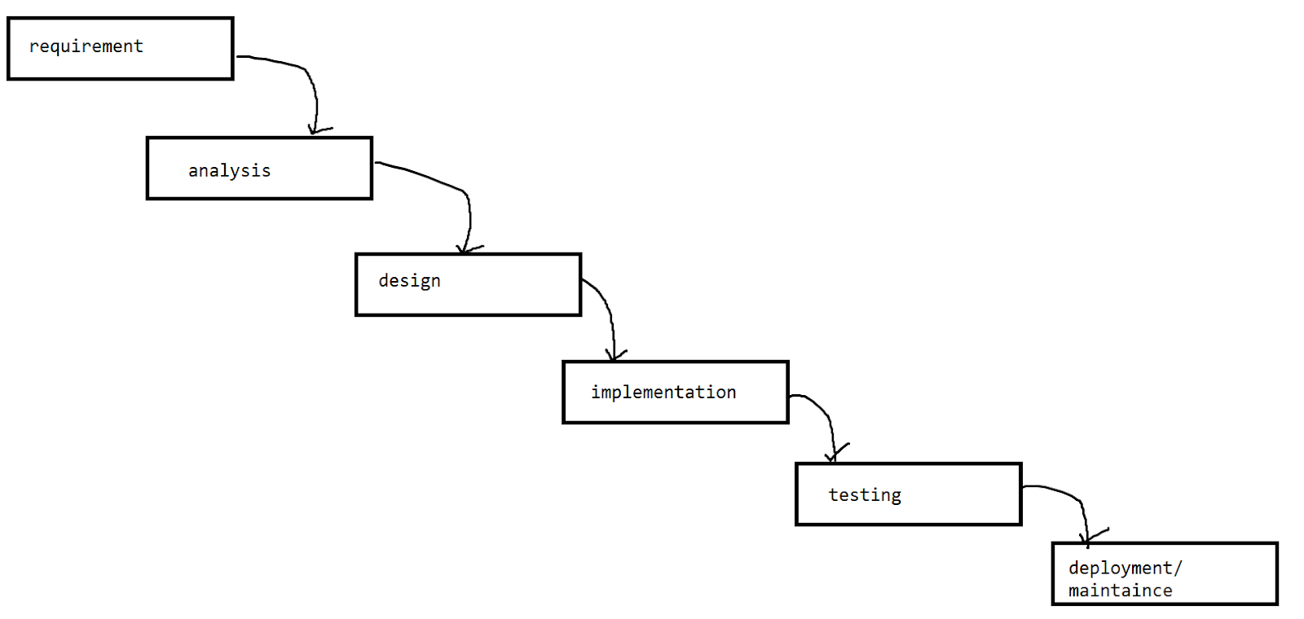

>Requirements:

Task: we gather the requirements/inputs from the client

Role: Business analyst, Engagement manager

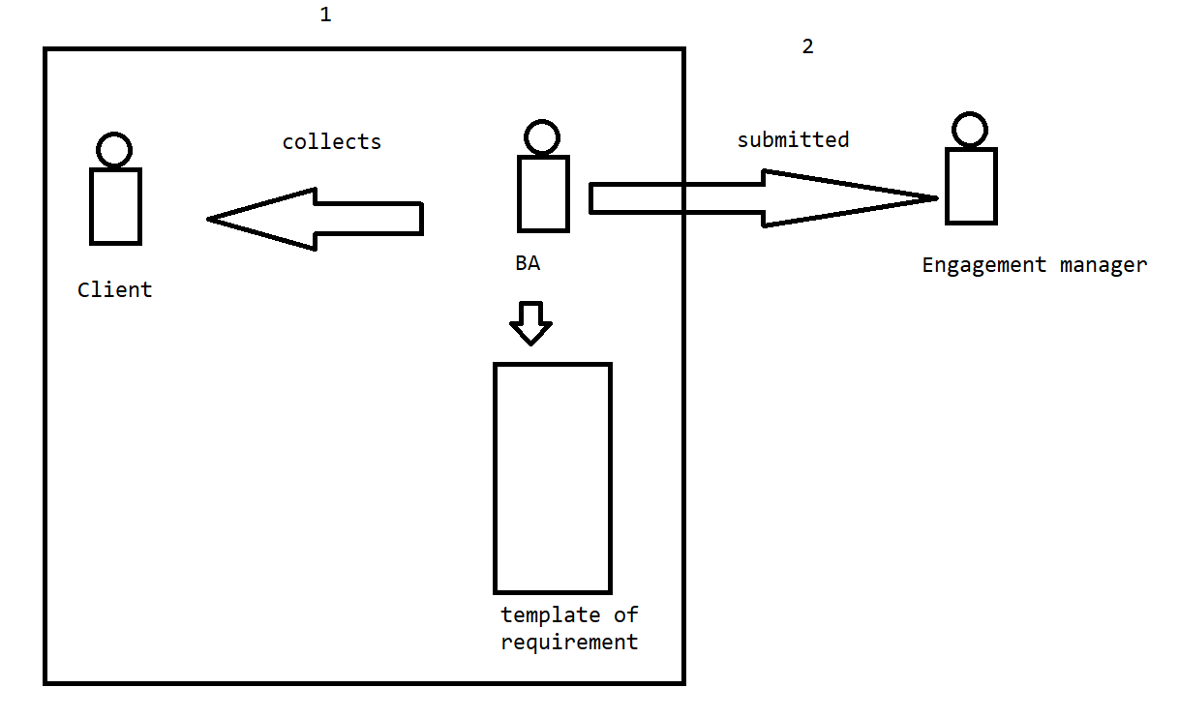

Proof: requirement template

Analysis:

Task: budget, deadlines, no of ppl , sw,hw, language….

Role : project manager, team lead, test lead, system lead, HR…..

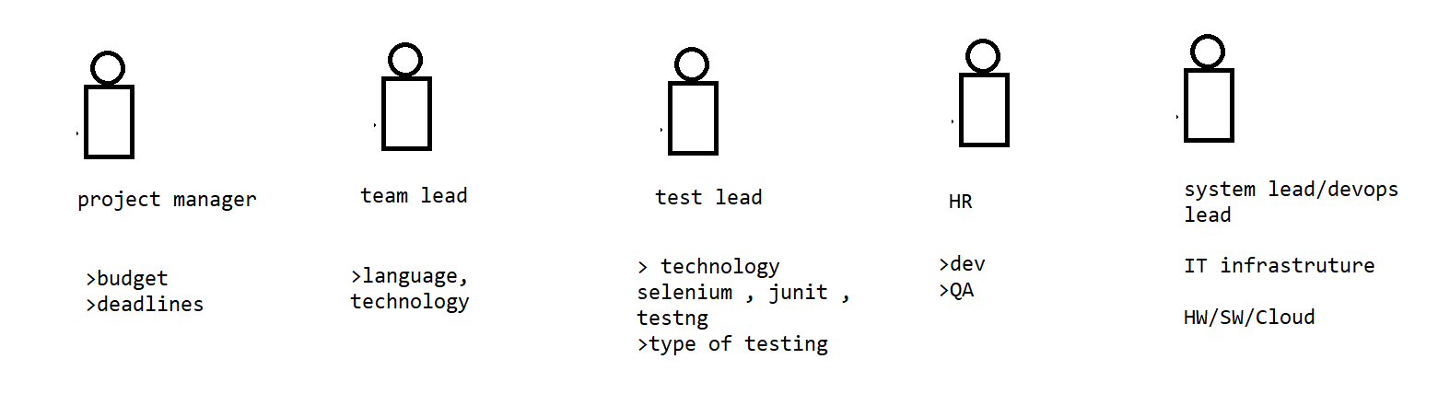

Proof: analysis report

>Design

Task : web pages , UML diagrams , ER diagrams

Role : Architects, dev, designer , db admins

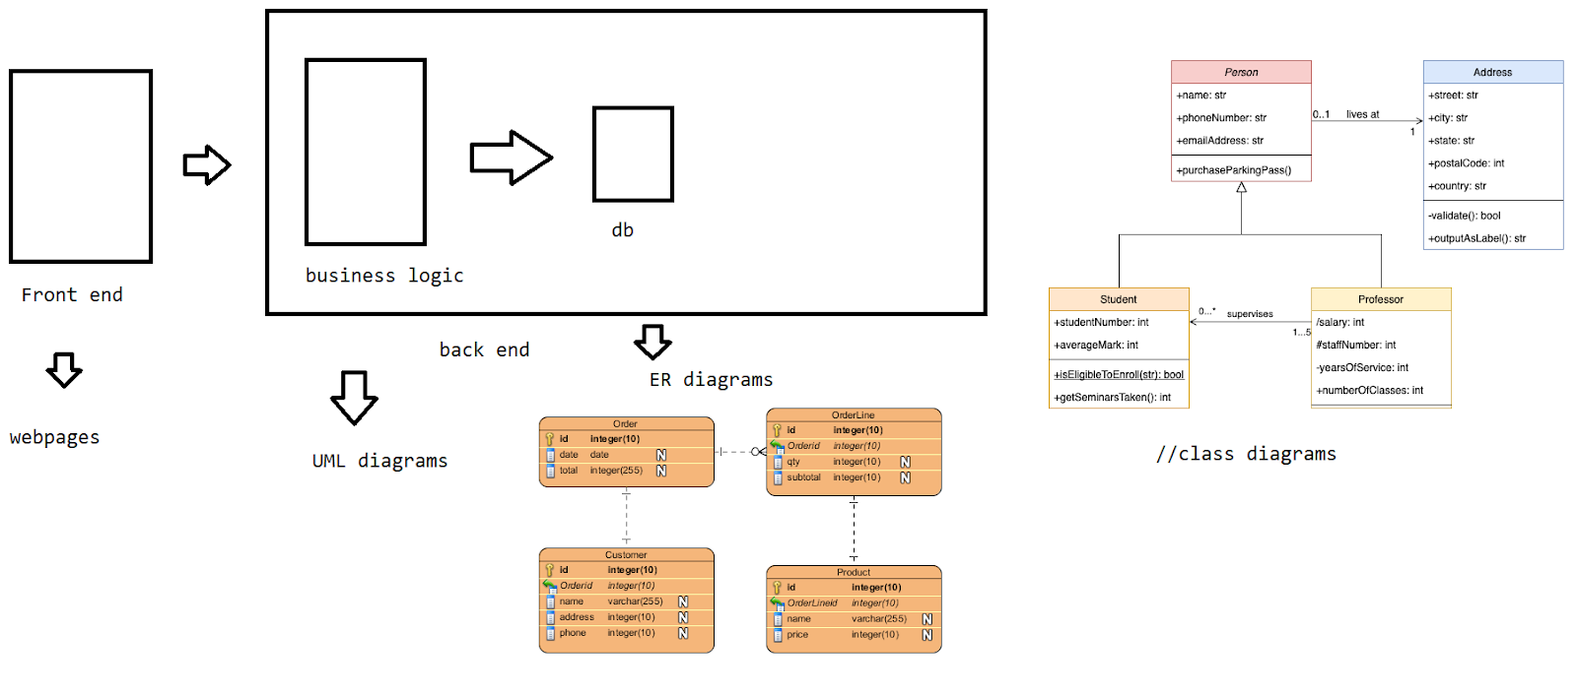

Proof : Functional design document

Implementation:

Task: development/implementation of the functionalities required for the project

Role: Developers, technical lead, functional lead

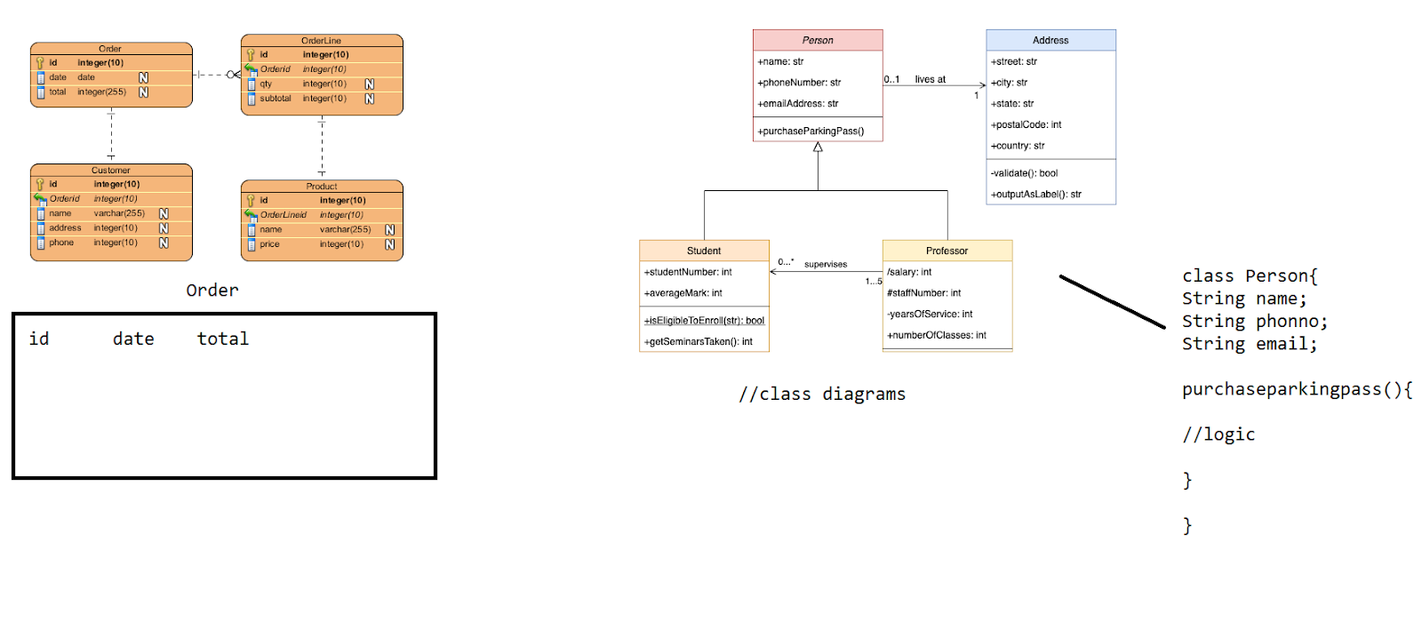

Proof: src (source code)

>Testing

Task: test the quality of the code and prepare the test cases/scenarios

Role: QA lead, QA team (testers)

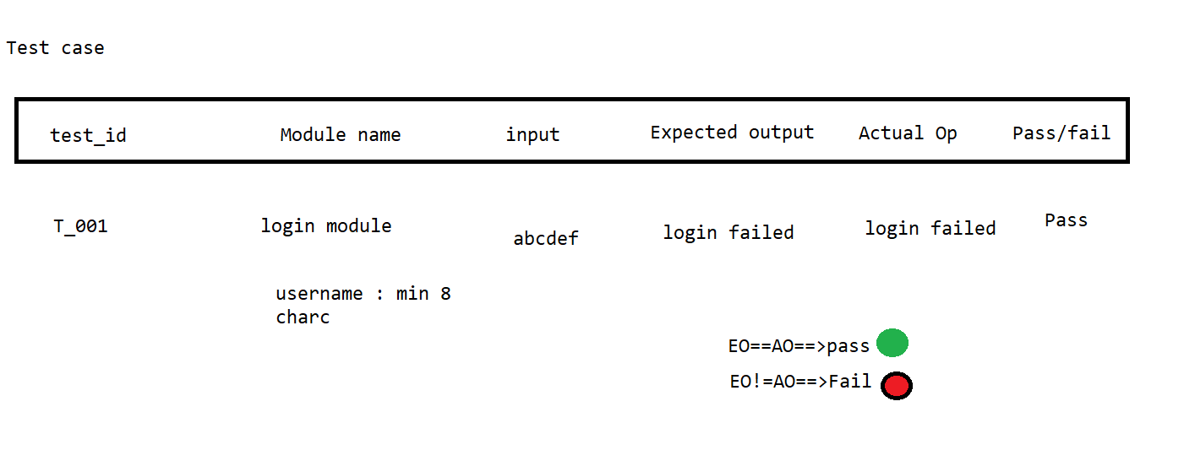

Proof: test report

Iff the test cases are 100 % bug free.

> Delivery/maintenance

Task : Deploy the code over the client environment

Role : Deployment team (nw,cloud eng, dev…), deployment head

Proof : release manual

In the deployment =>establish the env at the client end and deploy this code on it .

=>production server - deployment

In the deployment i have the term called dollar→$ ⇒maintaince

-the corporate ppl visit the client and do the modifications

-the corporate provides the KT to the client and hand over it completely .

Advantages

1. Freezing of the work
2. Smaller projects - requirements are well defined
3. Phases won't overlap
4. Validation and verification
5. Planning

Disadvantages

1. The client has been involved at the demo time.
2. Not recommended for complex projects
3. Time-taking process if planning was not done

 ======> Agile

>Agile

It is an interactive process and iterative process.

In each iteration, a small part of the functionality is delivered to the client

Iteration -> [define - analyze - code - integrate -test - deliver]

4 values and 12 principles

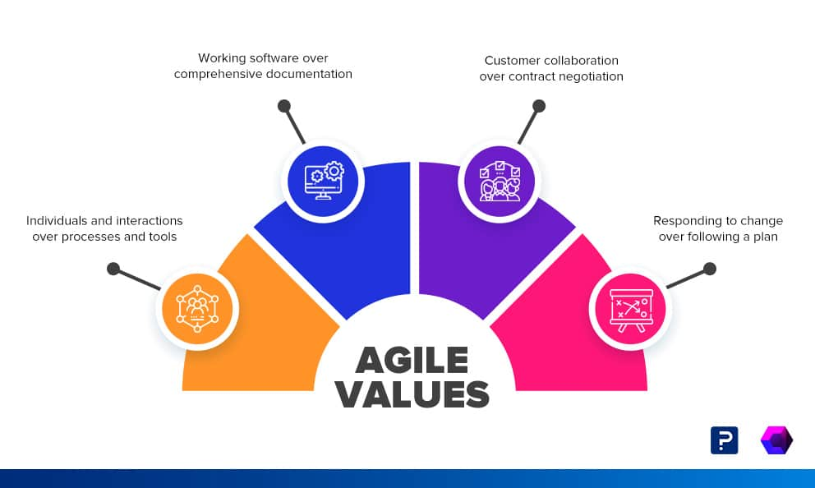

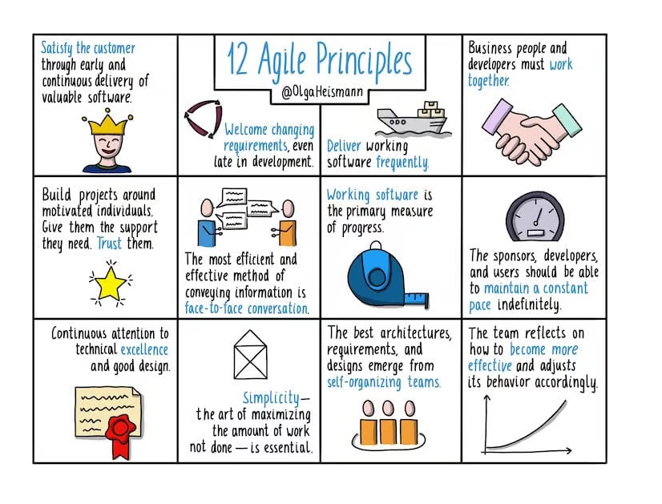

3/5/2023 - GIT -SL

The framework that follows the Agile model is Scrum.

Agile - iterative process

Scrum - Sprint[1w-4w]--2 w->10 days of work

Roles:

>Product Owner

>Business Analyst

>Scrum Master

>Scrum team

->Product Owner (Client)

He/She defines the requirements , priorities , release dates

->Scrum master(-project manager)

1. Remove the blockers
2. Safe guard
3. Progress of the work - monitor

->Scrum Team :

Cross functional team:

[Dev lead + functional lead + Dev + QA + QA lead]

1 FL+1 QAL+1 DevL+4 dev + 3 qa===>Scrum Master

Health care -insurance =>SM from the Health care side + FL from one TCS + DEV mphasis + QA from Infosys

Business Analyst - client / company

Collect the requirements from the product owner.

EPICS - a large body of work that can be further broken.

Ex: Open_cart_epic

For a new ecommerce website , the highest business value will be when the users are able to buy an item from the website

Business Analyst—> user stories - subtasks of an epic.

Us - login , registration , cart , payment …..

User story is a short requirement which can be taken into the sprint for a delivery.

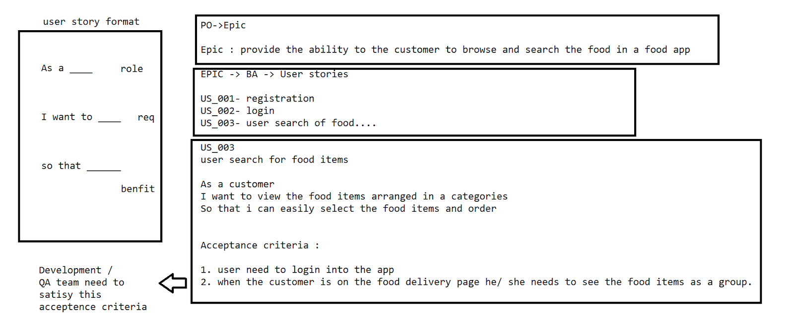

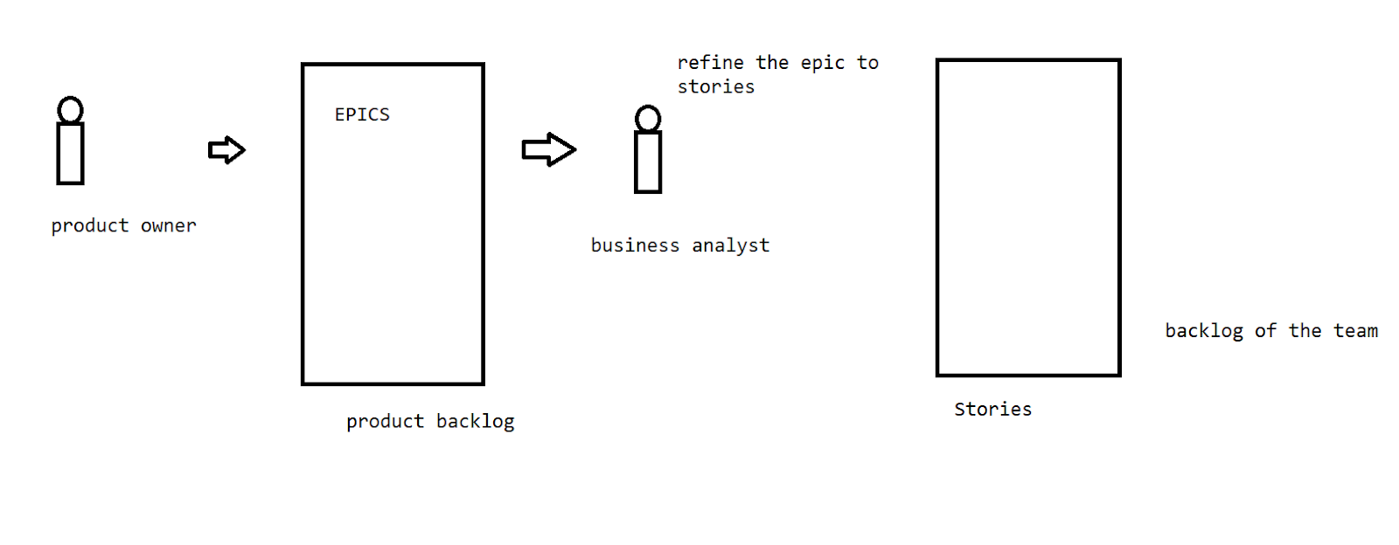

The BA has a call/online meeting with the scrum team and explain the requirements

[refinement calls]

The BAs asks for each user story - how many days are required as an effort to complete it [dev + qa]

Story point - estimates the time line for the completion of a user story .

Fibonacci series ->[3,5,8,13……]

Sprint - 2 weeks - 10 days - 8 pointer

10 days

- 5 days for the dev

-1 day for the deployment

-3 days for the QA

-1 day for the review⇒ PO

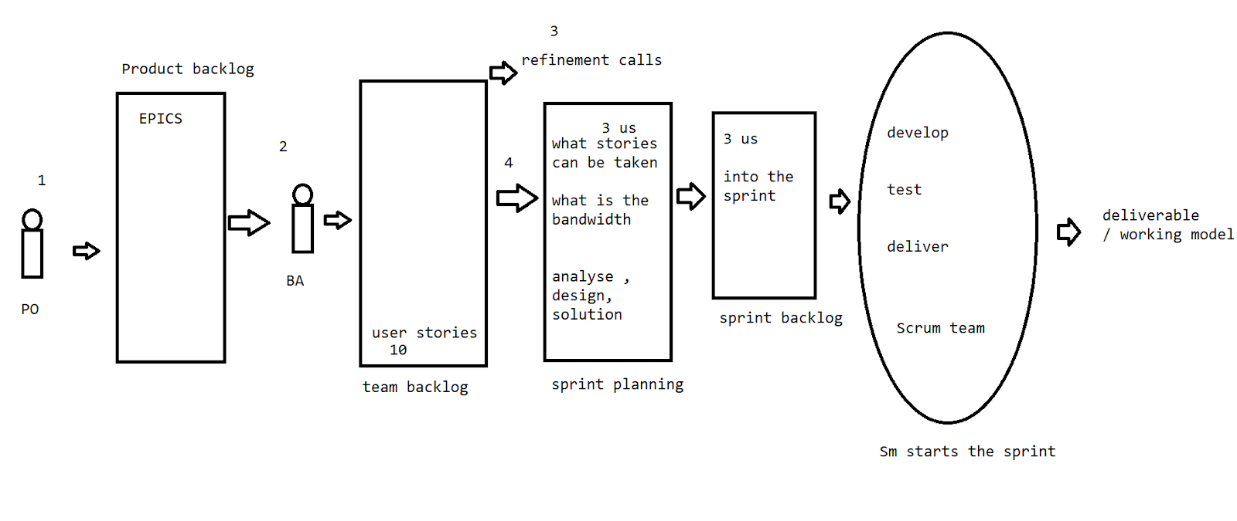

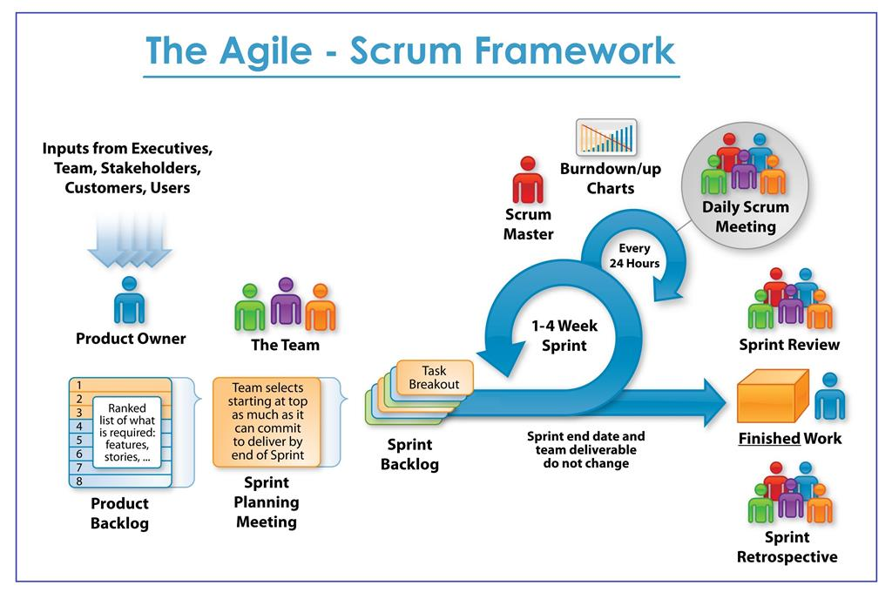

The BA creates the user story and keeps it on the team backlog.

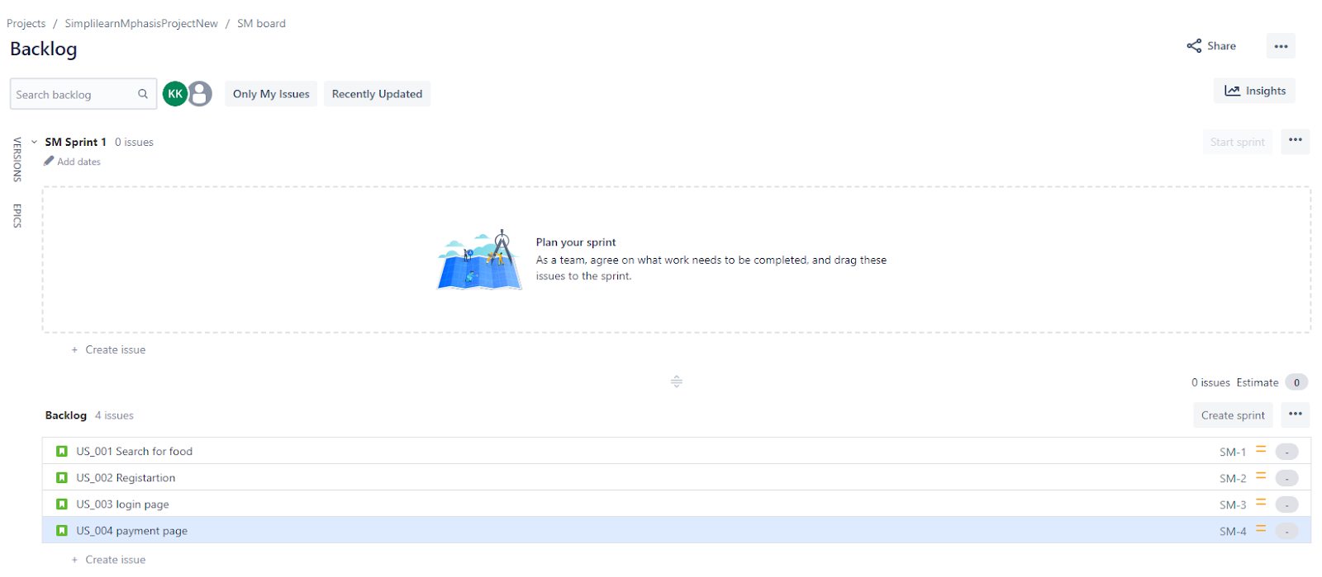

Sprint refinement

BA explains the stories and asks for the pointers

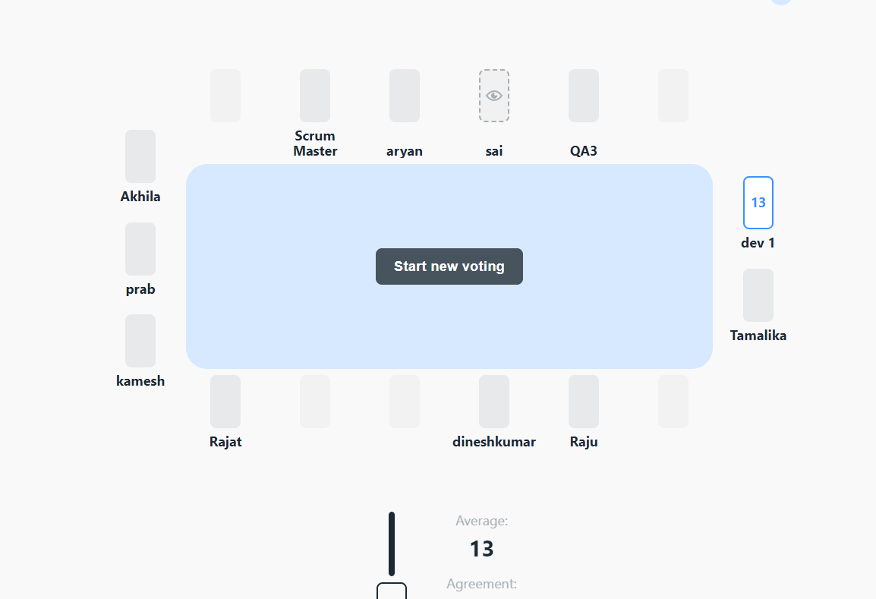

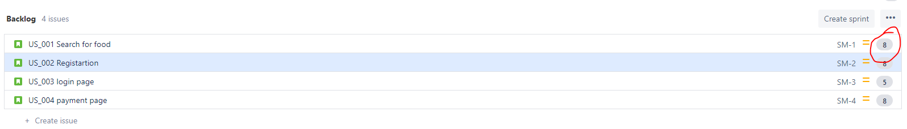

Sprint planning

We need to decide on the stories which can be committed into the sprint

Then  the SM moves the stories into the sprint backlog

Assign the developers

Sprint

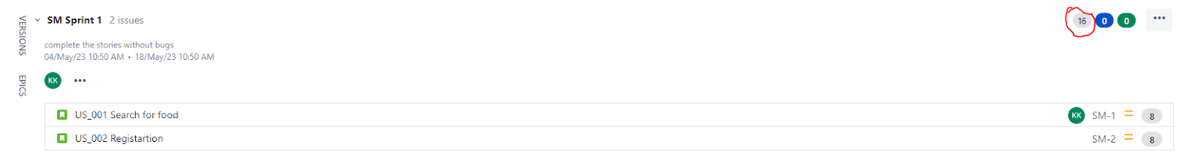

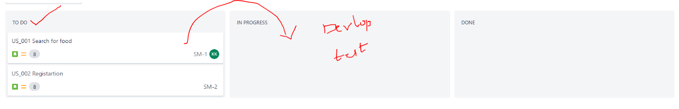

After the sprint the scrum master is going to close the sprint.

Ceremonies (meetings)

> Sprint daily stand-up call - Sm and the scrum team

What we have done in the past 24 hrs and what is planned for the next 24 hrs => 15 min

>Sprint planning

>Sprint review - have a demo to the business to review the deliverable

> Sprint retrospective -  end meeting of the sprint/closing meeting

What went well?

What are the blockers?

How we can overcome such issues in the upcoming sprint?

Todo -> in progress-> ready -> test -> done=>Sprint life cycle

Task:

Advantages

1. Quick and efficient
2. Changes are accepted for the future
3. Predictable cost and time
4. Strong collaboration
5. Customer satisfaction

Disadvantages

1. Timeline
2. Team distribution can impact
3. Less doc

Assignment: Water fall Vs Agile

V-Model

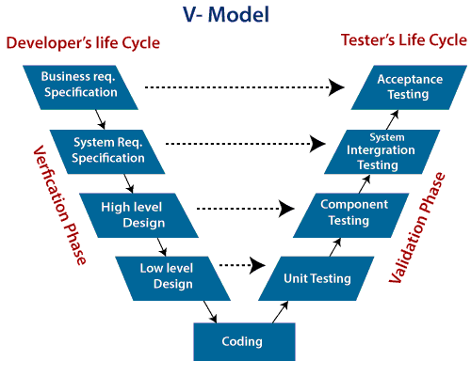

The V model concentrate more on the development and the testing phases

Verification -static analysis is done without having a code —>detail requirement specification

Validation - dynamic analysis - functional/nonfunctional aspects -test

Unit testing - functions/methods what we write in our code //Junit

Component testing - modular wise testing

Integration - complete project (the module that was tested is added to the existing project and tested )

Acceptance testing - business requirement

RAD- Rapid application development  model

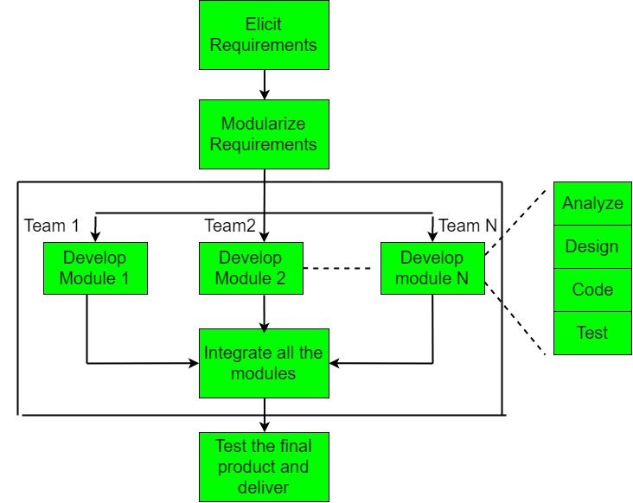

FAST - facilitated application development technique

//we are more dependent on the tools ====> feedback from the client

Spiral model

Requirement + risk analysis + design + code + test + release

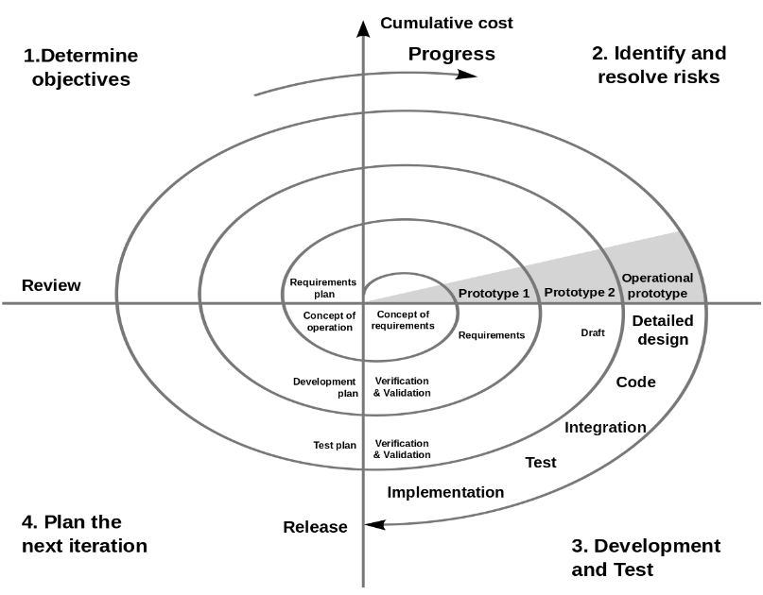

//software engineering / software project management - additional

Java - <https://drive.google.com/file/d/1Xw0OSgYxJo3NtEsy-ieQSu0soVwhoEbB/view?usp=share_link>

-Extract the file of java from the drive and keep it on the local C:/programfiles/

Create a folder called Java and paste the jdk and the jre folder into it .

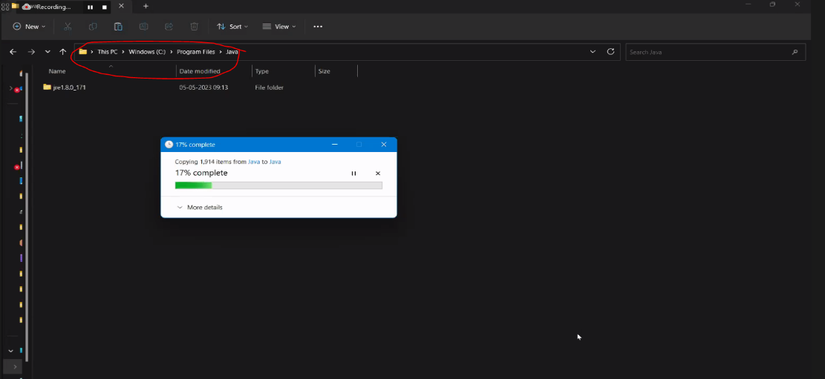

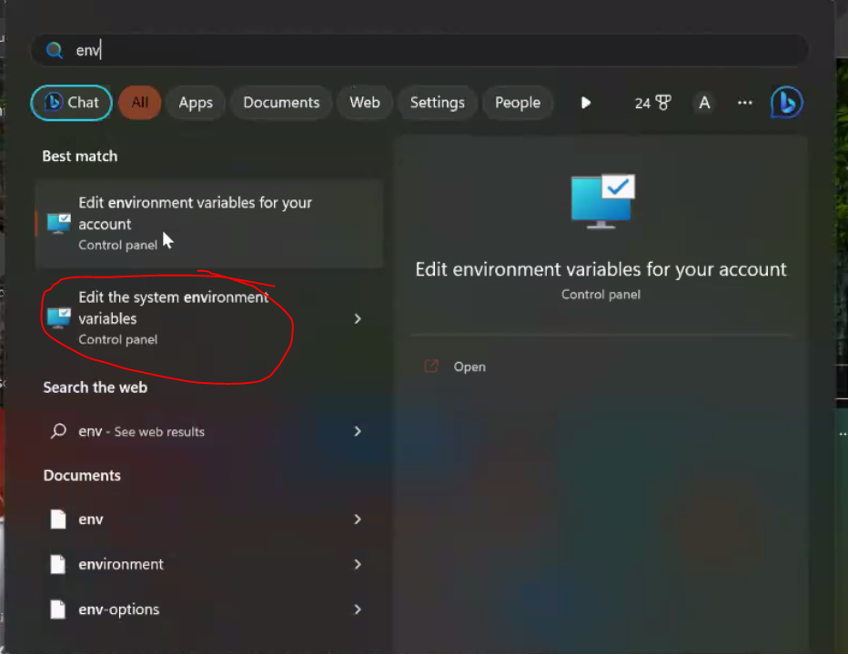

Click on path

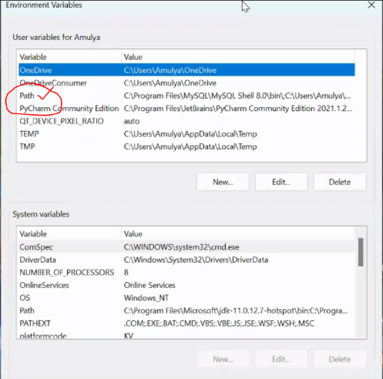

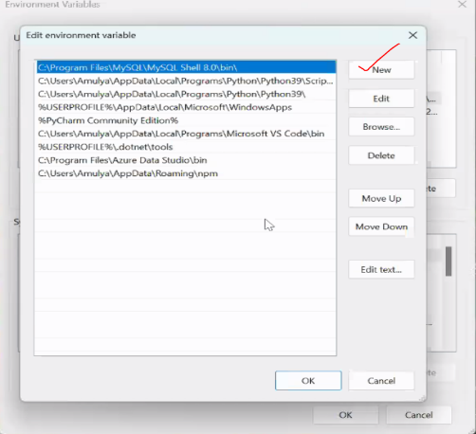

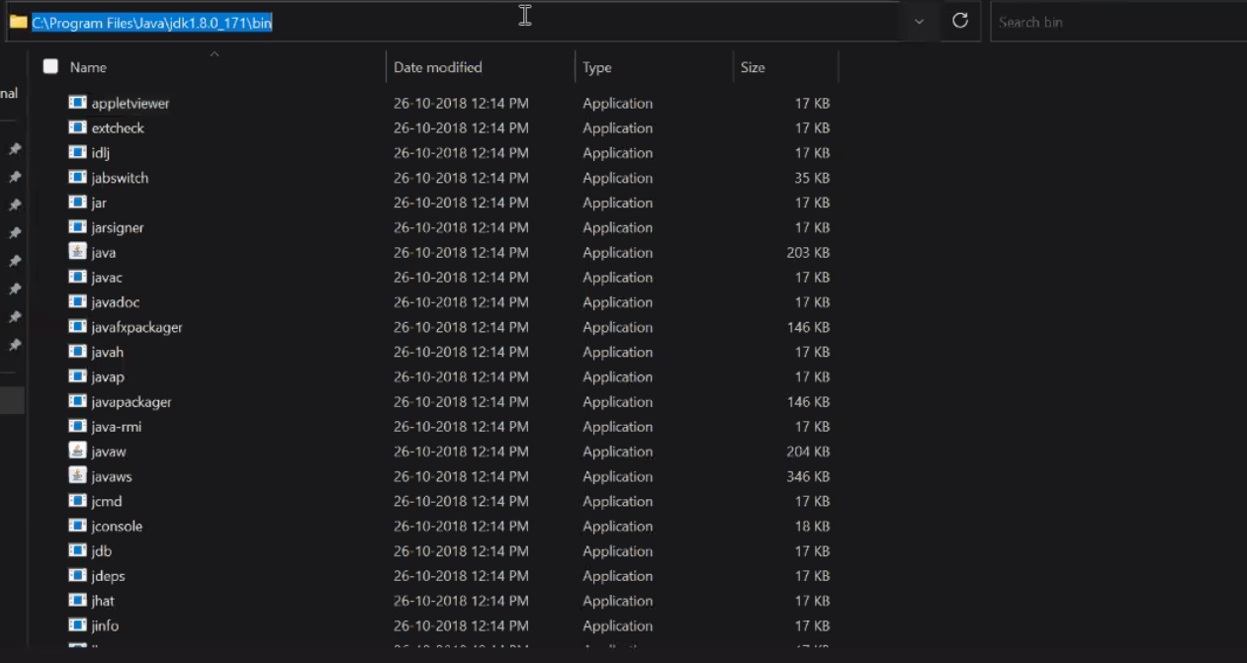

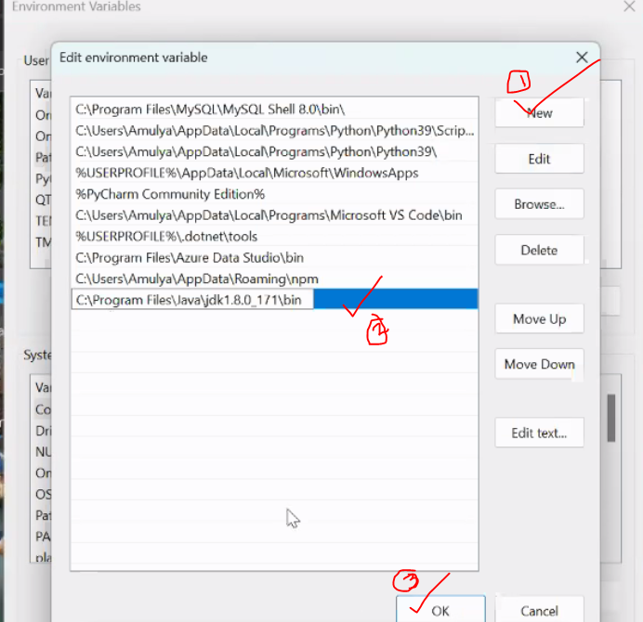

Open the command prompt and type “javac” and see that all the files related to it are coming on the screen

–IDE

Download <https://spring.io/tools>

-Direct download link

<https://download.springsource.com/release/STS4/4.18.0.RELEASE/dist/e4.27/spring-tool-suite-4-4.18.0.RELEASE-e4.27.0-win32.win32.x86_64.self-extracting.jar>

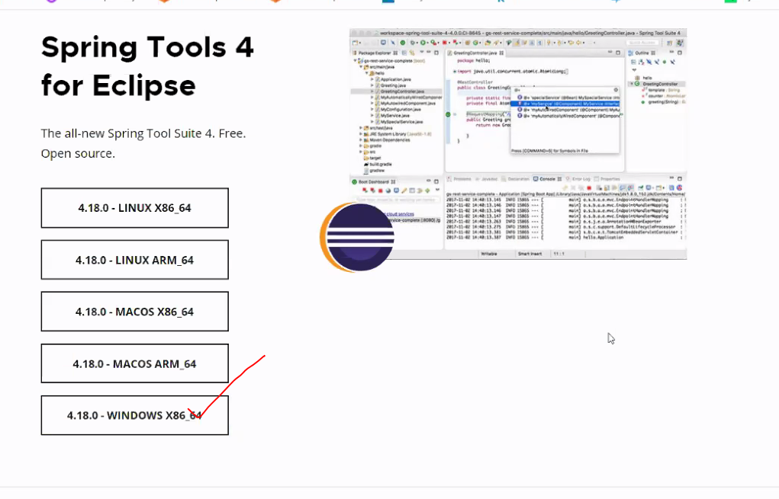

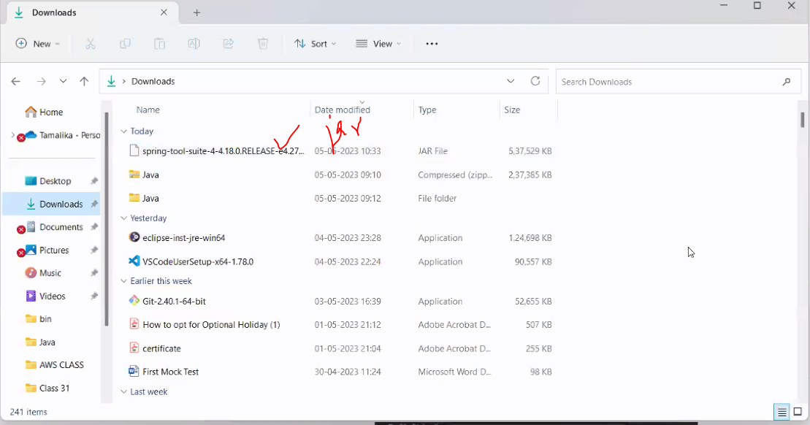

Go to the path where you have downloaded the file and go to the url and type cmd

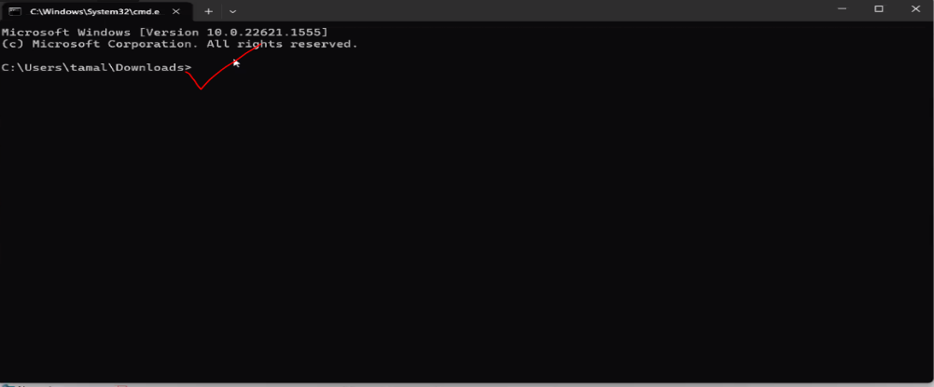

Write the command java -jar <type spring and press tab>

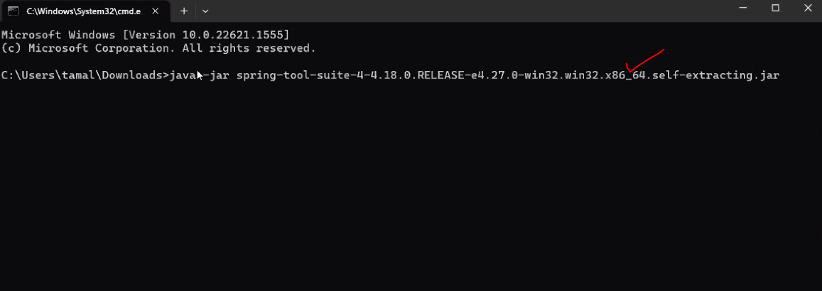



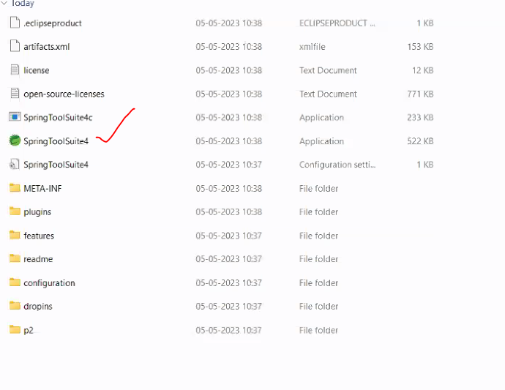

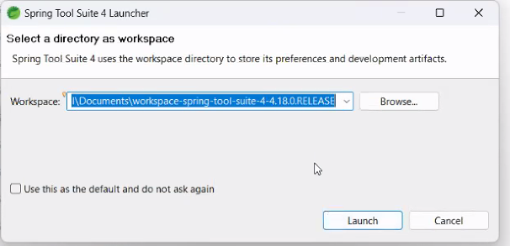

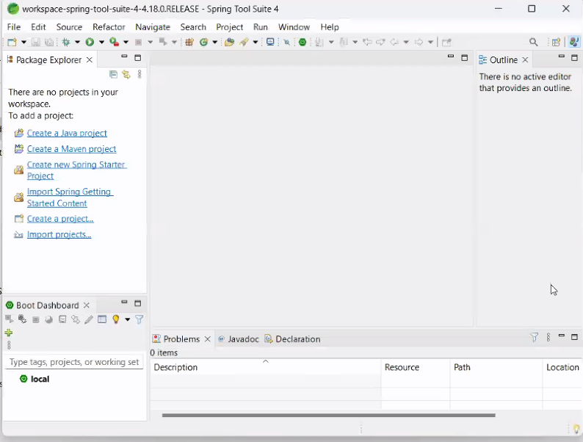

//if the path is not working in the command prompt

Type in the command prompt

set path=” ”//java path over here -=====> temporary path

**>Steps to process java project on IDE -**

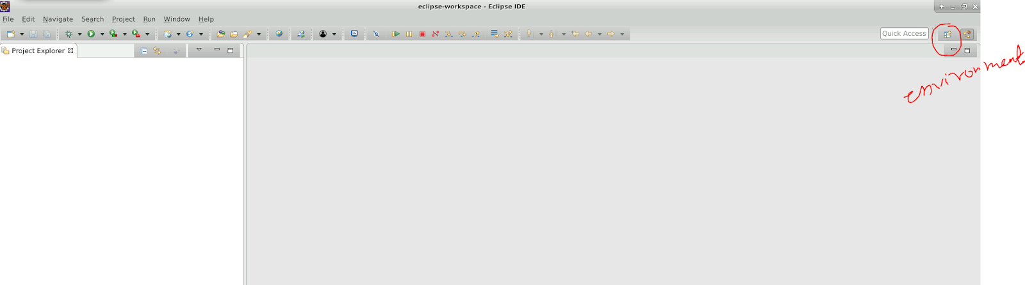

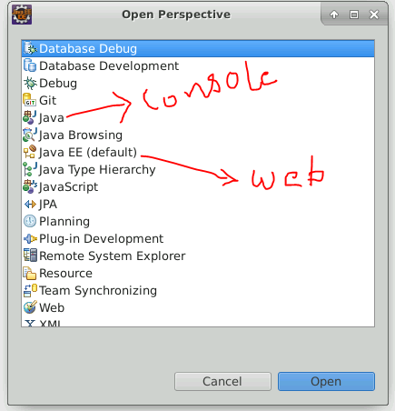

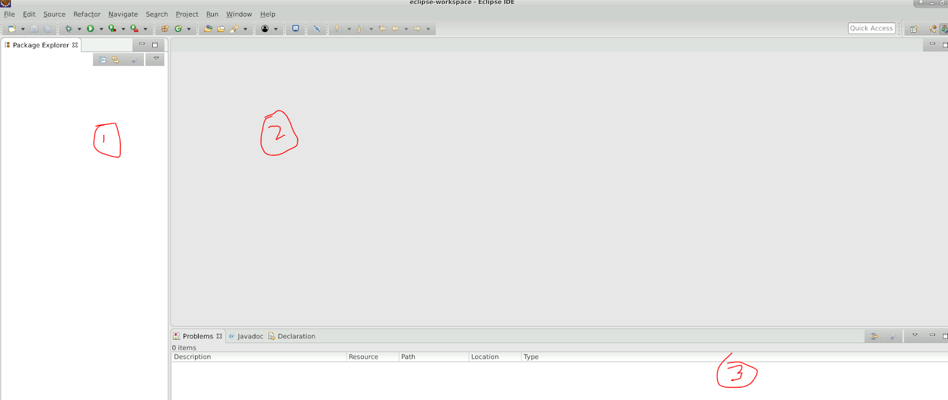

1. Project structure
2. Editor
3. Output =console

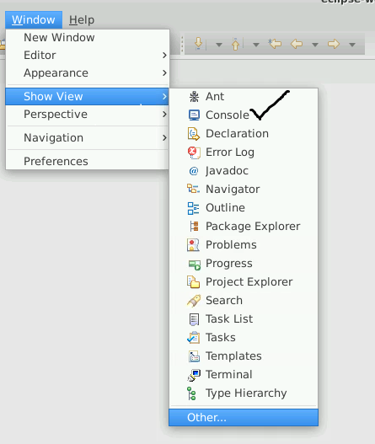

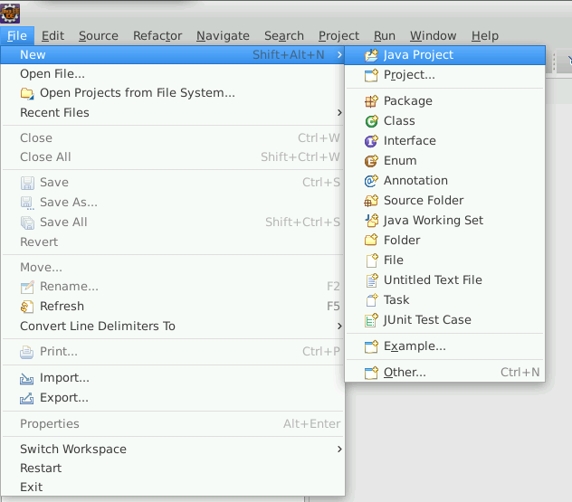

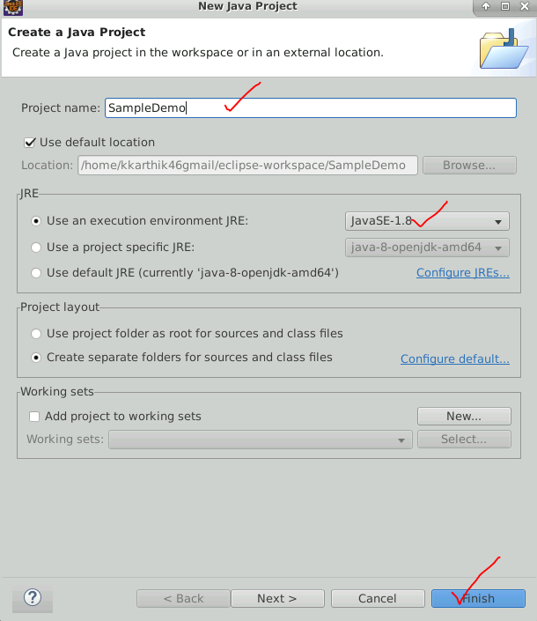

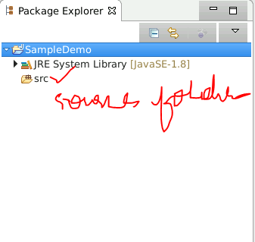

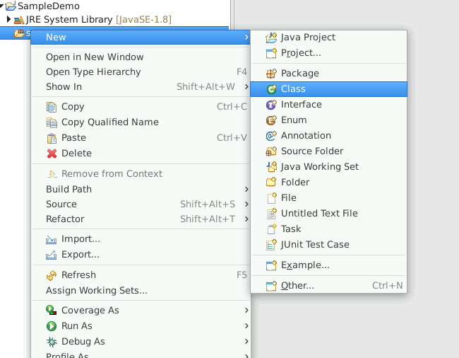

//zoom in/out - contrl + shift + (+/-)  on keyboard

//control+ space bar + enter - suggestions

//main -control+ space bar + enter - main block

//syso -control+ space bar + enter -printing ststement

public class HelloWorld {

public static void main(String[] args) {

System.out.println("HelloWorld");

}

}

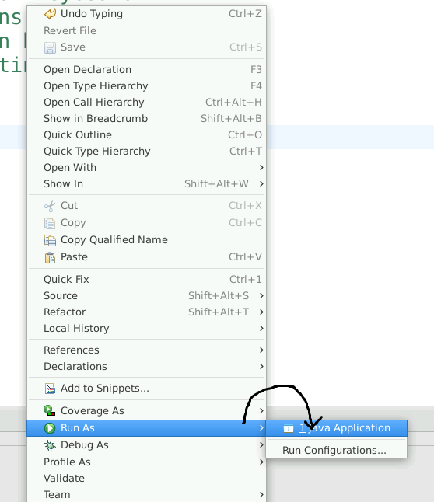

Program: a set of instructions to perform a task.

Language: rules and regulations used to handle a program

Instructions: in the form of an algorithm or flow chart

Programming Language - Java -[J2SE- standalone , J2EE-web based ,J2ME(outdated)]

“Java as an Object-oriented Programming Language”

**When can we say a PL to OOPL?**

Principles:

1. Class and object
2. Encapsulation
3. Inheritance
4. Abstraction
5. Polymorphism

>Class and Object

Object : real-world entity

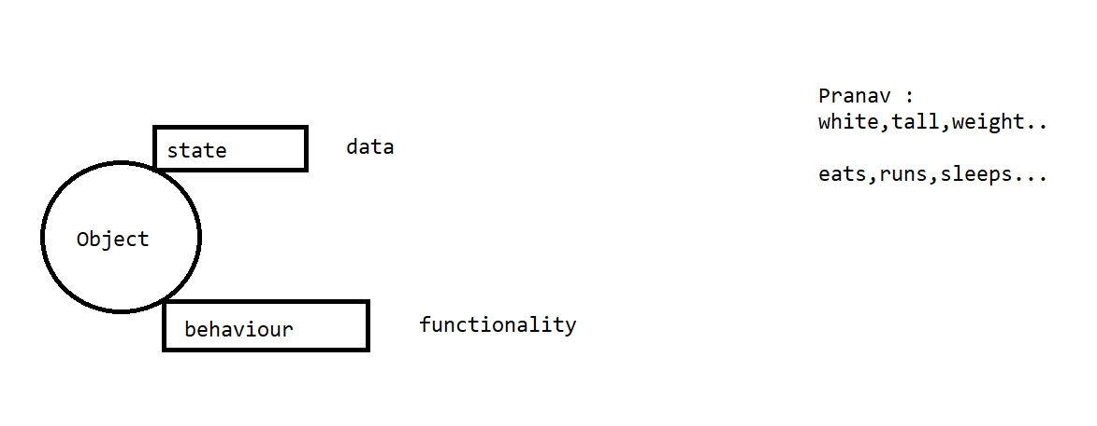

Class - collection of objects

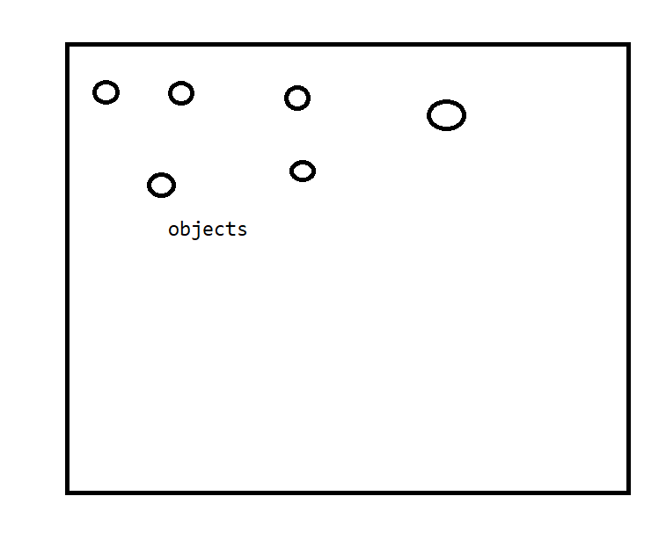

Encapsulation

Binding the data with its functionality as a single unit .

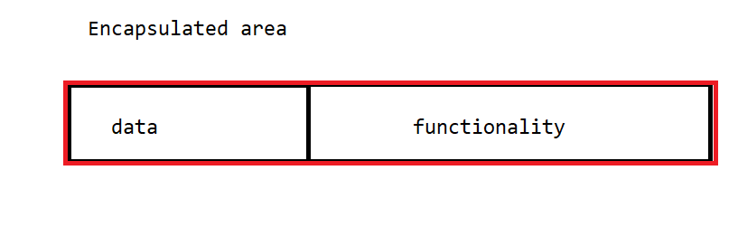

Abstraction :

Hide the functionalities / internal details by showing its external view of it .

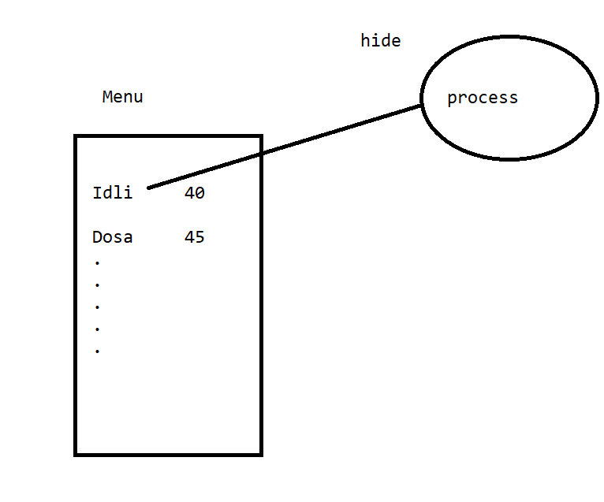

Inheritance

Sharing of the properties

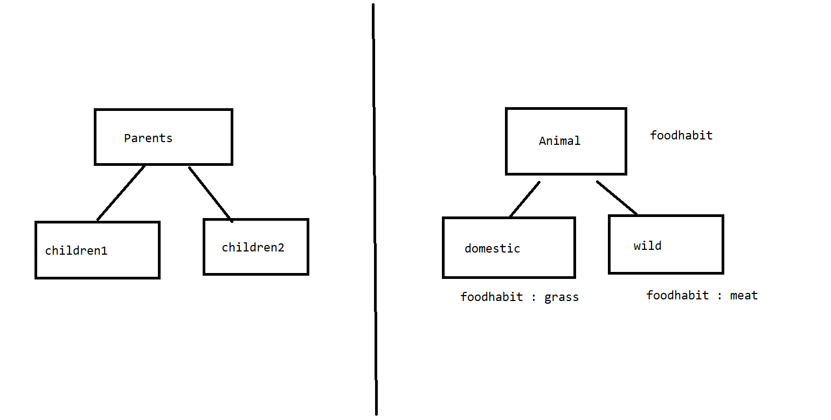

Polymorphism :

Poly: many

Morphism: forms

Same thing exists in many forms

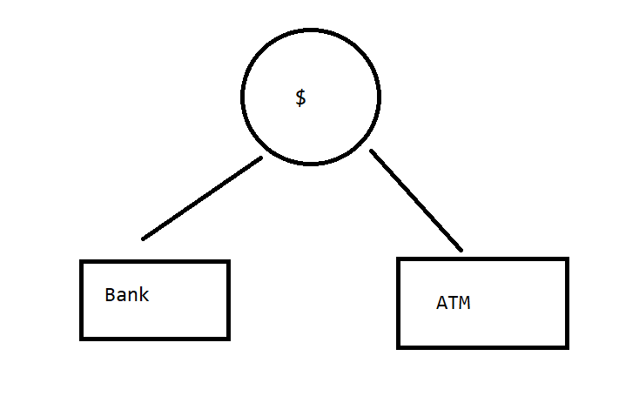

—----------------------------------------OOP—------------------------------------------------------

Java :

Class and objects

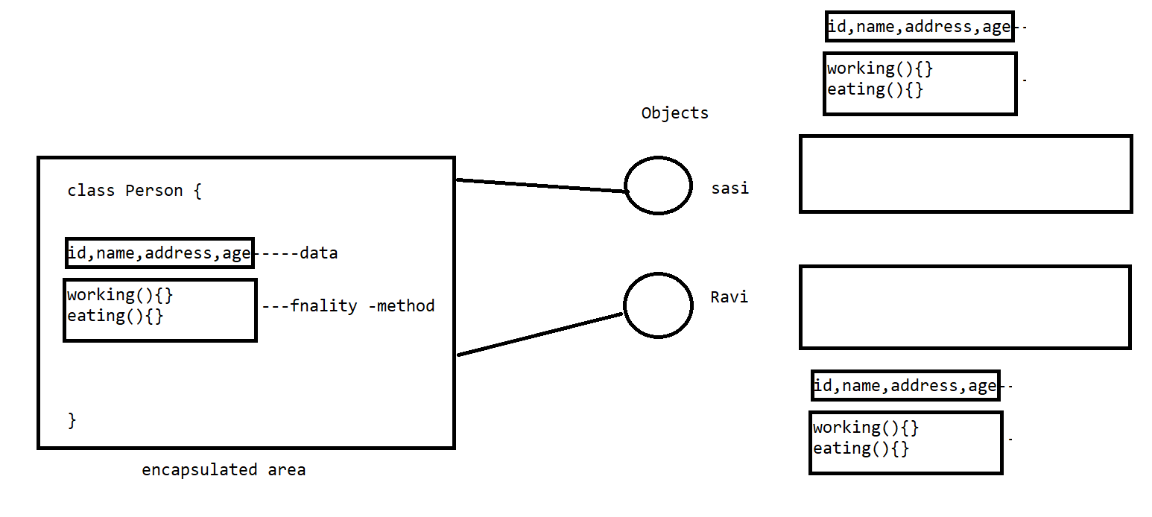

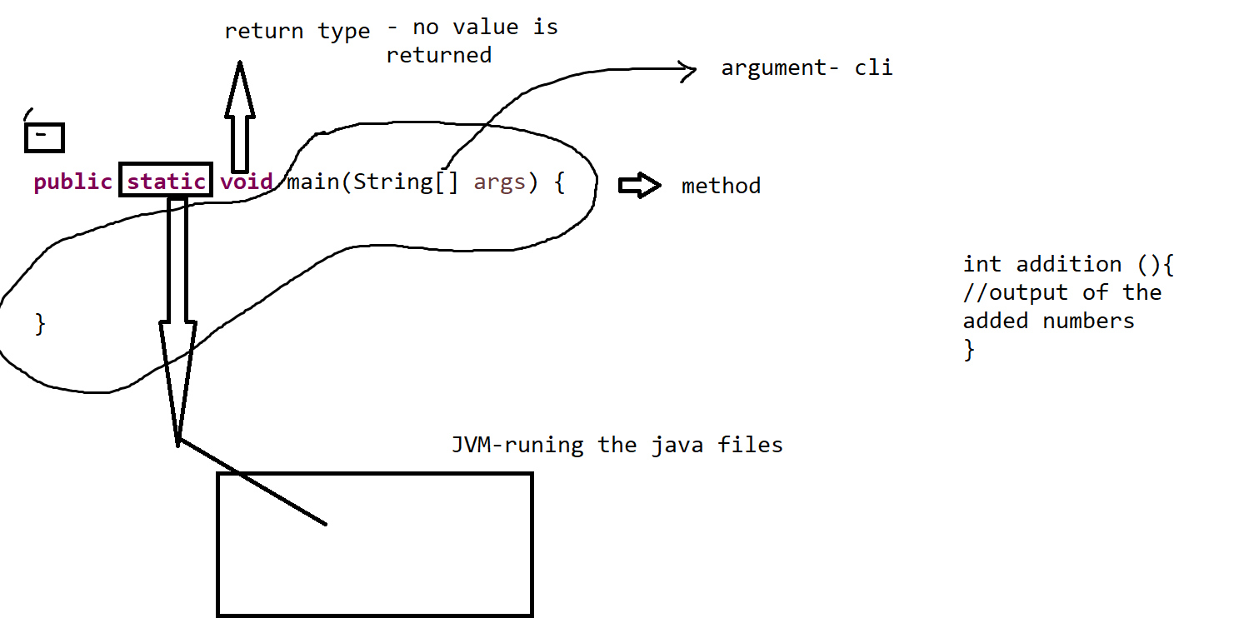

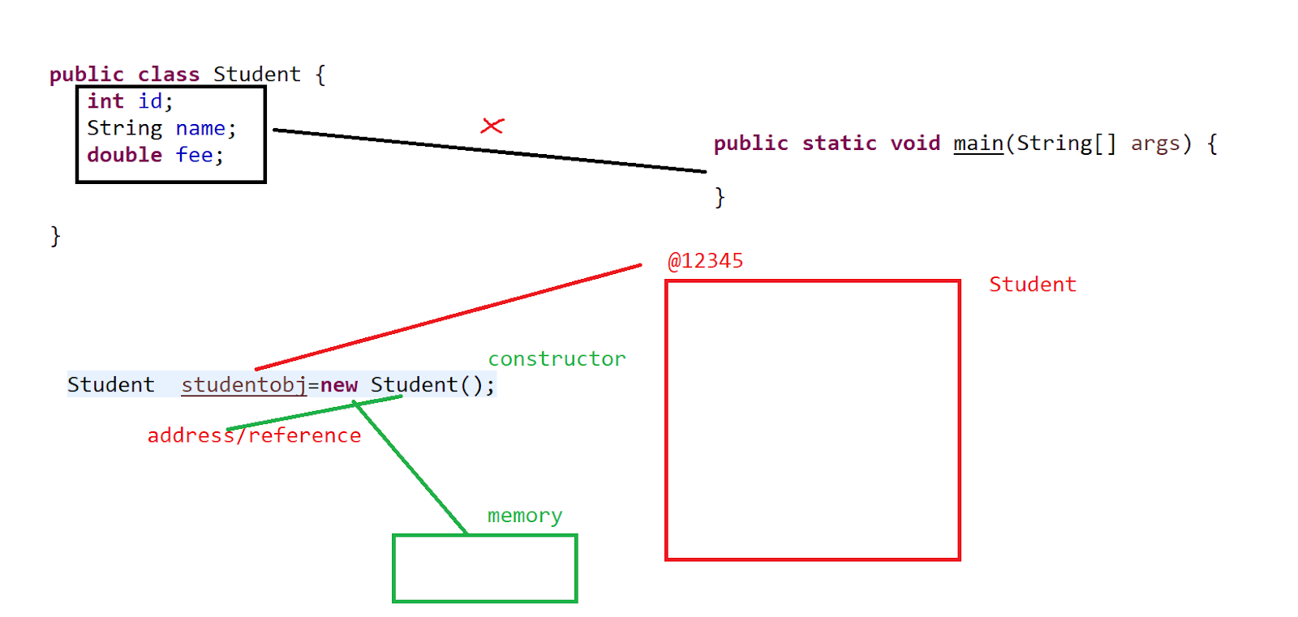

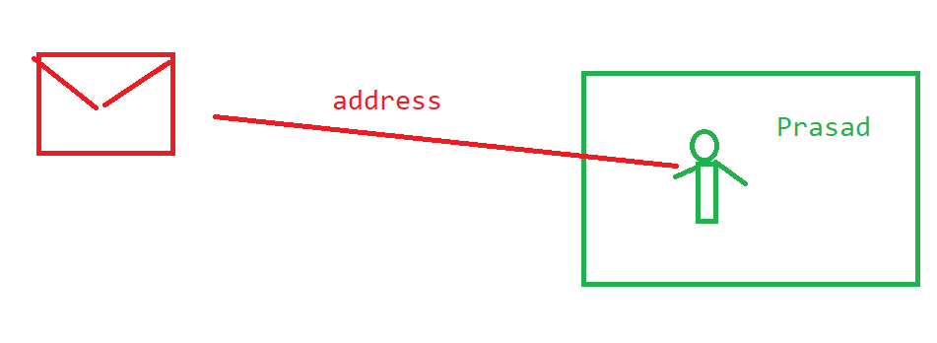

public class Student {

int id;

String name;

double fee;

//what ever the data we had in the main ..only that is going to get executed .

public static void main(String[] args) {

//any thing which is out side the main to get it accessed we need "object"

//classname objname    keyword  constructor

  Student  studentobj1=new Student();

  studentobj1.id=14;

  studentobj1.name="prasad";

  studentobj1.fee=35000.00;

  Student  studentobj2=new Student();

  studentobj2.id=15;

  studentobj2.name="krishna";

  studentobj2.fee=45000.00;

// System.out.println("the student 1 details "+ studentobj1.id +","+studentobj1.name);

}

}

//method : it is a block used to perform a task or logic [logical block]

return_type  method_name(arguments)

{

//logic

return //value;

}

Ex:

int calculation(int a, int b){

return a+b;

}

public class Student {

//instance variable - which can be accesed by the object and outside the main in a class

int id;

String name;

double fee;

void display() {

System.out.println("the student details are" + id+" ,"+name);

}

//what ever the data we had in the main ..only that is going to get executed .

public static void main(String[] args) {

//any thing which is out side the main to get it accessed we need "object"

//classname objname    keyword  constructor

  Student  studentobj1=new Student();

  studentobj1.id=14;

  studentobj1.name="prasad";

  studentobj1.fee=35000.00;

  Student  studentobj2=new Student();

  studentobj2.id=15;

  studentobj2.name="krishna";

  studentobj2.fee=45000.00;

  //cntl + space bar fr suggetions

  studentobj1.display();

  studentobj2.display();

}

}

Types of methods

With return type , without arg

With return type , with arg

Without return type , without arg

Without return type , with arg

**//With return type , with arg**

import java.util.Scanner;

class EmployeeCalImp{

int incSalary(int salary,int bonus) {

return salary+bonus;

}

}

public class EmployeeSalaryCal{

public static void main(String[] args) {

EmployeeCalImp calimp=new EmployeeCalImp();

//from the keyboard if we need input //shft+cntrl+o

Scanner sc=new Scanner(System.in);

System.out.println("enter the salary details ");

int salary=sc.nextInt();

System.out.println("enter the bonus details");

int bonus=sc.nextInt();

int newSal=calimp.incSalary(salary, bonus);

System.out.println("final salary is "+newSal);

}

}

**//With return type , without arg**

import java.util.Scanner;

class EmployeeCalImp{

int salary,bonus;

int incSalary() {

return salary+bonus;

}

}

public class EmployeeSalaryCal{

public static void main(String[] args) {

EmployeeCalImp calimp=new EmployeeCalImp();

//from the keyboard if we need input //shft+cntrl+o

Scanner sc=new Scanner(System.in);

System.out.println("enter the salary details ");

calimp.salary=sc.nextInt();

System.out.println("enter the bonus details");

calimp.bonus=sc.nextInt();

int newSal=calimp.incSalary();

System.out.println("final salary is "+newSal);

}

}

**//Without return type , without arg**

import java.util.Scanner;

class EmployeeCalImp{

int salary,bonus;

void incSalary() {

System.out.println("the updated salary is "+ (salary+bonus));

}

}

public class EmployeeSalaryCal{

public static void main(String[] args) {

EmployeeCalImp calimp=new EmployeeCalImp();

//from the keyboard if we need input //shft+cntrl+o

Scanner sc=new Scanner(System.in);

System.out.println("enter the salary details ");

calimp.salary=sc.nextInt();

System.out.println("enter the bonus details");

calimp.bonus=sc.nextInt();

calimp.incSalary();

//System.out.println("final salary is "+newSal);

}

}

**//Without return type , with arg**

import java.util.Scanner;

class EmployeeCalImp{

void incSalary(int salary,int bonus) {

System.out.println("the updated salary is "+ (salary+bonus));

}

}

public class EmployeeSalaryCal{

public static void main(String[] args) {

EmployeeCalImp calimp=new EmployeeCalImp();

//from the keyboard if we need input //shft+cntrl+o

Scanner sc=new Scanner(System.in);

System.out.println("enter the salary details ");

int salary=sc.nextInt();

System.out.println("enter the bonus details");

int bonus=sc.nextInt();

calimp.incSalary(salary,bonus);

//System.out.println("final salary is "+newSal);

}

}

Assignment:

Complete the 4 models on the class Box with l,b,h and calculate the volume=l*b*h of the box?

//constructor

>constructor is used to assign a reference to an object.

> We call the constructor only at the time of creation of an object.

EmployeeCalImp calimp=new EmployeeCalImp();

>constructor is capable of performing few tasks.

>don't have a return value

>constructor name and the class name must be the same.

* 2 models

>parameteried constructor

>default constructor

//parameteried constructor

import java.util.Scanner;

class EmployeeCalImp{

EmployeeCalImp(int salary,int bonus) {

System.out.println("the updated salary is "+ (salary+bonus));

}

}

public class EmployeeSalaryCal{

public static void main(String[] args) {

Scanner sc=new Scanner(System.in);

System.out.println("enter the salary details ");

int salary=sc.nextInt();

System.out.println("enter the bonus details");

int bonus=sc.nextInt();

EmployeeCalImp calimp=new EmployeeCalImp(salary,bonus);

}

}

//default constr

import java.util.Scanner;

class EmployeeCalImp{

EmployeeCalImp() {

int salary=50000,bonus=5000;

System.out.println("the updated salary is "+ (salary+bonus));

}

}

public class EmployeeSalaryCal{

public static void main(String[] args) {

EmployeeCalImp calimp=new EmployeeCalImp();

}

}

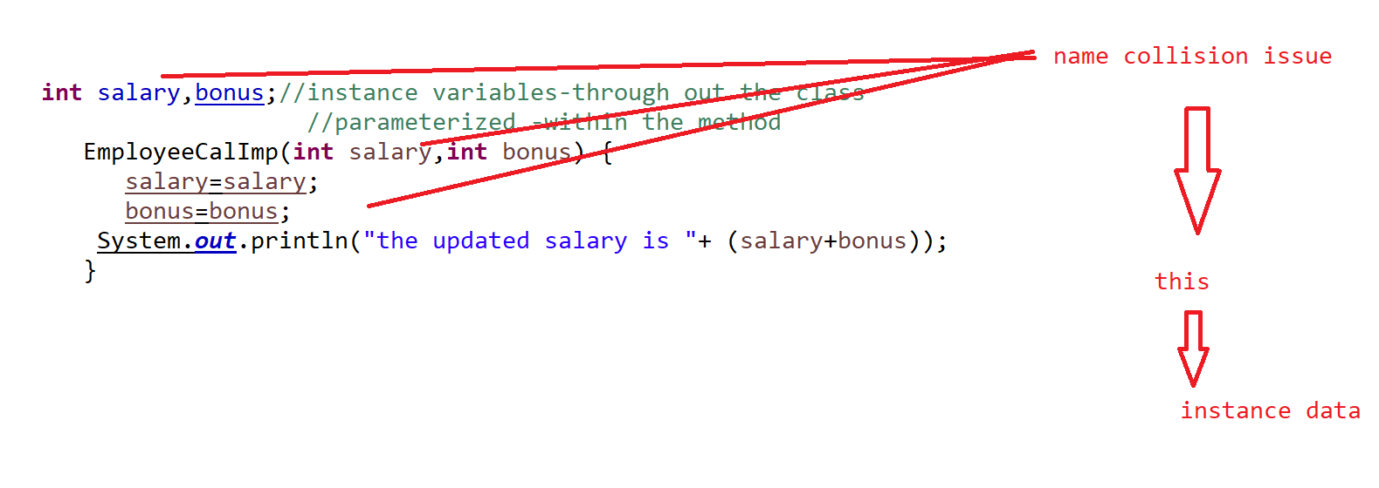

* Note: we use the constructor in assigning the data to the instance data members by using “this” keyword.

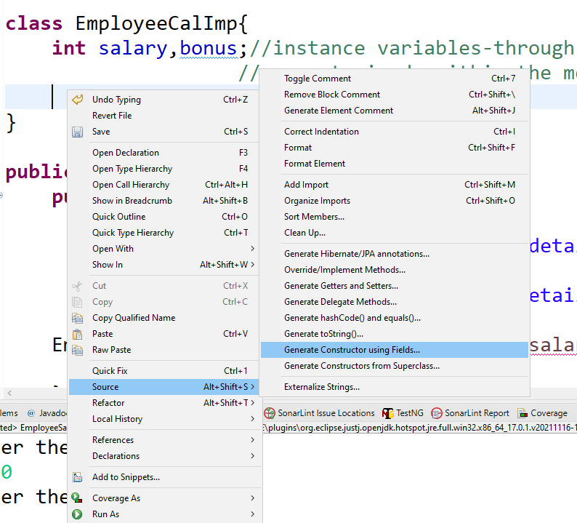

import java.util.Scanner;

class EmployeeCalImp{

int salary,bonus;//instance variables-through out the class

                //parameterized -within the method

public EmployeeCalImp(int salary, int bonus) {

this.salary = salary;

this.bonus = bonus;

int newSal=salary+bonus;

System.out.println("the updated salary is "+newSal);

}

}

public class EmployeeSalaryCal{

public static void main(String[] args) {

Scanner sc=new Scanner(System.in);

System.out.println("enter the salary details ");

int salary=sc.nextInt();

System.out.println("enter the bonus details");

int bonus=sc.nextInt();

EmployeeCalImp calimp=new EmployeeCalImp(salary,bonus);

}

}

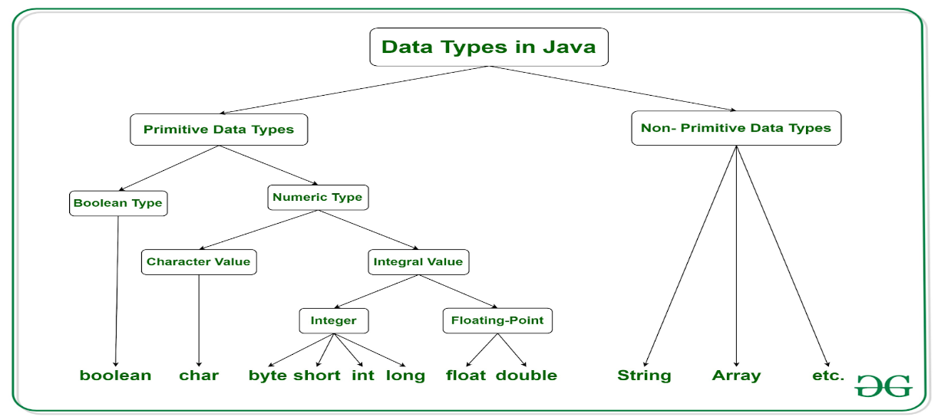

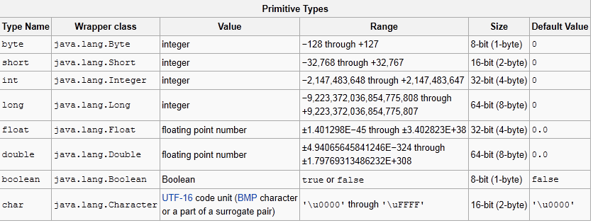

import java.util.Scanner;

public class EmployeeSalaryCal{

public static void main(String[] args) {

//implicit type casting

int num=15;

double value=num;

System.out.println(value);

//widening of memory ==>

double value1=15.0;

//4      8  ===>narrowing

//explicit type casting

int num1=(int)value1;

System.out.println(num1);

}

}

//cal arth proj

import java.util.Scanner;

class CalImp{

public int add(int a,int b) {

return a+b;

}

public int sub(int a,int b) {

return a-b;

}

}

public class CalcuMain{

public static void main(String[] args) {

CalImp calimp=new CalImp();

Scanner sc=new Scanner(System.in);

while(true) {

System.out.println("Menu");

System.out.println("1. addtion  2. substraction 3. exit");

System.out.println("enter the choice ");

int ch=sc.nextInt();

switch(ch) {

case 1 : System.out.println("enter the num1 value ");

int num1=sc.nextInt();

System.out.println("enter the num2 value ");

int num2=sc.nextInt();

System.out.println("the final addition is "+calimp.add(num1,num2 ) );

break;

case 2: System.out.println("enter the num1 value ");

int num3=sc.nextInt();

System.out.println("enter the num2 value ");

int num4=sc.nextInt();

System.out.println("the final addition is "+calimp.sub(num3,num4 ) );

break;

case 3: System.exit(0);

}

}

}

}

Encapsulation:

Binding the data with its corresponding data methods

* It is recommended to take the instance data always in a private mode.
* How can we interact with the data which is required in the other classes?

Public methods

//setters and getters

Setter - set the value of the private data.

Getter - get the value of the private data.

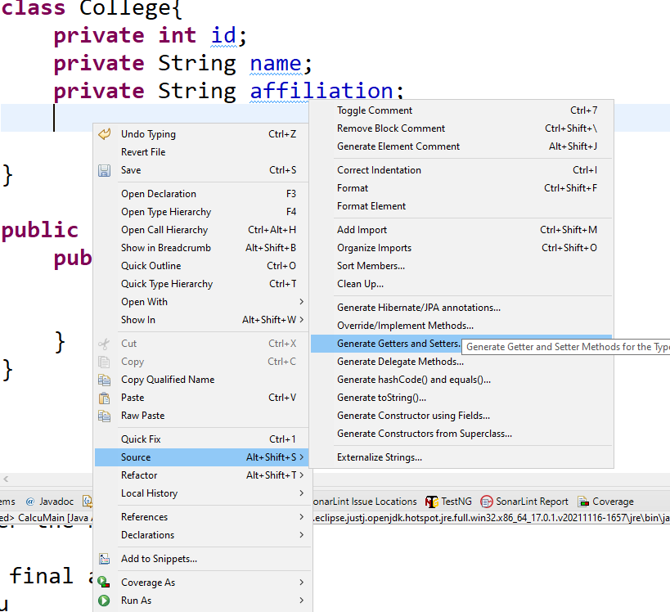

class College{

private int id;

private String name;

private String affiliation;

public int getId() {

return id;

}

public void setId(int id) {

this.id = id;

}

public String getName() {

return name;

}

public void setName(String name) {

this.name = name;

}

public String getAffiliation() {

return affiliation;

}

public void setAffiliation(String affiliation) {

this.affiliation = affiliation;

}

@Override

public String toString() {

return "College [id=" + id + ", name=" + name + ", affiliation=" + affiliation + "]";

}

}

public class CollegeMain{

public static void main(String[] args) {

College college=new College();

college.setId(1);

college.setName("XYZ");

college.setAffiliation("MNP");

System.out.println(college);

}

}

//task :

Take an employee class with id,name,salary - private mode

Take a main class and assign the values and display the values for 3 employee

Take a method with the arg bonus  and add the salary to it.

And display the new salary .

I need to see the new salary without calling it by object ->hint - tostring()

>**static**

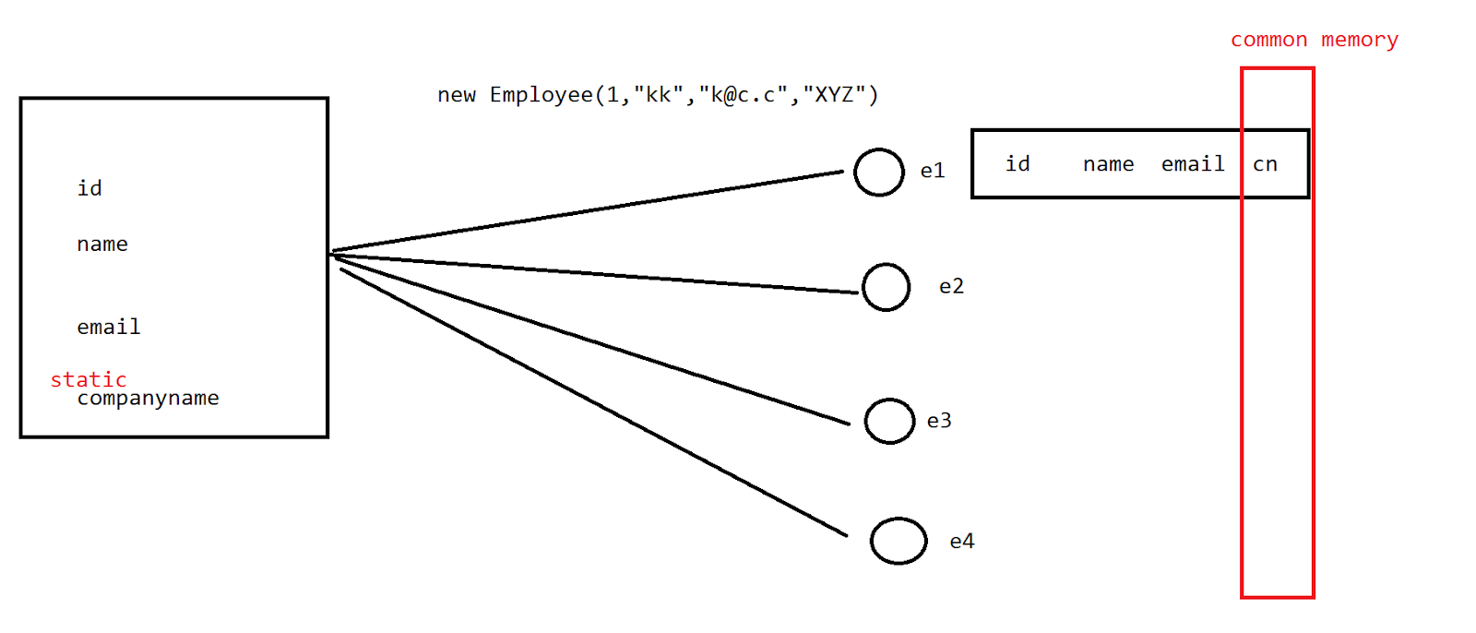

If we need a memory management wrt the object on a variable/object the we prefer defining it with static keywork

class Counter{

int counter=0;

static int counter2=0;

Counter(){

counter++;

counter2++;

System.out.println("counter "+counter+" counter2 "+counter2);

}

}

public class CounterMain{

public static void main(String[] args) {

Counter count1=new Counter();

Counter count2=new Counter();

Counter count3=new Counter();

}

}

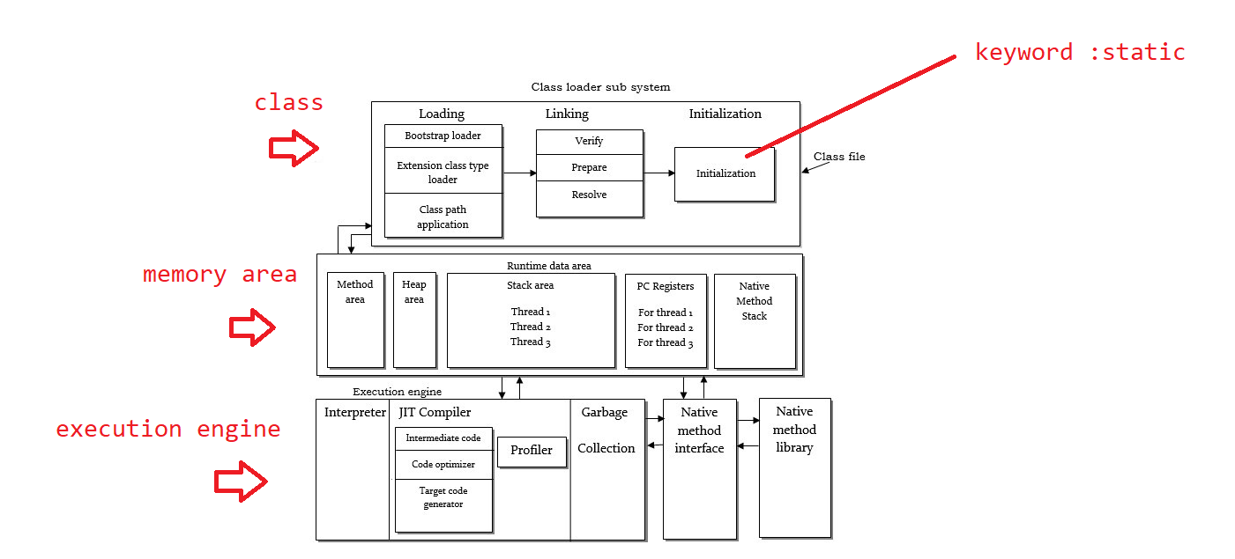

class Counter{

static int counter=0;

static int counter2=0;

//rule 1: when ever we define a static method it need to have static variables in it - non static info

static void display(){

counter++;

counter2++;

System.out.println("counter "+counter+" counter2 "+counter2);

}

}

public class CounterMain{

public static void main(String[] args) {

//rule 2 :no need to create an object for accessing that method - we can access directly with the class name

Counter.display();

}

}

>Inheritance

Sharing of the properties

 -reusability of the code .

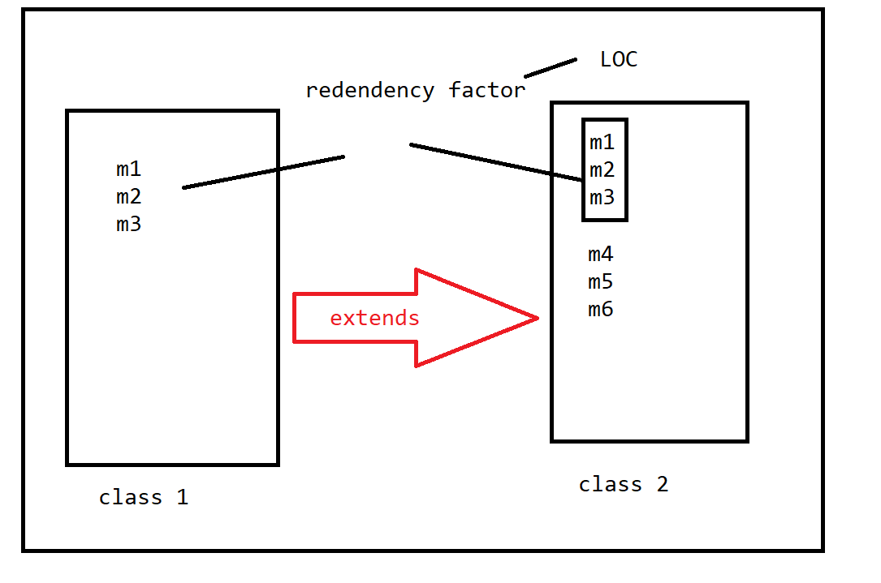

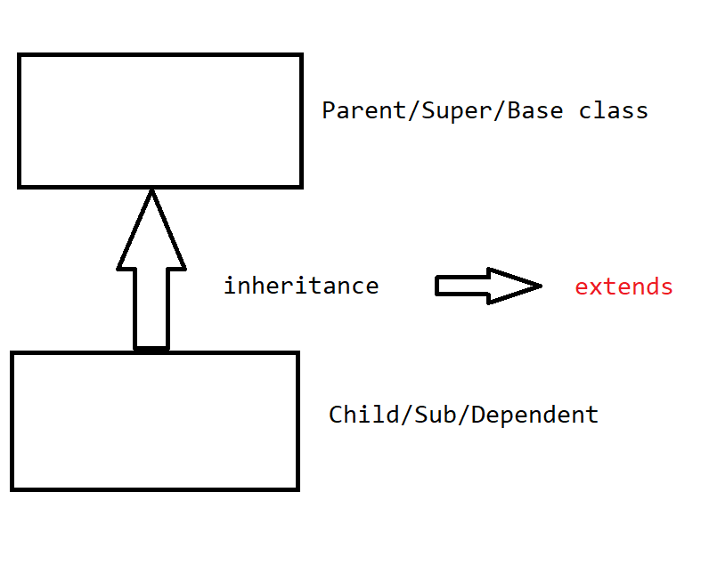

syntax:

class Parent {}

class Child extends Parent{}

**Note : extends keyword can only get the properties of a single parent into the child**

Types of inheritance :

1. Single
2. MultiLevel
3. Multiple
4. Hierarichal
5. Hybrid

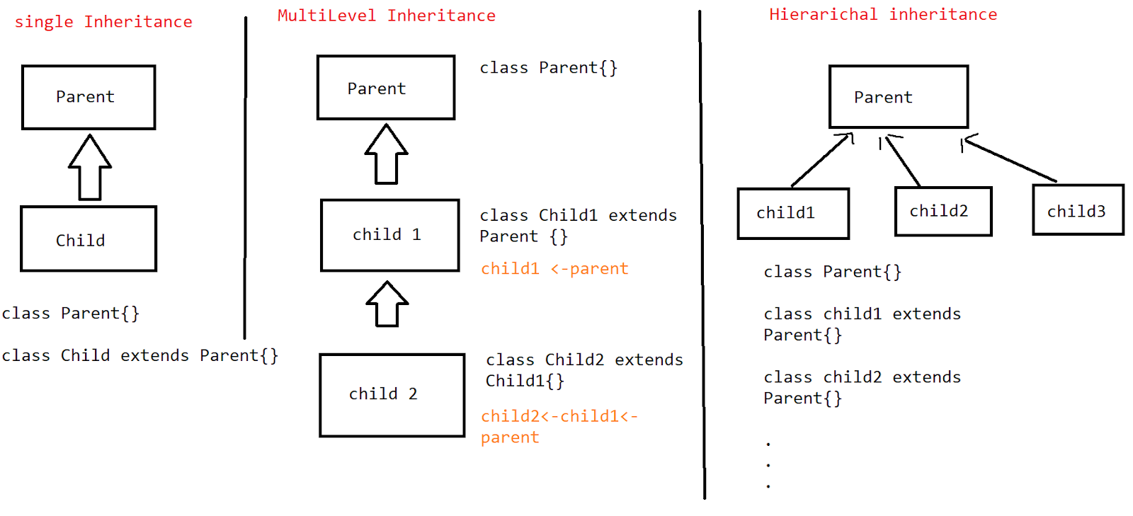

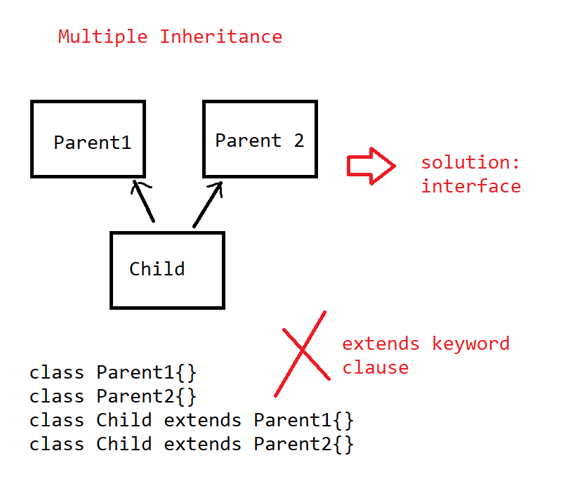we cannot have multiple inheritance bw the classes because of the extends keyword clause.

This model is implemented by using the interface .

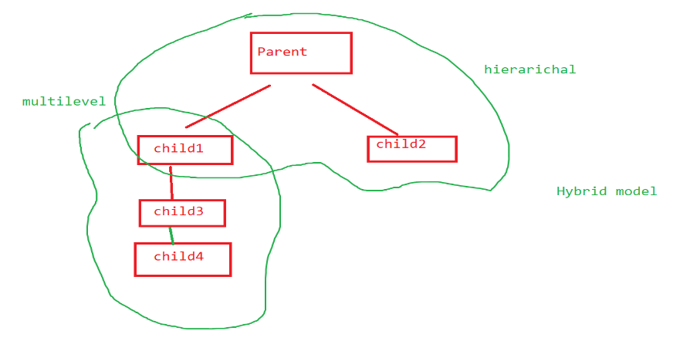

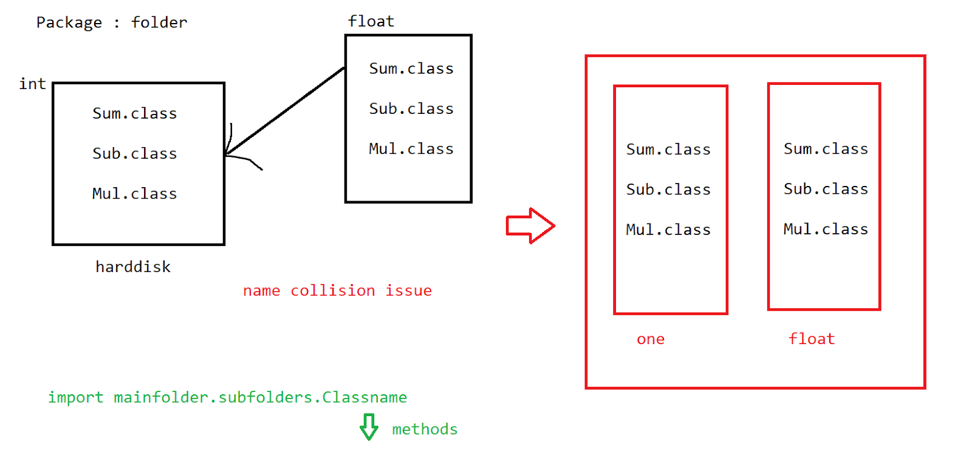

Single inheritance:

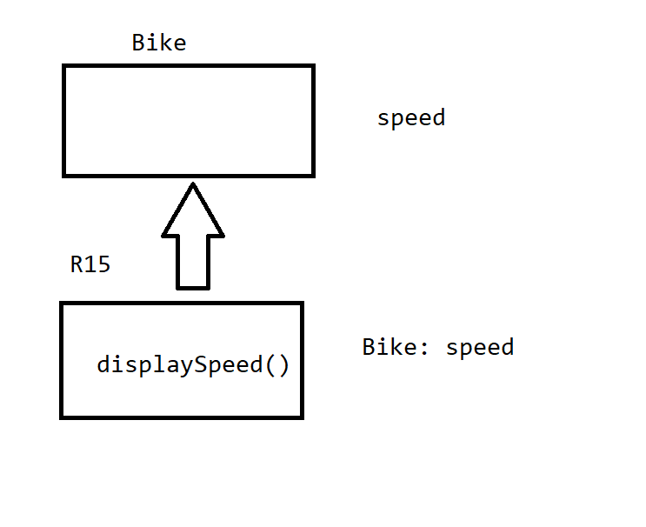

package com.mphasis.inheritance;

class Bike{

int speed=200;

}

class R15 extends Bike{

void displaySpeed() {

System.out.println("the bike speed is "+ speed);

}

}

public class BikeEx{

public static void main(String[] args) {

R15 r15=new R15();

r15.displaySpeed();

}

}

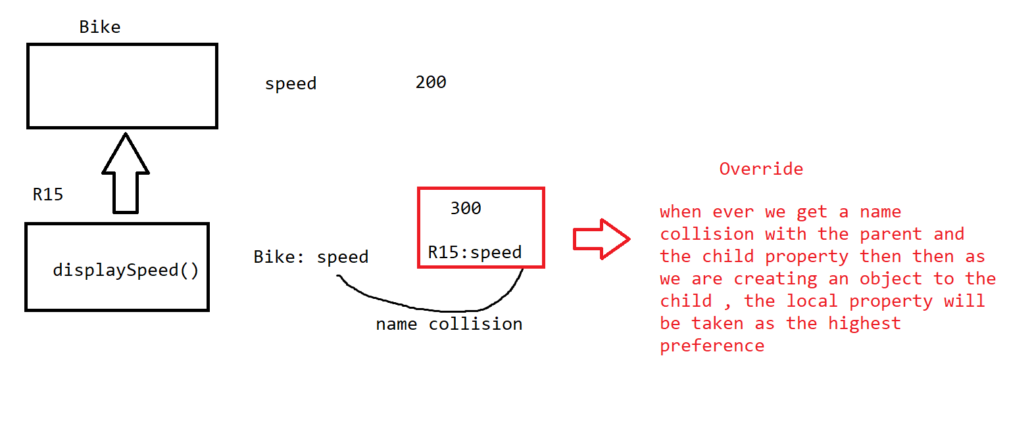

class R15 extends Bike{

int speed=300;

void displaySpeed() {

System.out.println("the bike speed is "+ speed);

}

}

//Multilevel

package com.mphasis.inheritance;

class Bike{

int speed=200;

}

class R15 extends Bike{

void displaySpeed() {

System.out.println("the bike speed is "+ speed);

}

}

class newR15 extends R15{

void displaySpeed() {

int addspeed=120;

int newSpeed=speed+addspeed;

System.out.println("the bike speed is "+ newSpeed);

}

}

public class BikeEx{

public static void main(String[] args) {

newR15 newr15=new newR15();

newr15.displaySpeed();

}

}

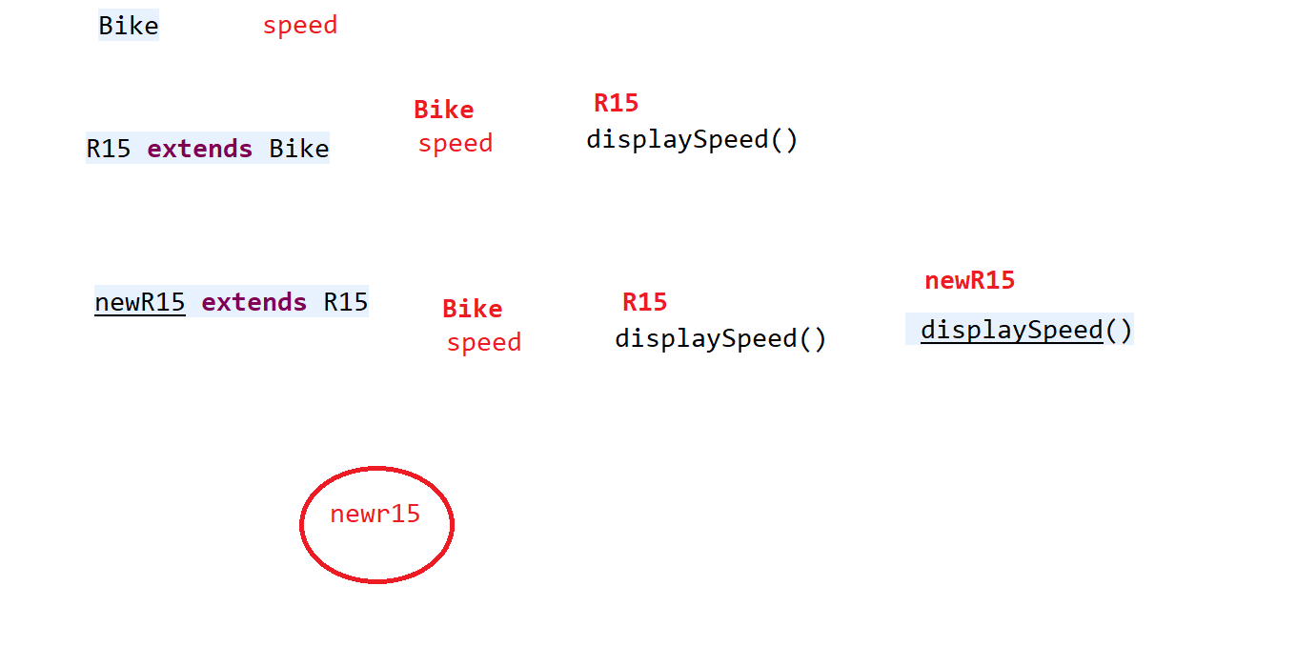

>Hierarichal inheritance

Note: Single Parent - multi child

package com.mphasis.inheritance;

class Bike{

int speed=200;

}

class R15 extends Bike{

void displaySpeed() {

System.out.println("the bike speed is "+ speed);

}

}

class newR15 extends Bike{

void displaySpeed() {

int addspeed=120;

int newSpeed=speed+addspeed;

System.out.println("the bike speed is "+ newSpeed);

}

}

public class BikeEx{

public static void main(String[] args) {

newR15 newr15=new newR15();

newr15.displaySpeed();

}

}

Hybrid - 10 min



Super 👍

If we have a name collision issue with the super class and the sub class property , if we create an object to the subclass then we have the scope of the variable / object with that sub class accessibility only because the child property is going to override the existing parent property.

But still we can get the super class property into it with the keyword “super”

package com.mphasis.inheritance;

class Bike{

int speed=200;

}

class R15 extends Bike{

int speed=300;

void displaySpeed() {

System.out.println("the bike speed is "+ super.speed);

}

}

public class BikeEx{

public static void main(String[] args) {

R15 r15=new R15();

r15.displaySpeed();

}

}

//get super property method

package com.mphasis.inheritance;

class Bike{

int speed=200;

}

class R15 extends Bike{

void displaySpeed() {

System.out.println("the bike speed is "+ speed);

}

}

class newR15 extends R15{

void displaySpeed() {

int addspeed=120;

int newSpeed=speed+addspeed;

System.out.println("the bike speed is "+ newSpeed);

}

void getparent() {

//we need to call the method with super keyword with in any method

super.displaySpeed();

}

}

public class BikeEx{

public static void main(String[] args) {

newR15 newr15=new newR15();

newr15.getparent();

}

}

Task :    10 min

Create a class Bank - roi as the variable , calIntrest(amount)

Create a class HDFC and update the roi variable with 8.5%

and display the final amount

Create a class ICICI and update the roi variable with 7.5%

and display the final amount

//final :

Final is a keyword

1. Before a variable- stops the variable to get change in the value//freezes the value
2. Before a method-then it stops the overriding of method
3. Before a class-then it stops the inheritance

package com.mphasis.inheritance;

class Bike{

//stops the variable

final int speed=200;

}

//it doesnt allow the inheritance

final class R15 extends Bike{

//it doesnt allow the overriding

 final void displaySpeed() {

speed=speed+10;

System.out.println("the bike speed is "+ speed);

}

}

class newR15 extends R15{

void displaySpeed() {

int addspeed=120;

speed=speed+addspeed;

System.out.println("the bike speed is "+ speed);

}

void getparent() {

//we need to call the method with super keyword with in any method

super.displaySpeed();

}

}

public class BikeEx{

public static void main(String[] args) {

newR15 newr15=new newR15();

newr15.displaySpeed();

}

}

//abstraction

It is the process where we hide the internal details and show only the external view of it .

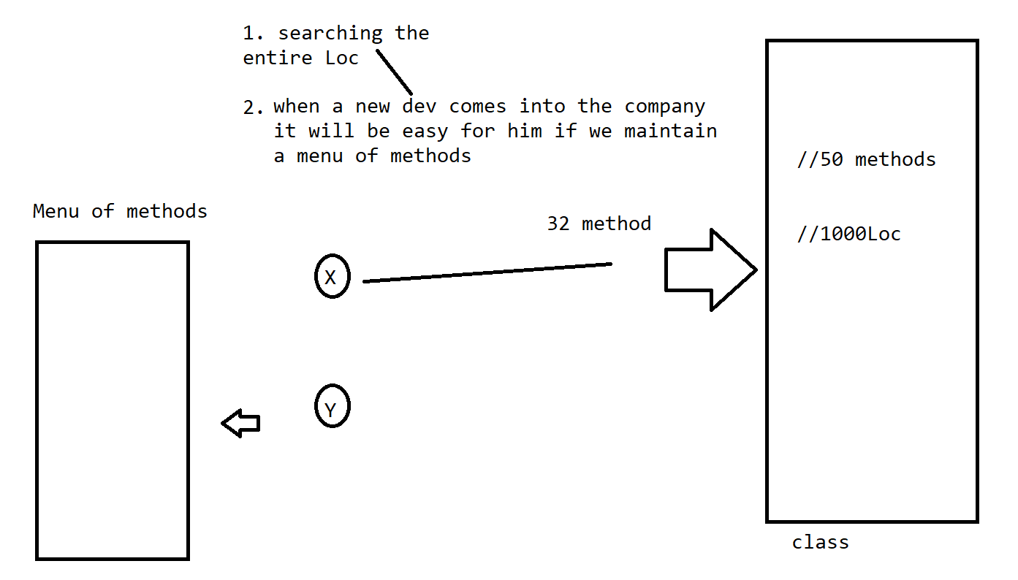

* When ever we are implementing the abstraction we need to maintain abstract methods
* It need to follow inheritance to get it implemented .

package com.mphasis.abstraction;

//menu of methods

public abstract class CalAbs {

//abstract methods : methods without body.

public abstract void addition(int num1,int num2);

                  //cntl + click =>implementation

public abstract void substraction(int num1,int num2);

}

package com.mphasis.abstraction;

public class CalImp extends CalAbs{

@Override

public void addition(int num1, int num2) {

// TODO Auto-generated method stub

System.out.println("the addtition is "+(num1+num2));

}

@Override

public void substraction(int num1, int num2) {

// TODO Auto-generated method stub

System.out.println("the sub is "+(num1-num2));

}

}

package com.mphasis.abstraction;

public class ExMain {

public static void main(String[] args) {

CalImp imp=new CalImp();

imp.addition(2, 3);

}

}

Abstraction with the abstract keyword is not satisfying 100 % abstraction

Still we can write concrete methods in it

100% abstract nature - interface

//interface

It allows only the abstract methods in it .

If we need implementation we need to under go [inheritance -implements]

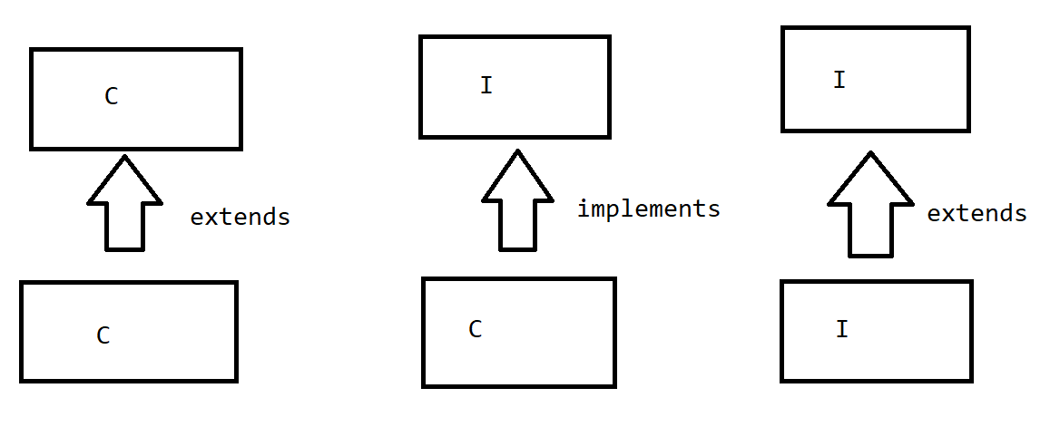

-solution for multiple inheritance .

class <classsname> implements <interface>,......{  }

package com.mphasis.abstraction;

//menu of methods

interface CalAbs1  {

//abstract methods : methods without body.

public abstract void addition(int num1,int num2);

}

package com.mphasis.abstraction;

public interface CalAbs2 {

public abstract void substraction(int num1,int num2);

}

package com.mphasis.abstraction;

public class CalImp implements CalAbs1,CalAbs2{

@Override

public void addition(int num1, int num2) {

// TODO Auto-generated method stub

System.out.println("the addtition is "+(num1+num2));

}

@Override

public void substraction(int num1, int num2) {

// TODO Auto-generated method stub

System.out.println("the sub is "+(num1-num2));

}

}

package com.mphasis.abstraction;

public class ExMain {

public static void main(String[] args) {

CalImp imp=new CalImp();

imp.addition(2, 3);

}

}

//Polymorphism

Poly:many

Morphism : forms

Same thing existing in many forms

->complile time , run time

Overloading        Overriding

>Method overloading

>method overriding

package com.mphasis.polymorphism;

class Cal{

int amount;

int salCal(float bonus) {

System.out.println("in float");

return amount;

}

int salCal(int bonus) {

System.out.println("in int");

return amount+bonus;

}

}

//1. check the method names -2    2. counts the no of arg -2     3. type of the data within the arg-1

public class ExMain {

public static void main(String[] args) {

Cal cal=new Cal();

cal.amount=10000;

System.out.println(cal.salCal(5000));

}

}

//method overriding

package com.mphasis.polymorphism;

class Cal{

int amount;

int salCal(int bonus) {

System.out.println("in int");

return amount+bonus;

}

}

class Cal1 extends Cal{

int salCal(int bonus) {

System.out.println("in float");

return amount;

}

}

public class ExMain {

public static void main(String[] args) {

Cal1 cal=new Cal1();

cal.amount=10000;

System.out.println(cal.salCal(5000));

}

}

 Task :10 min

Take a class EmployeeSal with bonus as the variable , method : CalSalary(int salary)

Take a class ContractEmployee - bonus of 5000

Take a class permanentEmployee- bonus of 10000

What is the final salary for both??

//Array

It is a linear datastructure

int empno1,empno2…….

int empno[100]--[0–99]

//creation of an array

1. int a[]=new int[]{2,3,34};
2. int a[]=new int[5];--freeze the limit

package com.example.array;

import java.util.Scanner;

public class ArrayEx {

public static void main(String[] args) {

Scanner sc=new Scanner(System.in);

System.out.println("enter the limit of the array");

int limit=sc.nextInt();

//define a dynamic array

int arr[]=new int[limit];

//how to read array values

for(int i=0;i<arr.length;i++) {

System.out.println("enter the value of index"+i);

arr[i]=sc.nextInt();

}

//how to display this array details

for(int i=0;i<arr.length;i++) {

System.out.println("the value at index i "+i+" "+arr[i] );

}

//display all values in the array---for each

for(int data:arr) {

System.out.println(data);

}

}

}

Task : 5min

Create a main class where you declare an array with values dynamically

Create a method in a class which is exclusively going to display the array values -displayArray(//){}---call by reference

Pass the array from main into this method .

Content in an array =>copy into another array

System.arraycopy(arr,0, arr1, 0, limit);

                       //src  srcin des design limit

package com.example.array;

import java.util.Arrays;

import java.util.Scanner;

public class ArrayEx {

public static void main(String[] args) {

int arr1[]=new int[] {4,1,3,2,6};

//array should be sorted

Arrays.sort(arr1);

for(int data:arr1) {

System.out.println(data);

}

}

}

//take an unsorted array and give me the

nth highest number separate method -5min

2 d arrays

1d - a[]

2d-a[][]

3d-a[][][]

2-D

package com.example.array;

import java.util.Arrays;

import java.util.Scanner;

public class ArrayEx {

public static void main(String[] args) {

Scanner sc=new Scanner(System.in);

System.out.println("enter the no of rows");

int row=sc.nextInt();

System.out.println("enter the no of cols");

int col=sc.nextInt();

int arr1[][]=new int[row][col];

for(int i=0;i<row;i++) {

for(int j=0;j<col;j++) {

System.out.println("enter the value of "+i+","+j);

arr1[i][j]=sc.nextInt();

}

}

for(int i=0;i<row;i++) {

for(int j=0;j<col;j++) {

System.out.print(arr1[i][j]+"\t");

}

System.out.println();

}

}

}

//assignment - addition , multiplication , transpose -2D

>String

Collections of a character

char c=’a’;

String value =”abcsd”;

Model 1:

String s1=””;

Model 2:

String s1=new String();

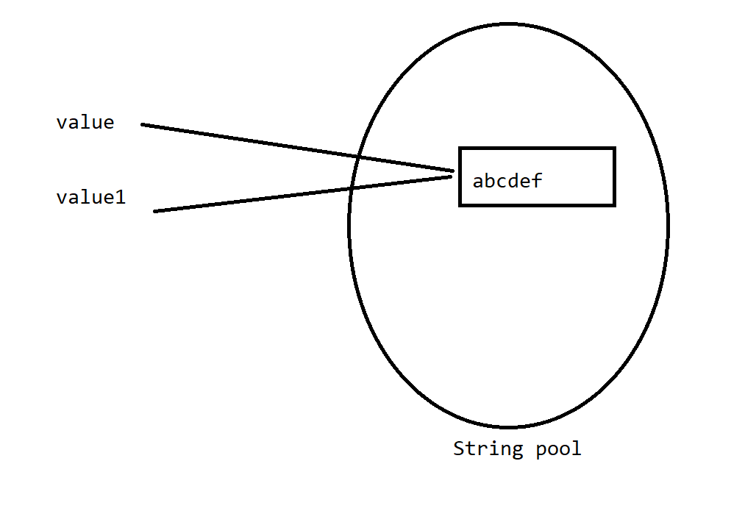

package com.example.array;

public class StringEx{

public static void main(String[] args) {

String value="abcdef";

String value1=new String("abcdef");

System.out.println(value +value.hashCode());

System.out.println(value1 + value1.hashCode());

}

}

Strings are said to called as immutable - when we make the manipulations over the object of the string it is not going to change the original string value rather it is a temporary manipulation .

package com.example.array;

public class StringEx{

public static void main(String[] args) {

String value="abcdef";

System.out.println(value=value.toUpperCase());

System.out.println(value);

}

}

//arrays and strings - <https://codingbat.com/java>

Collections :

Array - limitation - size is not dynamic

Insertion and deletions

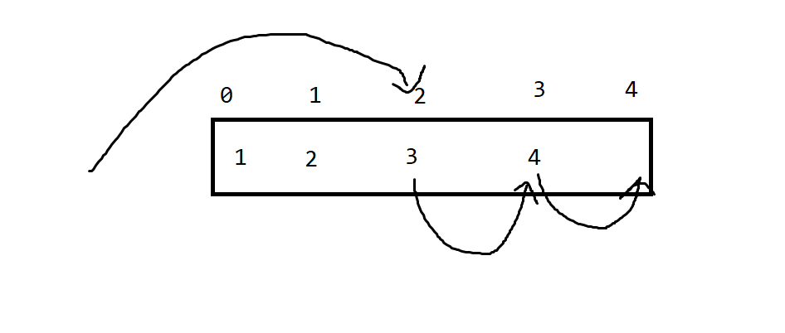

Collections is a framework used to collect the objects .

It is an architecture with predefined classes and methods in it.

Framework :   [Class->obj ->fetch methods]

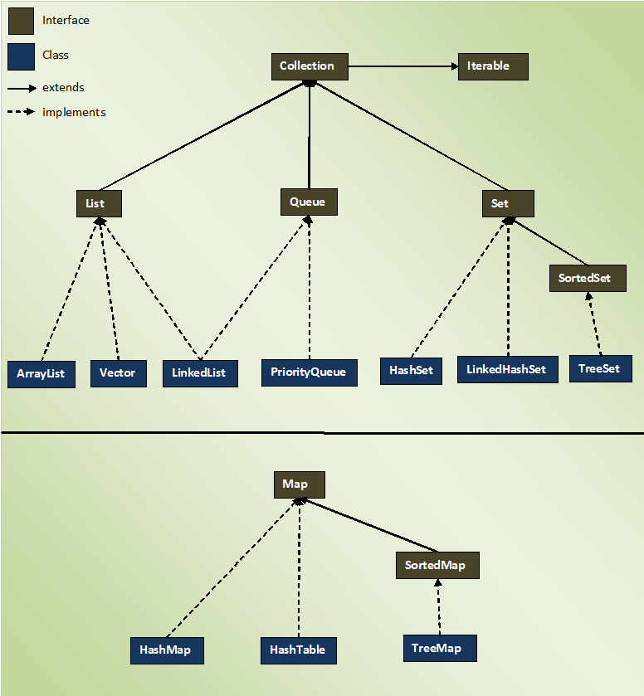

Collection:[List,Set,Map]

* Collection framework doesnt have any limitation in storing the objects .
* Objects are stored in collection depending on its predefined DS in it.
* We need to check / remember the properties of each collection such as duplication , null, order….

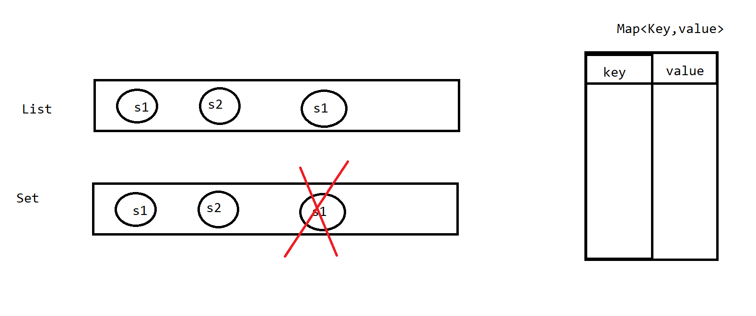

List<interface>

1.ArrayList

2.LinkedList

3.Vector

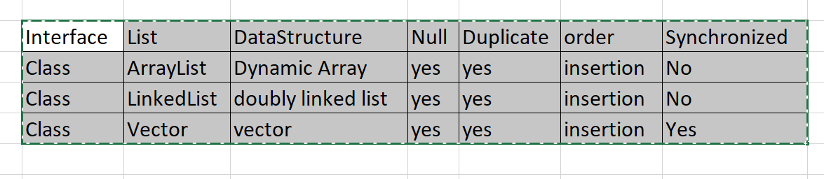

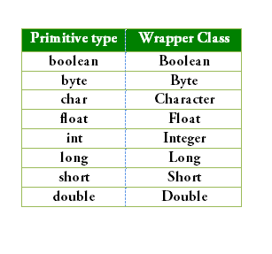

package com.collections.example;

import java.util.ArrayList;

public class CollEx {

public static void main(String[] args) {

//non generic collection

ArrayList al=new ArrayList();

al.add("abcd");

al.add(1);

al.add(5.0);

System.out.println(al);

//generic collection=>Wrapper classes/UserDefined/Predefined

ArrayList<Integer> al1=new ArrayList();

al1.add(3);

al1.add(1);

al1.add(5);

al1.add(5);

al1.add(null);

System.out.println(al1);

for(int i=0;i<al1.size();i++)

{

System.out.println(al1.get(i));

}

al1.remove(0);

System.out.println(al1.size());

for(Integer i:al1) {

System.out.println(i);

}

}

}

Note : all the collection are under the package of java.util.*;

//userdefined

package com.collections.example;

import java.util.ArrayList;

class Student{

private int sid;

private String name;

private String email;

public int getSid() {

return sid;

}

public void setSid(int sid) {

this.sid = sid;

}

public String getName() {

return name;

}

public void setName(String name) {

this.name = name;

}

public String getEmail() {

return email;

}

public void setEmail(String email) {

this.email = email;

}

@Override

public String toString() {

return "Student [sid=" + sid + ", name=" + name + ", email=" + email + "]";

}

}

public class StudentInfo{

public static void main(String[] args) {

Student s1=new Student();

s1.setSid(1);

s1.setName("kk");

s1.setEmail("k@c.c");

Student s2=new Student();

s2.setSid(2);

s2.setName("pp");

s2.setEmail("p@c.c");

ArrayList<Student> al=new ArrayList<>();

al.add(s1);

al.add(s2);

System.out.println(al);

for(Student ss:al) {

System.out.println(ss);

}

}

}

//task : 5 min

Create an employee class which has eid , ename , salary .

Create 3 employee data and collect it in a collection.//dynm

//1.have a collection defined

2. take a class dummy object outside the loop

3. take the obj assignment in the loop and scan all values and add to  the collection

Iterator<Student> i=al.iterator();//i we are going to store the base address of the arraylist object

while(i.hasNext()) {

Student s=i.next();

System.out.println(s.getSid()+"  "+s.getName());

}

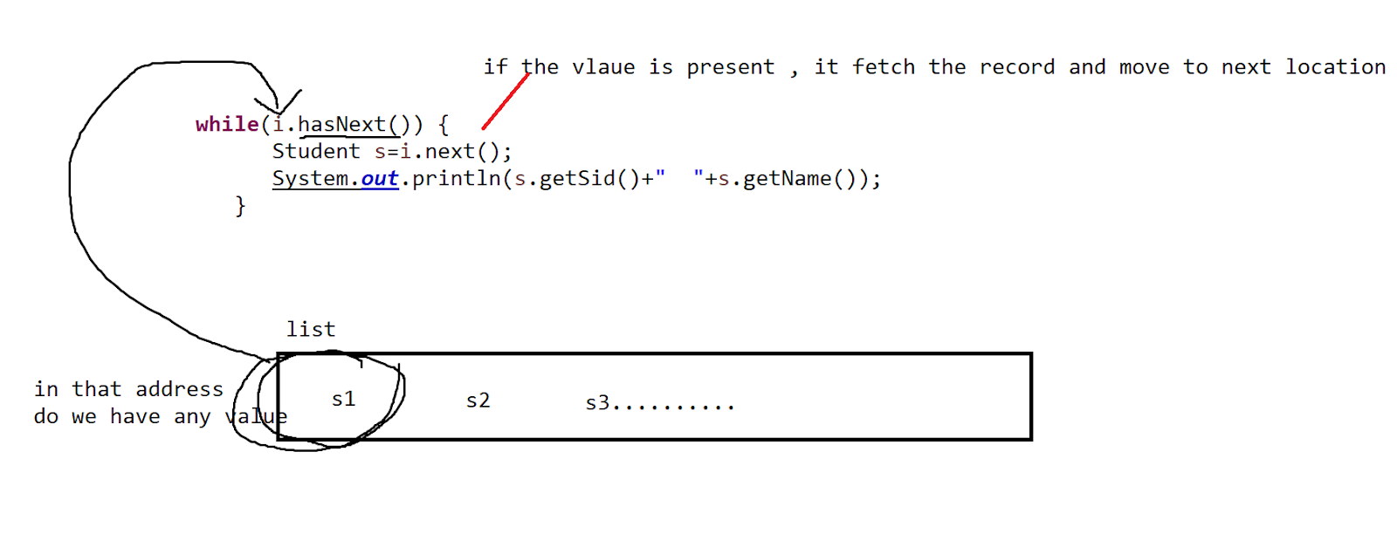

When we are in a need to quick accessibility of values - Arraylist

Linked List - when we need more insertions and deletions .

Set:

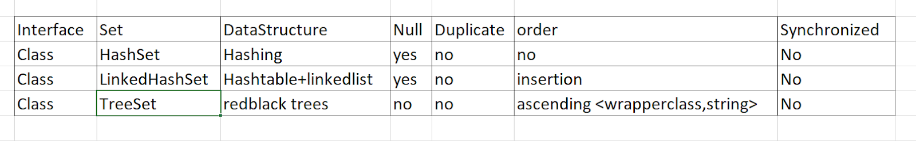

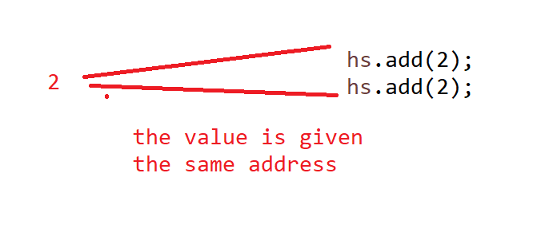

package com.collections.example;

import java.util.HashSet;

import java.util.LinkedHashSet;

public class DemoEx{

public static void main(String[] args) {

LinkedHashSet<Integer> hs=new LinkedHashSet();

hs.add(2);

hs.add(2);

hs.add(3);

hs.add(null);

System.out.println(hs);

}

}

package com.collections.example;

import java.util.HashSet;

import java.util.LinkedHashSet;

import java.util.TreeSet;

public class DemoEx{

public static void main(String[] args) {

TreeSet<String> hs=new TreeSet<>();

hs.add("defg");

hs.add("abcd");

hs.add("abde");

System.out.println(hs);

}

}

Task : 5 min

Create a Student class with some member data

//setters and getters

Create 2 objects and try to duplicate the object in adding and store it in linkedhashset and display the content and make the observations?

>Map

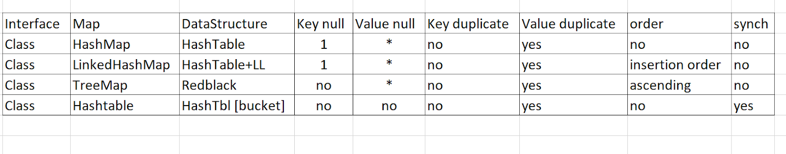

package com.collections.example;

import java.util.HashMap;

import java.util.Iterator;

import java.util.Map;

import java.util.Set;

public class DemoEx{

public static void main(String[] args) {

HashMap<Integer,String> map=new HashMap<>();

map.put(1,"kk");

map.put(2, "pp");

System.out.println(map);

//set values    =>

Set s=map.entrySet();

Iterator i=s.iterator();

while (i.hasNext()) {

Map.Entry mapobj= (Map.Entry)i.next();

System.out.println(mapobj.getKey()+"   "+mapobj.getValue());

}

}

}

Exception:

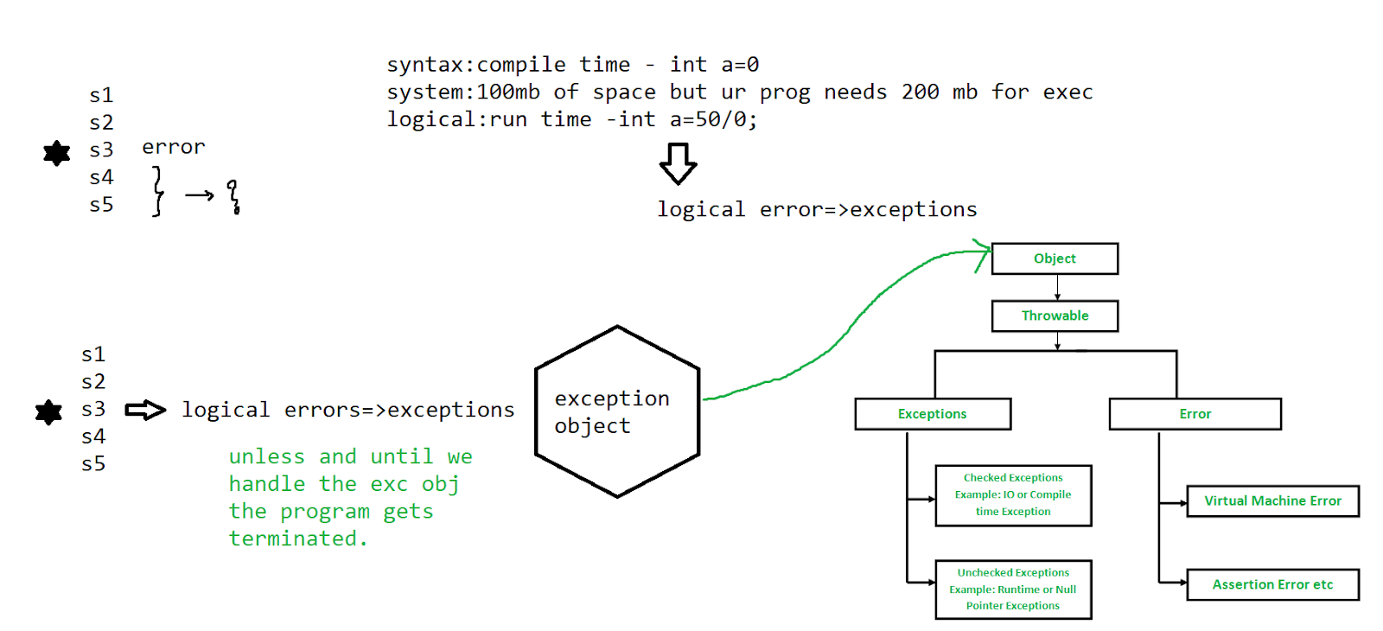

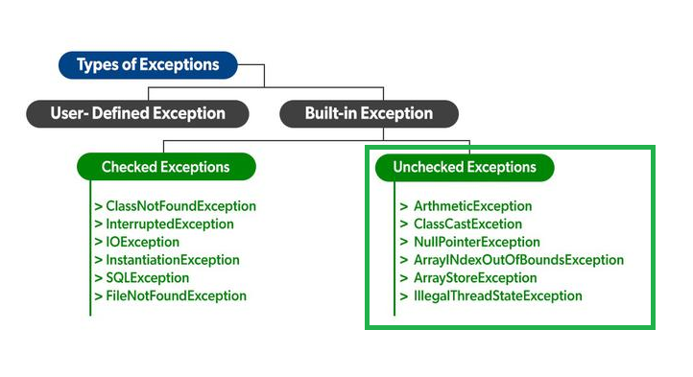

package com.example.exception;

public class ExExcep {

public static void main(String[] args) {

System.out.println("hi learners");

int a=50/0;//exception object is invoked

System.out.println("welcome to exceptions");

}}

Exception handling mechanism :

try{} catch(){}

package com.example.exception;

public class ExExcep {

public static void main(String[] args) {

System.out.println("hi learners");

try {

int a=50/0;//exception object is invoked

}

catch(Exception e) {

System.out.println("the exception in the program is "+ e);

}

System.out.println("welcome to exceptions");

}

}

//nested try

package com.example.exception;

public class ExExcep {

public static void main(String[] args) {

System.out.println("hi learners");

try {

try {

int b[]= {2,3,5};

b[6]=50;

}

catch(Exception e1) {

System.out.println("the exception in the program is "+ e1);

}

int a=50/0;//exception object is invoked

}

catch(Exception e) {

System.out.println("the exception in the program is "+ e);

}

System.out.println("welcome to exceptions");

}

}

finally :

The main use of the finally block is to close the connections .

Even if you get an exception or not in loc this block is going to get executed .

* To execute a finally block we need min one try block
* Without the catch we can write a try block ..by using finally

package com.example.exception;

import java.util.Scanner;

public class ExExcep {

public static void main(String[] args) {

Scanner sc = null;

try {

sc=new Scanner(System.in);

System.out.println("enter a value1 ");

int value1=sc.nextInt();

System.out.println("enter a value2 ");

int value2=sc.nextInt();

int res=value1/value2;

System.out.println("the result is "+res);

}

catch(Exception e) {

System.out.println("the exception is "+e);

}

finally {

System.out.println("closing of object");

sc.close();

}

}

}

Throw and throws

throw  is used to define an exception statement.

Throws is used to remove the exception in a method and throw it out of the program automatically.

if(){

//true

}

else{

//false  ⇒exception ->User defined exception

}

How to define user define exceptions?

1. Create a UDE class and extend it to super class “Exception”
2. Create a constructor / tostring() with the statement of exception as an arg
3. Pass the statement to the super constructor of the exception so as to link it to the super class Exception

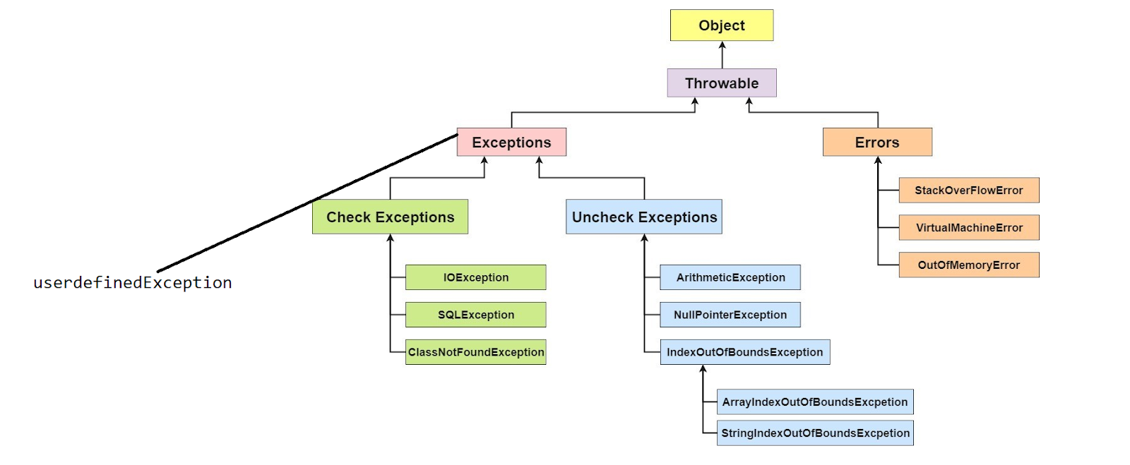

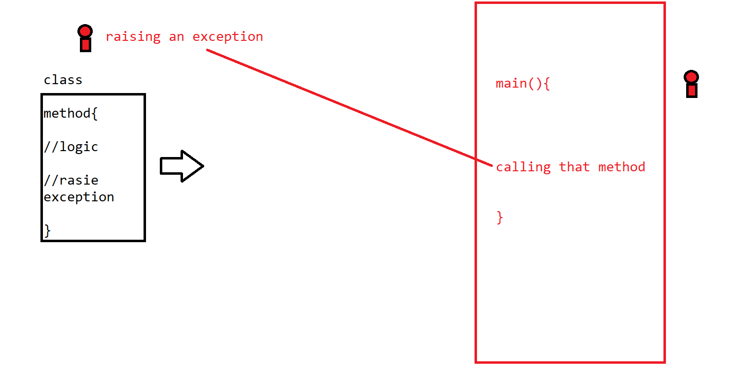

package com.example.exception;

public class AgeInvalidException extends Exception {

public AgeInvalidException(String exmsg) {

super(exmsg);

}

}

package com.example.exception;

public class AgeValidator {

public void ageValid(int age) throws AgeInvalidException {

if(age>=18) {

System.out.println("valid to vote ");

}

else {

        //constructor

throw new AgeInvalidException("invalid to vote");//raise an exception ->statement

}

}

}

package com.example.exception;

public class AgeExceptionEx {

public static void main(String[] args) throws AgeInvalidException {

AgeValidator agevalid=new AgeValidator();

agevalid.ageValid(19);

}

}

**Note : whenever we are calling the method which has the exception in it . then the methos where your calling it is also going to raise an exception.**

Task :

Ravi went to an ATM to withdraw 20K from the machine.

If he had enough money then the trasx needs to happen and debit the money from the account and print the final balance .

If your balance is low then raise an exception “LowBalanceException”  with a statement

“Your balance is low to meet the requirements ….”

Amount : 10000 ex

>Input - Output Streams:

We stored out data , with the help of variables , objects [tempory memory]

“Files”

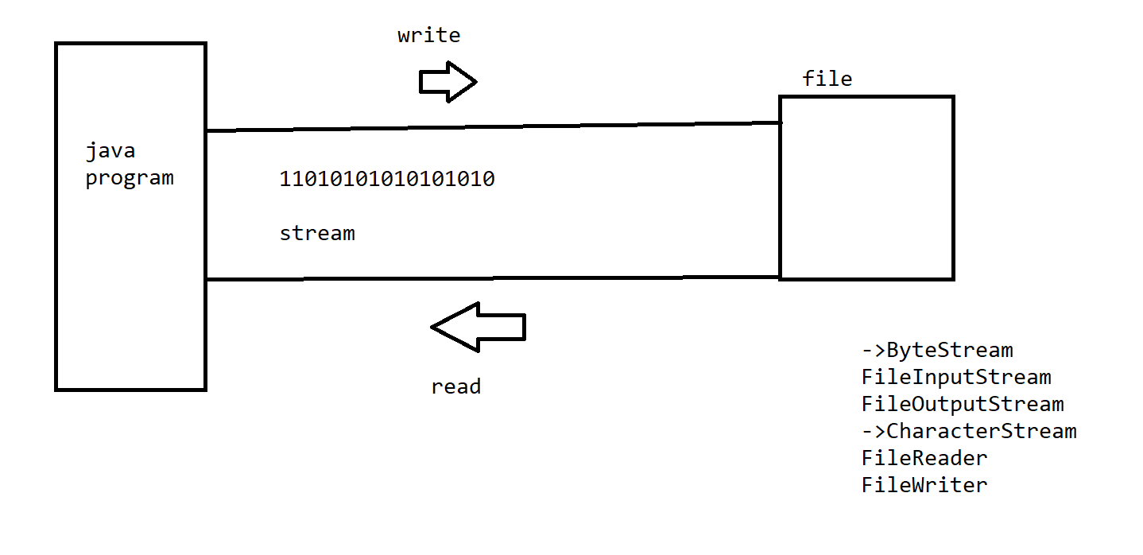

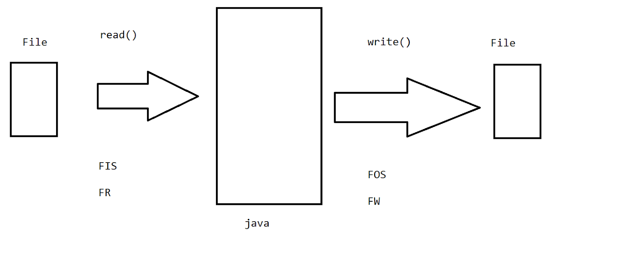

package com.example.file;

import java.io.FileNotFoundException;

import java.io.FileOutputStream;

import java.io.IOException;

import java.util.Scanner;

public class FilesEx {

public static void main(String[] args) throws IOException {

FileOutputStream fos=new FileOutputStream("input",true);

if(fos!=null) {

System.out.println("file created / open in write mode");

}

Scanner sc=new Scanner(System.in);

System.out.println("enter the input for the file ");

String fileInput=sc.nextLine();//sequence of characters

byte b[]=fileInput.getBytes();

fos.write(b);

System.out.println("write operation done");

fos.close();

}

}

// to append to the data in file

new FileOutputStream("input",true);

//file writer

package com.example.file;

import java.io.FileWriter;

import java.io.IOException;

import java.util.Scanner;

public class FilesEx {

public static void main(String[] args) throws IOException {

FileWriter fos=new FileWriter("input",true);

if(fos!=null) {

System.out.println("file created / open in write mode");

}

Scanner sc=new Scanner(System.in);

System.out.println("enter the input for the file ");

String fileInput=sc.nextLine();//sequence of characters

//byte b[]=fileInput.getBytes();

fos.write(fileInput);

System.out.println("write operation done");

fos.close();

}

}

//read

package com.example.file;

import java.io.FileInputStream;

import java.io.IOException;

import java.util.Scanner;

public class FilesEx {

public static void main(String[] args) throws IOException {

FileInputStream fis=new FileInputStream("input");

if(fis!=null) {

System.out.println("file exists in read mode");

}

int i=0;

//till we find EOF '-1'

while((i=fis.read())!=-1)

{

System.out.print((char)i);

}

fis.close();

}

}

//Task :

Copy a file content into another file - 5 min

package com.example.file;

import java.io.FileInputStream;

import java.io.FileOutputStream;

import java.io.IOException;

import java.util.Scanner;

public class FilesEx {

public static void main(String[] args) throws IOException {

FileInputStream fis=new FileInputStream("input");

FileOutputStream fos=new FileOutputStream("output");

if(fis!=null) {

System.out.println("file exists in read mode");

}

int i=0;

//till we find EOF '-1'

while((i=fis.read())!=-1)

{

fos.write(i);

}

fis.close();

}

}

//create a file in a directory

package com.example.file;

import java.io.File;

import java.io.IOException;

import java.util.Scanner;

public class FilesEx {

public static void main(String[] args) throws IOException {

//adding a file in a directory

String path="G:\\mphasis\\";

Scanner sc=new Scanner(System.in);

System.out.println("enter the file name");

String filename=sc.next();

String finalpath=path+filename;

System.out.println(" the file path is "+finalpath);

//create a file

File f=new File(finalpath);

boolean b=f.createNewFile();

if(b!=true) {

System.out.println("file is not created");

}

}

}

//delete a file

package com.example.file;

import java.io.File;

import java.io.IOException;

import java.util.Scanner;

public class FilesEx {

public static void main(String[] args) throws IOException {

//adding a file in a directory

String path="G:\\mphasis\\";

Scanner sc=new Scanner(System.in);

System.out.println("enter the file name");

String filename=sc.next();

String finalpath=path+filename;

System.out.println(" the file path is "+finalpath);

//create a file

File f=new File(finalpath);

//delete a file

boolean b=f.delete();

if (b==true) {

System.out.println("file deleted !!");

}

}

}

//display the list of files

package com.example.file;

import java.io.File;

import java.io.IOException;

import java.util.Scanner;

public class FilesEx {

public static void main(String[] args) throws IOException {

//adding a file in a directory

String path="G:\\mphasis\\";

// Scanner sc=new Scanner(System.in);

// System.out.println("enter the file name");

// String filename=sc.next();

// String finalpath=path+filename;

// System.out.println(" the file path is "+finalpath);

//create a file

File f=new File(path);

//list of files

File filename[]=f.listFiles();

for(File ff:filename) {

System.out.println(ff.getName());

}

}

}

//do a switch case logic where the menu is 1. Add 2. Delete 3. search 4. Display 5.exit

package com.example.file;

import java.io.File;

import java.io.IOException;

import java.util.Scanner;

public class FilesEx {

public static void main(String[] args) throws IOException {

//adding a file in a directory

String path="G:\\mphasis\\";

// Scanner sc=new Scanner(System.in);

// System.out.println("enter the file name");

// String filename=sc.next();

// String finalpath=path+filename;

// System.out.println(" the file path is "+finalpath);

//create a file

File f=new File(path);

Scanner sc=new Scanner(System.in);

System.out.println("enter the file name");

String filename1=sc.next();

//list of files

File filename[]=f.listFiles();

int flag=0;

for(File ff:filename) {

if(ff.getName().equals(filename1)) {

flag=1;

break;

}

else {

flag=0;

}

}

if(flag==1) {

System.out.println("found");

}

else {

System.out.println("not fond");

}

}

}

//Movie booking

1. Create a User class with username and password //set and getter
2. List collect the user objects
3. Create a Movies class with timings , movie name , seat object [][]
4. List collect the movie object
5. Work on the seats

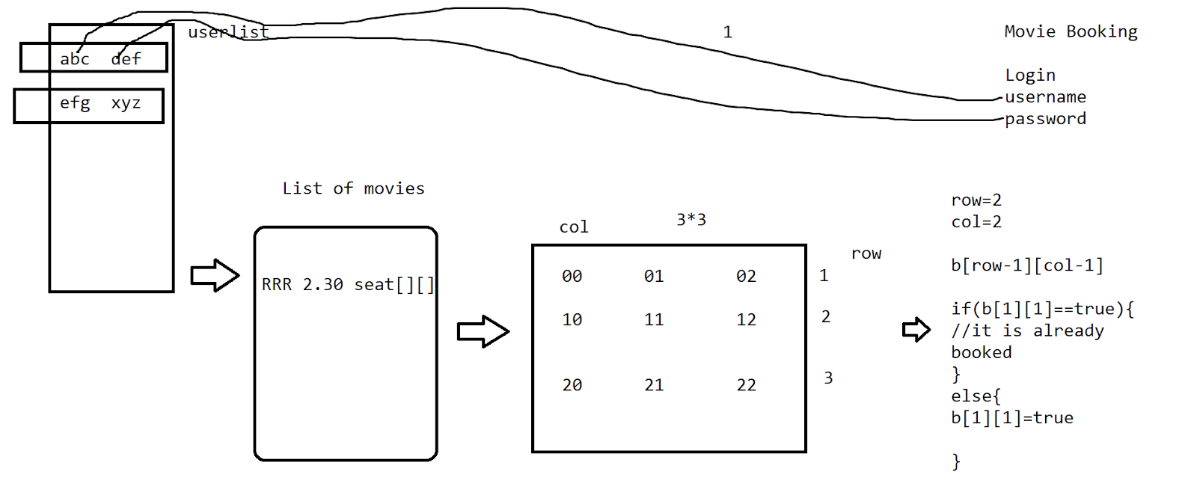

>Serialization/deserialization

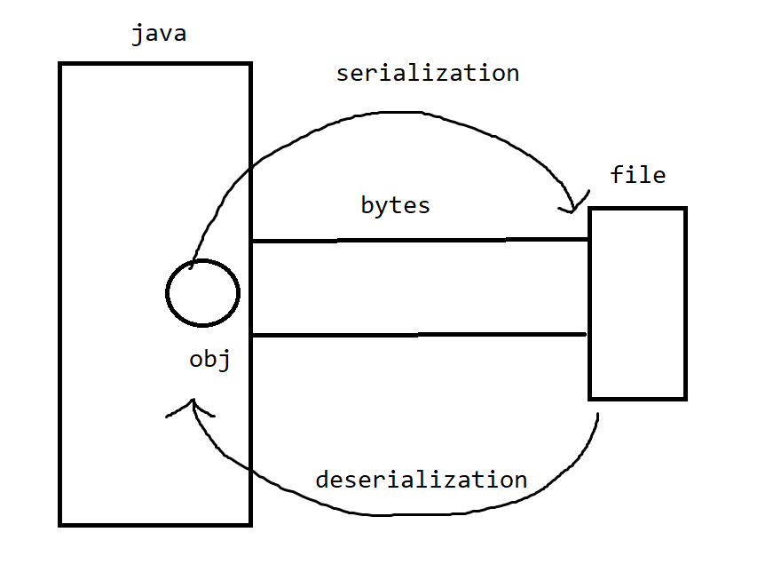

writeObject()

readObject()

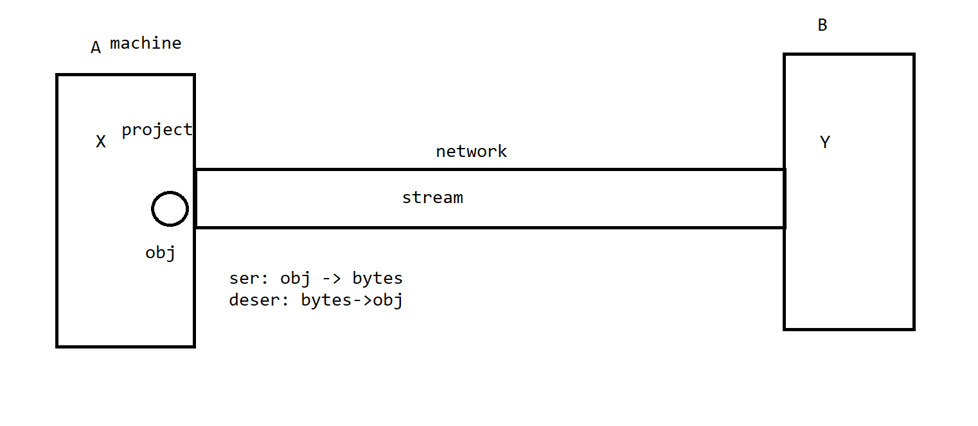

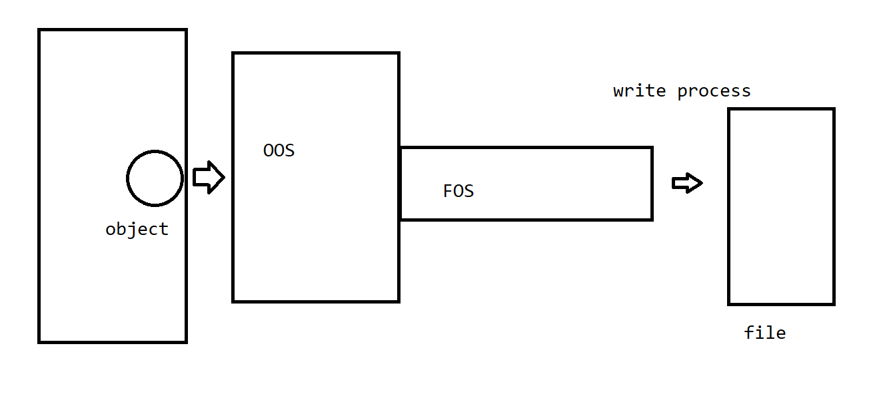

* The object class always need to have the implementation  of the interface serializable.

package com.example.seriable;

import java.io.FileNotFoundException;

import java.io.FileOutputStream;

import java.io.IOException;

import java.io.ObjectOutputStream;

import java.io.Serializable;

class Student implements Serializable{

private int stdid;

private String stdname;

public int getStdid() {

return stdid;

}

public void setStdid(int stdid) {

this.stdid = stdid;

}

public String getStdname() {

return stdname;

}

public void setStdname(String stdname) {

this.stdname = stdname;

}

@Override

public String toString() {

return "Student [stdid=" + stdid + ", stdname=" + stdname + "]";

}

}

public class StudentMain {

public static void main(String[] args) throws IOException {

FileOutputStream fo=new FileOutputStream("serInput");

Student s=new Student();

s.setStdid(1);

s.setStdname("kk");

ObjectOutputStream oos=new ObjectOutputStream(fo);

oos.writeObject(s);

oos.close();

fo.close();

}

}

//deserialization

package com.example.seriable;

import java.io.FileInputStream;

import java.io.IOException;

import java.io.ObjectInputStream;

import java.io.Serializable;

class Student implements Serializable{

private int stdid;

private String stdname;

public int getStdid() {

return stdid;

}

public void setStdid(int stdid) {

this.stdid = stdid;

}

public String getStdname() {

return stdname;

}

public void setStdname(String stdname) {

this.stdname = stdname;

}

@Override

public String toString() {

return "Student [stdid=" + stdid + ", stdname=" + stdname + "]";

}

}

public class StudentDesMain {

public static void main(String[] args) throws IOException, ClassNotFoundException {

FileInputStream fi=new FileInputStream("serInput");

ObjectInputStream ois=new ObjectInputStream(fi);

//LHS studentobj     RHS Object

Student ss=(Student) ois.readObject();

System.out.println(ss);

}

}

Threads:

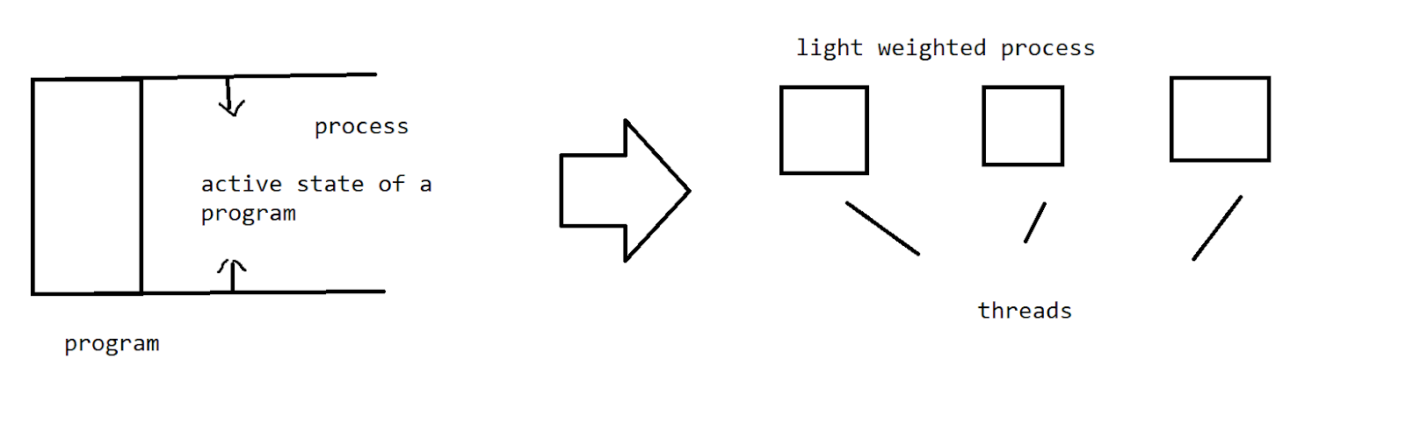

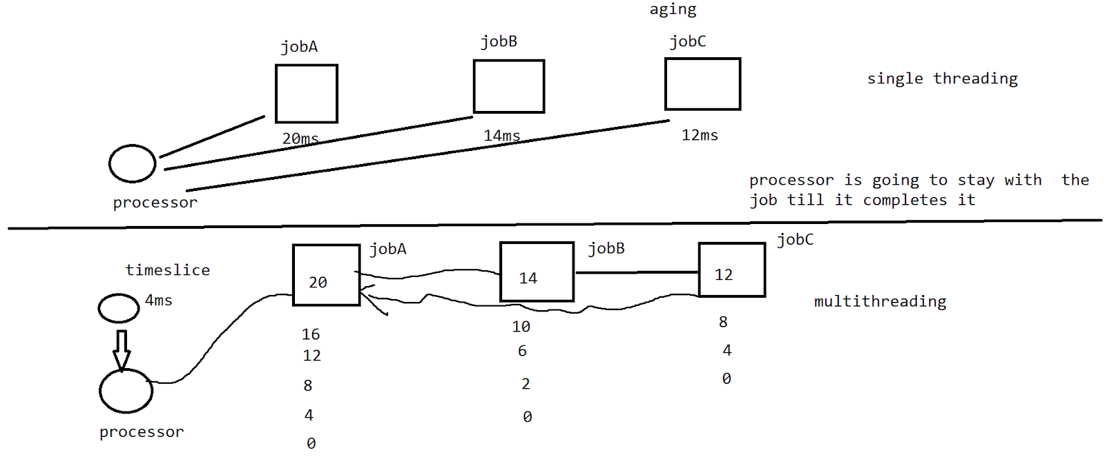

Creation of a thread:

1. Create a thread by using a class Thread.
2. Create a thread by using interface Runnable.

package com.example.threads;

//1. the class need to extends Thread   2. any logic -public void run()

class NumberIteration extends Thread{

public void run() {

for(int i=0;i<10;i++) {

System.out.println(i);

}

}

}

public class Threadmain {

public static void main(String[] args) {

NumberIteration itr1=new NumberIteration();

itr1.start();

NumberIteration itr2=new NumberIteration();

itr2.start();

}

}

// in the creation of the multiple threads we cannot expect the output to be in a sequence .

Model -2

package com.example.threads;

class NumberIteration implements Runnable{

public void run() {

for(int i=0;i<10;i++) {

System.out.println(i);

}

}

}

public class Threadmain {

public static void main(String[] args) {

NumberIteration itr1=new NumberIteration();

Thread t1=new Thread(itr1);

t1.start();

NumberIteration itr2=new NumberIteration();

Thread t2=new Thread(itr2);

t2.start();

}

}

=> model 2 is the best one which gives us the band of getting multiple properties into it.

package com.example.threads;

class NumberIteration implements Runnable{

public void run() {

show();

display();

}

public  void show() { System.out.println("excution in show");}

public  void display() {System.out.println("execution in display");}

}

public class Threadmain {

public static void main(String[] args) {

NumberIteration itr1=new NumberIteration();

Thread t1=new Thread(itr1);

t1.start();

NumberIteration itr2=new NumberIteration();

Thread t2=new Thread(itr2);

t2.start();

}

}

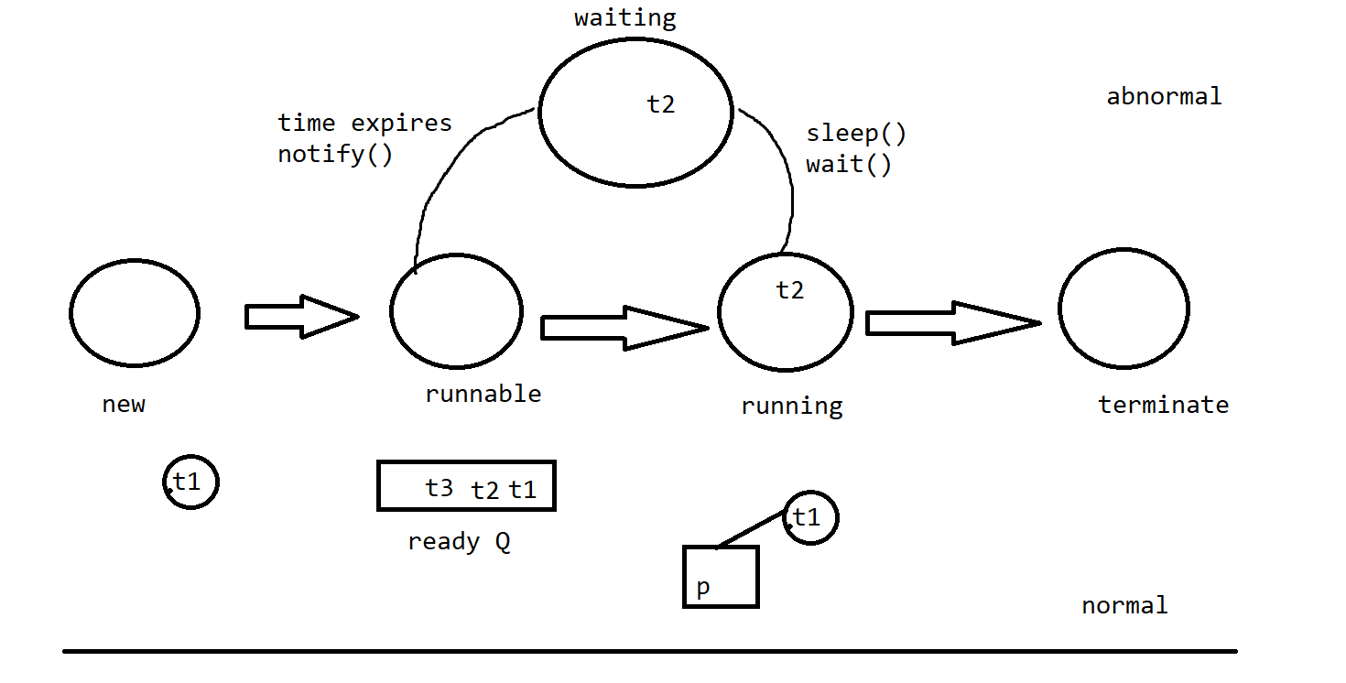

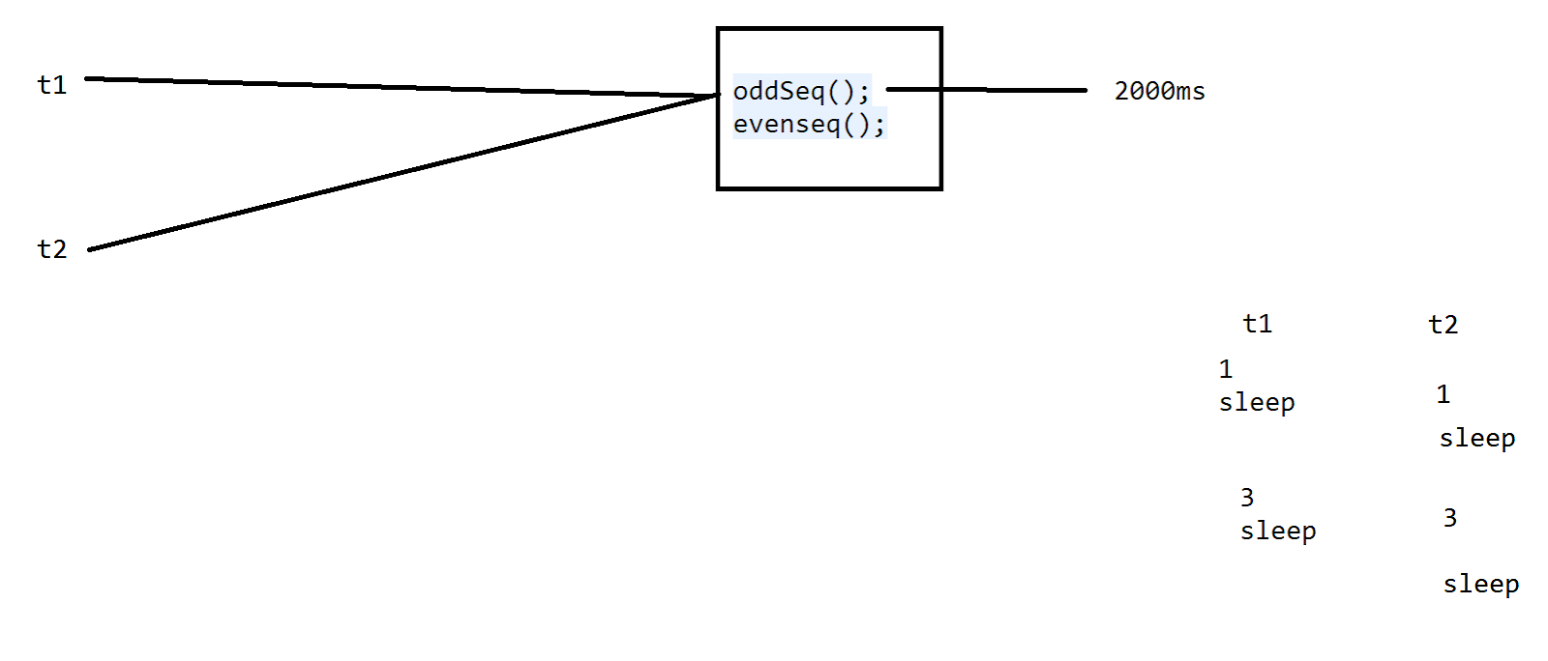

package com.example.threads;

class NumberIteration implements Runnable{

public void run() {

try {

oddSeq();

} catch (InterruptedException e) {

// TODO Auto-generated catch block

e.printStackTrace();

}

evenseq();

}

public  void oddSeq() throws InterruptedException { for(int i=1;i<=9;i=i+2) {System.out.println(i); Thread.sleep(2000);}}

public  void evenseq() {for(int i=2;i<=9;i=i+2) {System.out.println(i);}}

}

public class Threadmain {

public static void main(String[] args) {

NumberIteration itr1=new NumberIteration();

Thread t1=new Thread(itr1);

t1.start();

NumberIteration itr2=new NumberIteration();

Thread t2=new Thread(itr2);

t2.start();

}

}

//alternate way to choose the method

package com.example.threads;

class ATMUser{

int amount = 10000;

public synchronized void deposit(int depositamount) {

amount = amount + depositamount;

System.out.println("deposited the amount now balance is "+amount);

notify();

}

public synchronized void withdraw(int amountdraw) {

if(amount<amountdraw) {

System.out.println("you have a less balance ");

try {

wait();

} catch (InterruptedException e) {

// TODO Auto-generated catch block

e.printStackTrace();

}

}

else {

amount=amount-amountdraw;

System.out.println("the final amount is "+amount);

}

}

}

public class Threadmain{

public static void main(String[] args) {

ATMUser user=new ATMUser();

new Thread() {

public void run() {user.withdraw(15000);}

}.start();

new Thread() {

public void run() {user.deposit(5000);}

}.start();

}

}

//reprocess on wait and notify

package com.example.threads;

class ATMUser{

int amount = 10000;

public synchronized void deposit(int depositamount) {

amount = amount + depositamount;

System.out.println("deposited the amount now balance is "+amount);

notify();

}

public synchronized void withdraw(int amountdraw) {

if(amount<amountdraw) {

System.out.println("you have a less balance ");

try {

wait();

} catch (InterruptedException e) {

// TODO Auto-generated catch block

e.printStackTrace();

}

amount=amount-amountdraw;

System.out.println("the final amount is "+amount);

}

}

}

public class Threadmain{

public static void main(String[] args) {

ATMUser user=new ATMUser();

new Thread() {

public void run() {user.withdraw(15000);}

}.start();

new Thread() {

public void run() {user.deposit(5000);}

}.start();

}

}

DataStructure:

A structure used to organize the data ans store in it .

Linear based

>Arrays

>Stacks

>Queues….

Non Linear based

>Trees

>graphs

….

=> advantage - efficiency on time and space

=>arrangements of the data on our priorities .

//searching

It is the process in which we search for a key element in an array to find its location .

>Linear search- sorted, unsorted

>Binary search

* Prereq : sorted array

package com.example.ds;

import java.util.Arrays;

import java.util.Scanner;

public class DsMain {

public static void main(String[] args) {

int a[]= {2,3,1,4,99,11,23,45,66,8};//unsorted

Arrays.sort(a);

for(int b:a) {

System.out.print(b+",");

}

Scanner sc=new Scanner(System.in);

System.out.println("enter the element to serach");

int key=sc.nextInt();

int flag=0;

int i=0;

for(i=0;i<a.length;i++) {

if(a[i]==key) {

flag=1;

break;

}

else {

flag=0;

}

}

if(flag==1) {

System.out.println("the element found at ith location "+i);

}

else {

System.out.println("element is not found");

}

}

}

-binary search :

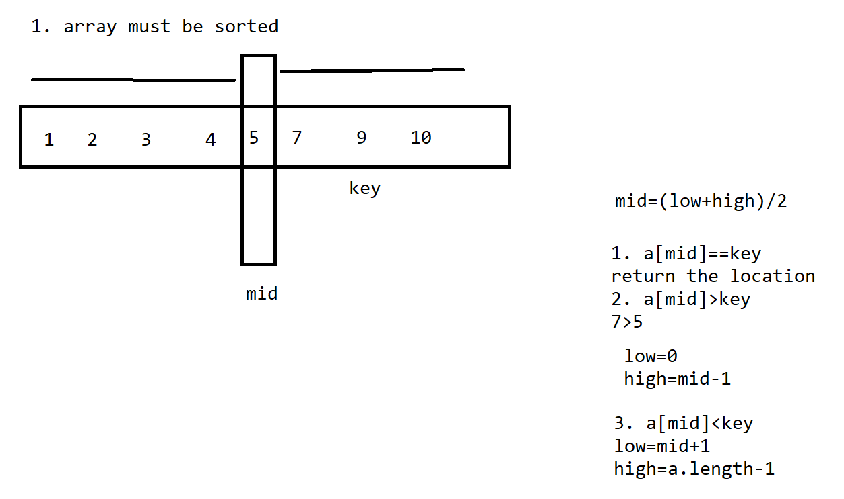

package com.example.ds;

import java.util.Arrays;

import java.util.Scanner;

public class DsMain {

public static void main(String[] args) {

int a[]= {2,3,1,4,99,11,23,45,66,8};//unsorted

Arrays.sort(a);

System.out.println("he sorted array is ");

for(int b:a) {

System.out.print(b+",");

}

System.out.println();

Scanner sc=new Scanner(System.in);

System.out.println("enter the element to serach");

int key=sc.nextInt();

int low=0;

int high=a.length-1;

int mid=0;

while(low<=high) {

mid=(low+high)/2;

if(a[mid]==key) {

System.out.println("element is found at the location "+ (mid+1));

break;

}

else if(a[mid]<key) {

low=mid+1;

}

else {

high=mid-1;

}

}

}

}

>Stack

It is a linear DS.

We have one end closed and one ended open.

LIFO - Last In First Out

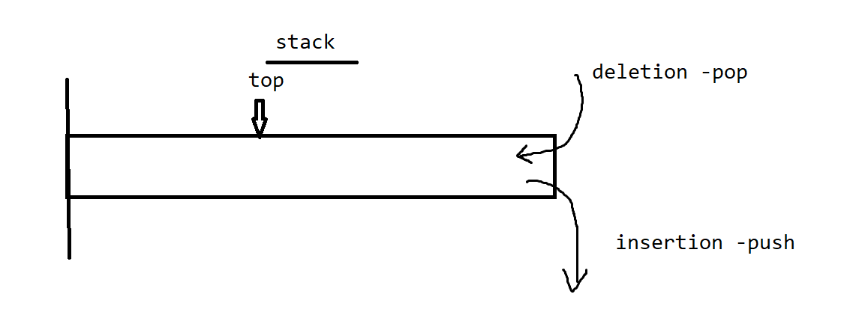

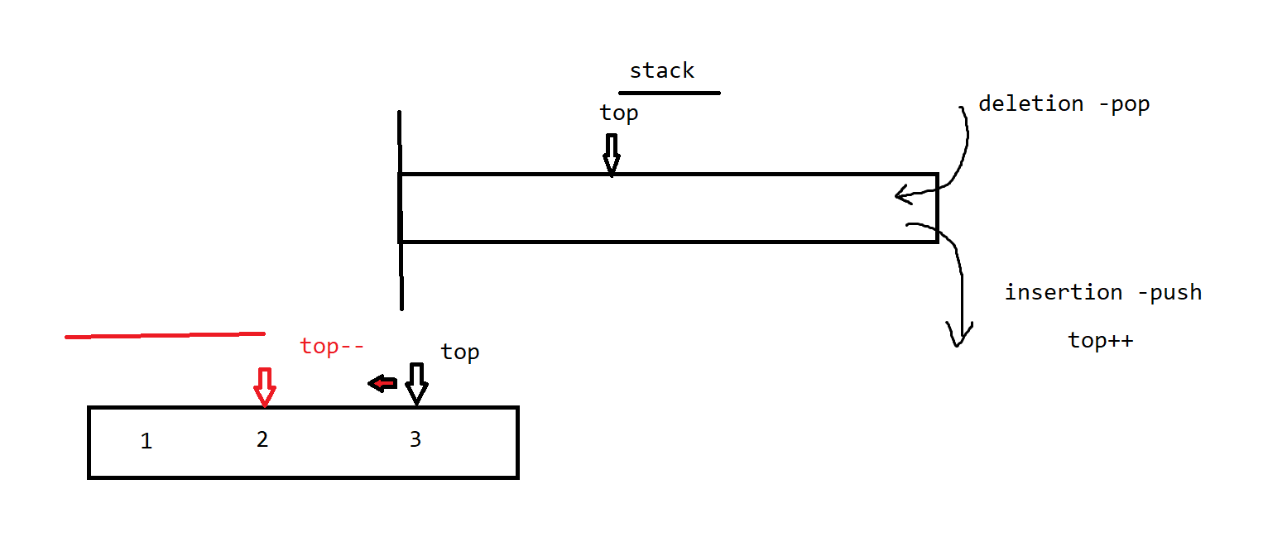

package com.example.ds;

import java.util.Arrays;

import java.util.Scanner;

public class DsMain {

public static void main(String[] args) {

Scanner sc=new Scanner(System.in);

System.out.println("enter the size of a stack");

int size=sc.nextInt();

int stack[]=new int[size];

int top=-1;

System.out.println("stack operations");

while(true) {

System.out.println("enter the choice 1. push 2. pop 3. display 4. exit");

int ch=sc.nextInt();

switch(ch) {

//overflow

case 1: if(top==size-1) {

System.out.println("stack has no more inserts it is full...");

}else{

System.out.println("enter the ele to insert");

int key=sc.nextInt();

top++;

stack[top]=key;

}

break;

case 2: //underflow

if(top==-1) {

System.out.println("stack is empty no more deletions ....");

}

else {

System.out.println("the element deleted is "+stack[top]);

top=top-1;

}

break;

case 3: //underflow

if(top==-1) {

System.out.println("stack is empty ....");

}

else {

for(int i=top;i>=0;i--) {

System.out.println(stack[i]);

}

}

break;

case 4: System.exit(0);

break;

default:System.out.println("check ur choice ");

break;

}

}

}

}

//Queues—-’Q’

FIFO - First In First Out

Elements get inserted from the rear→rear++

Elements get deleted from the front→front++

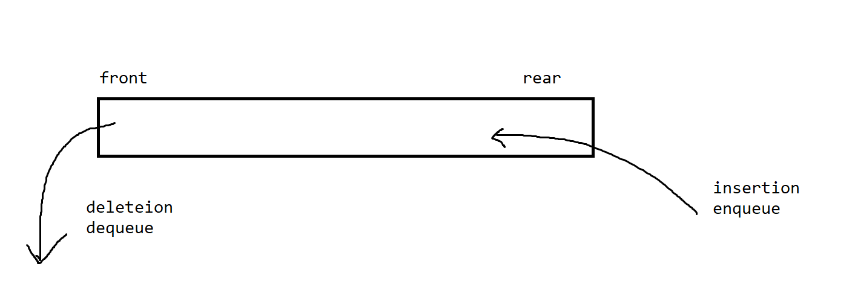

package com.example.ds;

import java.util.Arrays;

import java.util.Scanner;

public class DsMain {

public static void main(String[] args) {

Scanner sc=new Scanner(System.in);

System.out.println("enter the size of a Q");

int size=sc.nextInt();

int Q[]=new int[size];

int front=-1;

int rear=-1;

System.out.println("Q operations");

while(true) {

System.out.println("enter the choice 1. enqueue 2. dequeue 3. display 4. exit");

int ch=sc.nextInt();

switch(ch) {

//overflow

case 1:

if(rear==size-1) {

System.out.println("Q is full and no more insertions...");

}

else {

System.out.println("enter elemenet to insert");

int key=sc.nextInt();

rear++;

Q[rear]=key;

front=0;

}

break;

case 2: //underflow

if((front==-1&&rear==-1)||front>rear){

System.out.println("Q is empty");

}

else {

System.out.println("the elemnt got deleted is "+ Q[front]);

front=front+1;

}

break;

case 3: //underflow

if((front==-1&&rear==-1)||front>rear){

System.out.println("Q is empty");

}

else {

for(int i=front;i<=rear;i++) {

System.out.println(Q[i]);

}

}

break;

case 4: System.exit(0);

break;

default:System.out.println("check ur choice ");

break;

}

}

}

}

Algorithm 👍

Step by Step process to complete a task.

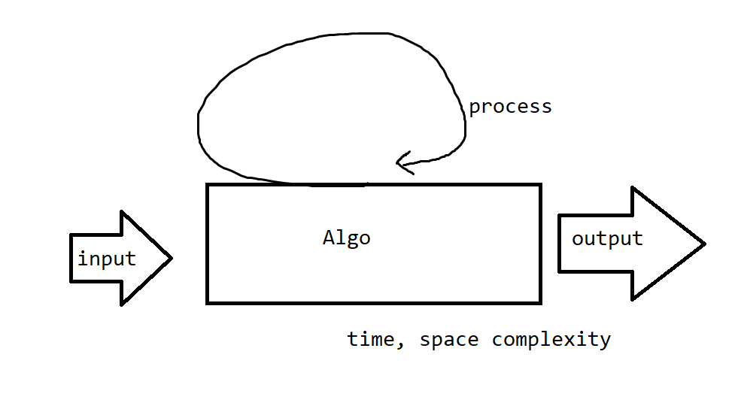

How much time does the algo taken to complete a task?

a=5 , b=6

c=b;

b=a;

a=c;

a=a+b;

b=a-b;

a=a-b;

a=(a+b)-(b=a);

How much space does it take to complete a task ?

—->Optimized way to solve a task ←—

Sortings of an array :

1. Bubble
2. Insertion
3. Selection
4. Merge
5. Quick

Bubble sort :

Comparison with neighbour element.

<https://www.hackerearth.com/practice/algorithms/sorting/bubble-sort/visualize/>

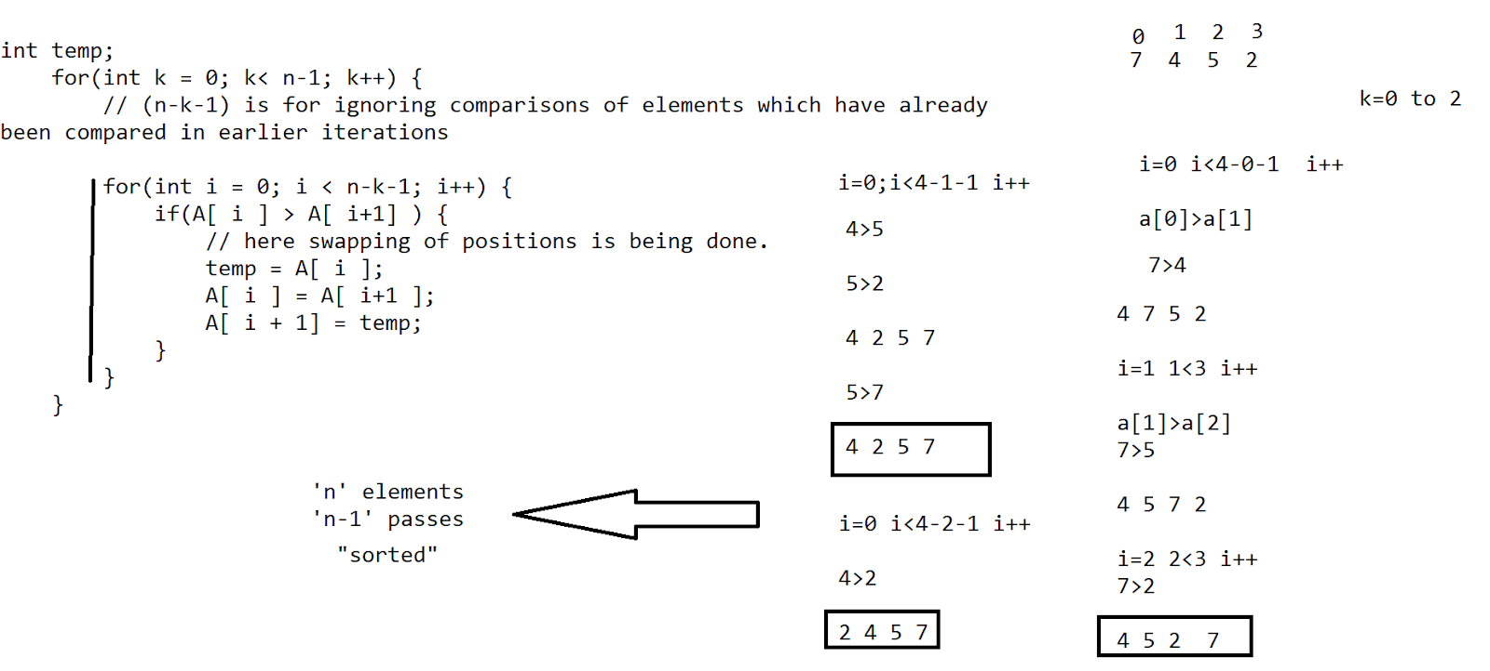

Selection :

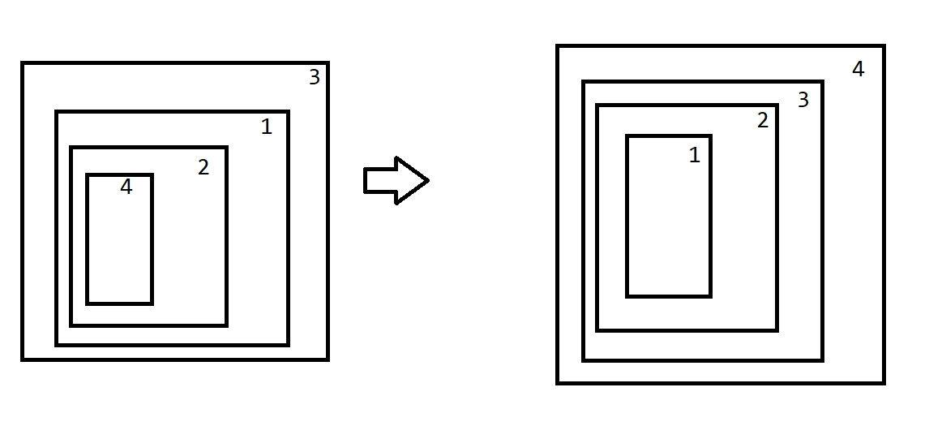

<https://www.hackerearth.com/practice/algorithms/sorting/selection-sort/visualize/>

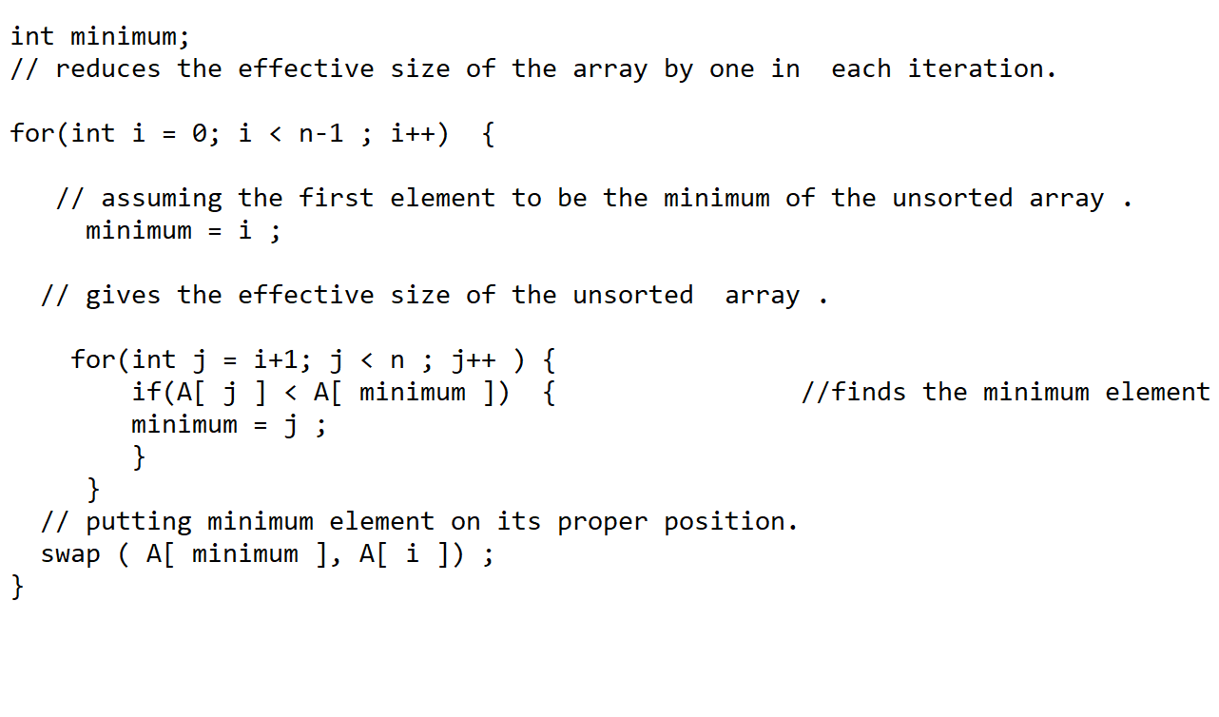

Insertion Sort :

<https://www.hackerearth.com/practice/algorithms/sorting/insertion-sort/visualize/>

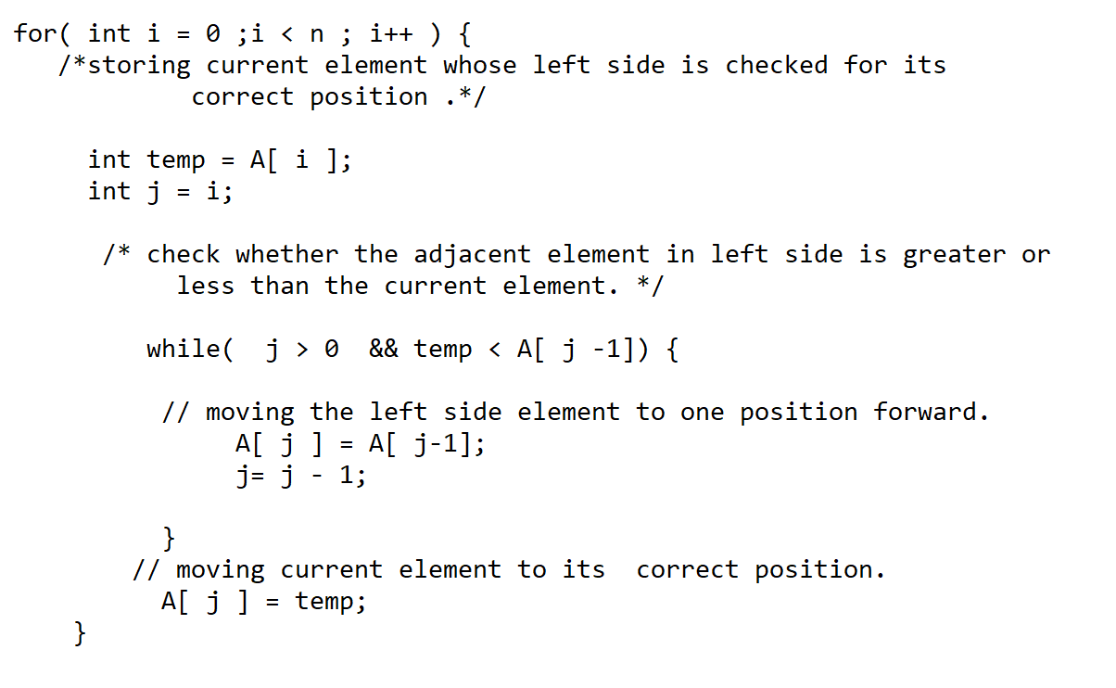

Camera Rental

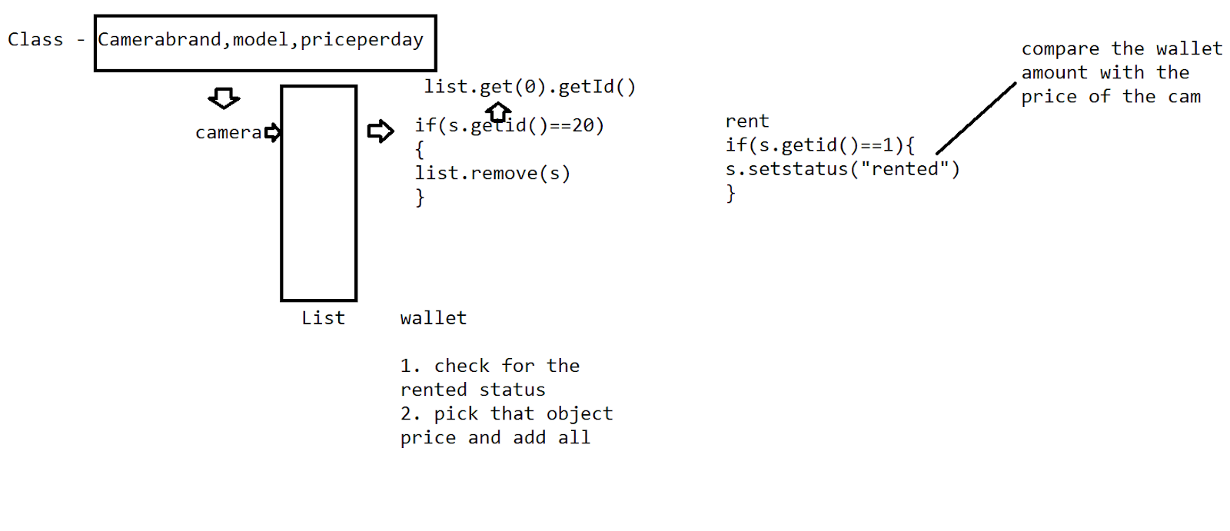

//merge sort

-Divide and Conquer

- make the elements individual -divide

-compare, [swap] and combine - Conquer

mid=(l+h)/2

[low,mid][mid+1,high]

<https://www.hackerearth.com/practice/algorithms/sorting/merge-sort/visualize/>

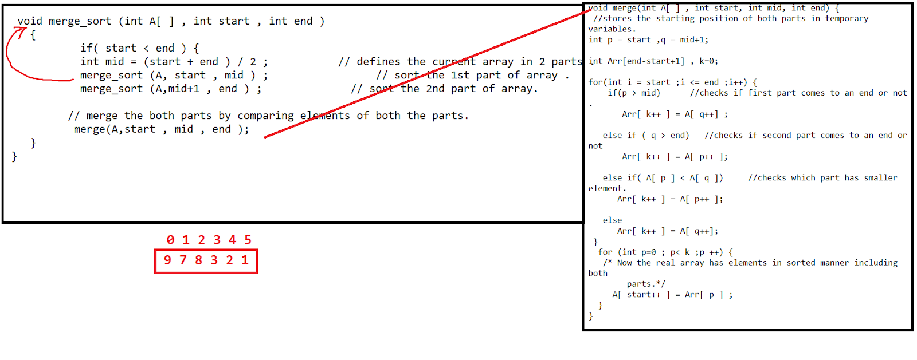

* In java from 1.8 version  a sorting methods called “parallelSort()” got introduced .

Which uses dual pivot on the parallel algorithm.

Quick sort:

-Choose the pivot element

* Divide and conquer
* Pivot -first element, last element, median, random

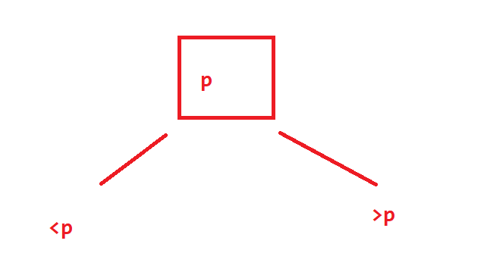

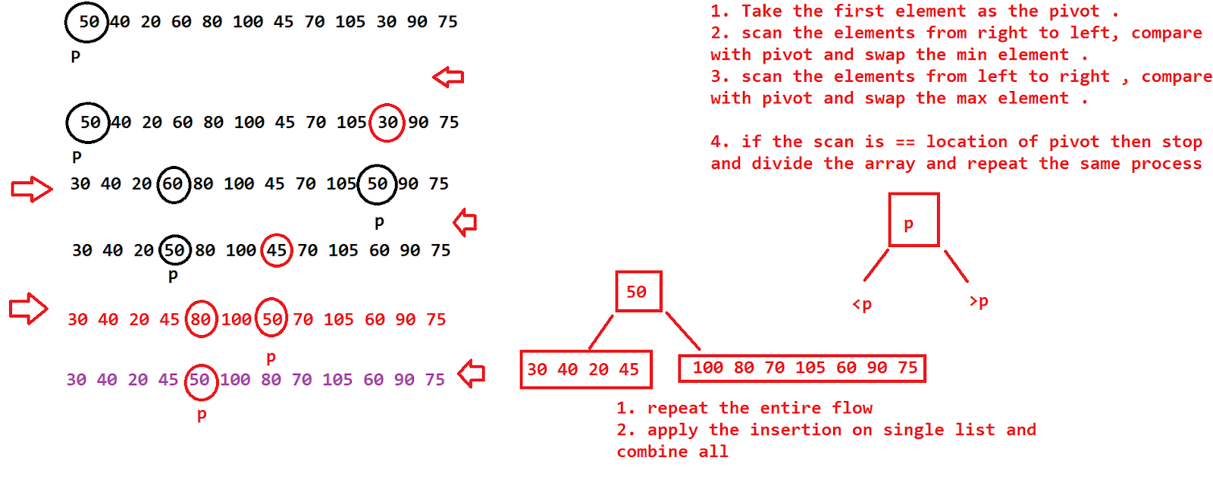

[9 7 5 3 2 1 10 6 18 15 8]- 5 min

Time Complexity :

>best

>worst

>avg

big O-worst , big Theta (Θ)-avg, and big Omega (Ω)-best

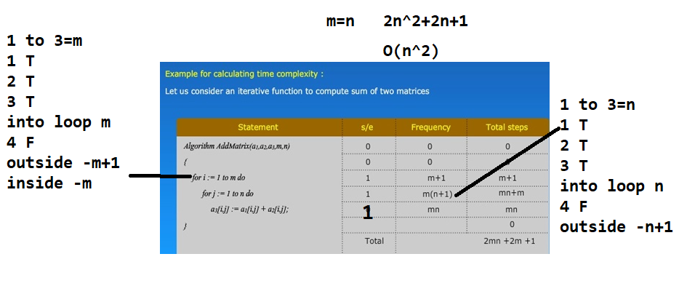

1 to 3 --->linear i++

1 to *2 or /2---->logarthmic - recursive

Task :

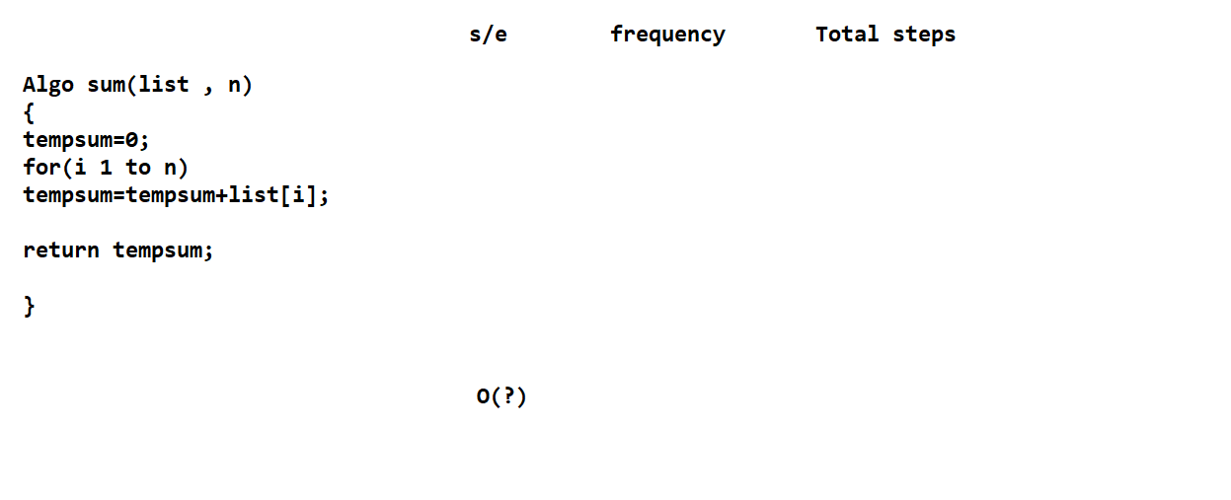

Recursive functions:

T(n)=a T(n/b) + constant

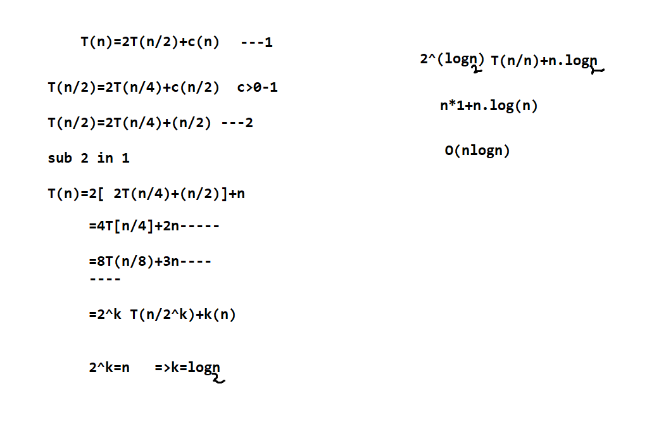

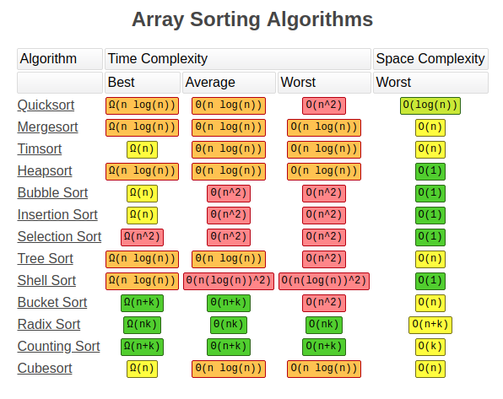

Best case - when we choose the elementary in the right way which can give us to process the algo with less time

Average case - we choose a random element

Avg case can be a best case

Avg case can be a worst case

Worst case : We choose an element in a wrong way which can make the algo process to take > time.

Space Complexity :

Estimation of the algorithm regarding the space .

1. Fixed variables
2. Dynamic variables

int sum=0;---->O(1) —-1 unit of space

A[] - array —>O(n)---n units of space

a[][] -multi →O(n*n)--n^2 units of space

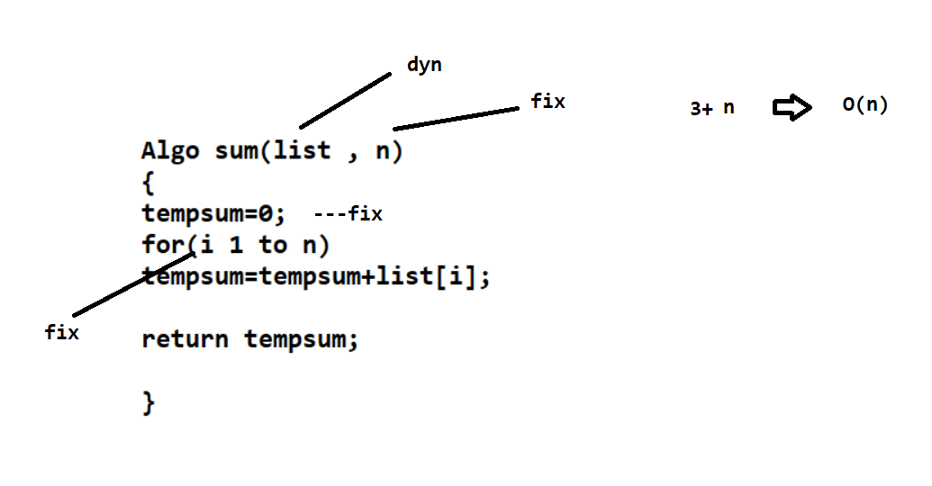

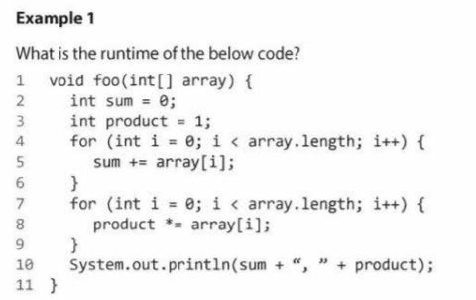

Asymptotic notations :

Estimation of the ‘n’ value from which the time complexity can be frozen.

